**TRANSBOUNDARY FISH STOCKS AND THEIR MANAGEMENT**

**UNDER CLIMATE CHANGE**

by

Juliano Emmanuel Palacios Abrantes

B.Sc. Universidad Autonoma Metropolitana unidad Xochimilco, 2012

M.Sc. University of California at Santa Barbara, 2016

A DISSERTATION SUBMITTED IN PARTIAL FULFILLMENT OF THE

REQUIREMENTS FOR THE DEGREE OF

DOCTOR OF PHILOSOPHY

in

THE FACULTY OF GRADUATE AND POSTDOCTORAL STUDIES

(Zoology)

THE UNIVERSITY OF BRITISH COLUMBIA

(Vancouver)

2021

©Juliano Emmanuel Palacios Abrantes

# 1 Abstract

Under the United Nations Law of the Seas and the delineation Exclusive Economic Zones (EEZs), fish stocks that cross neighbouring EEZs are known as transboundary stocks. The sustainability of these stocks depends on international cooperation. However, cooperation is faced with the challenges of the insufficient understanding of the where and how much fisheries resources are transboundary and climate change is shifting the distribution of marine species. My main objective is to understand the impacts of climate change-induced shifts on transboundary fish stocks distributions and their management, thereby informing international fisheries governance to prepare and respond to climate change. I rely on multiple data sources and numerical modelling to project species distributions under different scenarios of climate change.

I found that 67% of the species analyzed are transboundary and that between 2005 and 2014, fisheries targeting these species within global‐EEZs caught on average 48 million tonnes per year, equivalent to USD 77 billion in fishing revenue. As climate change alter ocean properties, the distribution of these species’ transboundary stocks are projected to shift to higher latitude, deeper waters or follow local environmental gradients. Specifically, 60% of the global transboundary stocks will have shifted beyond their historical distribution by 2020, and by 2075, all EEZs are projected to have a transboundary stock having shifted beyond its historical distribution. Moreover, the catch distribution proportion of transboundary stocks between neighboring EEZs will change by 2030 relative to the historic proportion. The changes in the distribution and share proportion of transboundary stocks can potentially impacts the management of the related fisheries. For example, Canada and the United States manage important transboundary stocks. However, by 2050, the proportion of the total catch of some transboundary fish stocks shared between the two countries are expected to change relative to the present, even under a low greenhouse gas emissions scenario.

My findings improve our understanding about the current status of transboundary stocks and highlight the challenges that fisheries management will face in a changing climate. Finally, I identify potential adaptation options for transboundary fisheries management such as side payments, dynamic rules, and interchangeable quotas that can improve their sustainability under climate change.

# 2 Lay Summary

The ocean is getting warmer, less oxygenated, and more acidic. As a consequence, marine species are shifting their distribution, challenging the management of fisheries that target stocks shared between Exclusive Economic Zones (transboundary stocks). Here, I aim to understand how climate change-driven shifts in species distribution will affect the management of transboundary stocks. I use a combination of numerical models and scenarios to project future oceanic conditions and species distributions. Two main findings emerge from my dissertation. First, transboundary species are more common and contributes more to present-day’s fisheries than previously known, highlighting the importance of ensuring effective management of their fisheries under the changing climate. Second, the distributions of many transboundary stocks have already shifted and many more are expected to shift in the coming decades. The incorporation of dynamic management could help reduce the negative impacts of climate change on the sustainability of shared stocks and their fisheries.

# 3 Preface

I am the main author of all chapters and lead author of all papers resulting from this work. I took primary responsibility for the research contained in the chapters, including the design, data curation, analysis and writing. This was done under the guidance of my supervisor Dr. William W.L. Cheung, and my committee members Dr. Daniel Pauly, Dr. U. Rashid Sumaila, and Dr. Villy Christensen. Moreover, each chapter has different co-authors that played a critical role in the development of the studies providing their expertise and advice with ideas, methods and data interpretation. Some of the chapters of this dissertation have been published or submitted for publication as stated below.

A version of Chapter 2 has been published in a peer review journal. I did the conceptualization, developed the methodology, performed the formal analysis and wrote the original draft. Gabriel Reygondeau supported the methodology, did the data curation, and contributed to the writing, reviewing and editing of the final draft. Colette Wabnitz supported the methodology, and contributed to the writing, reviewing and editing of the final draft. William Cheung did the supervision, and contributed to the writing, reviewing and editing of the final draft. The publication reference is as follows:

* Palacios-Abrantes, J., Reygondeau, G., Wabnitz, C. C. C., and Cheung, W. W. L., 2020. The transboundary nature of the world’s exploited marine species. *Scientific Reports*, 10 (1), 415–12.

A version of Chapter 3 is under review at peer review journal. I did the conceptualization, co-developed the methodology, performed the formal analysis and wrote the original draft. Thomas Frölicher and William Cheung helped develop the methods, William Cheung supported the conceptualization, did the supervision, and contributed to the writing, reviewing and editing of the final draft. Rashid Sumaila, Gabriel Reygondeau, and Colette Wabnitz contributed to the discussion analysis, writing, reviewing and editing of the final draft. The working title of this chapter is:

* Juliano Palacios-Abrantes, Thomas Frölicher, U. Rashid Sumaila, Alessandro Tagliabue,Gabriel Reygondeau, Colette Wabnitz, and William W.L. Cheung. Early range shifts in transboundary fish stocks challenge their management under climate change

A version of Chapter 4 has been published in a peer review journal. I developed the methodology, performed the formal analysis, and wrote the original draft. Rashid Sumaila and William Cheung supported the conceptualization of the study and contributed to the writing, reviewing and editing of the final draft.

* Palacios-Abrantes, J., Sumaila, U. R., and Cheung, W. W. L., 2020. Challenges to transboundary fisheries management in North America under climate change. *Ecology and Society*, 25 (4), art41–17.

# 5 Acknowledgements

I would like to start by acknowledging that this dissertation was mainly written in the traditional, ancestral, and unceded territory of the Musqueam People.

Many thanks to my adviser, William, for your brilliant guidance in this adventure, these were four years of smooth sailing! Thank you for your commitment and support to my professional development and for giving me so many opportunities. But also thank you for your kindness and humanity, you are certainly an inspiring person and a role model for current and future generations. I am very grateful to my committee members Daniel, Rashid and Villy for they support and advice. Special thanks to Rashid who was fundamental to many aspects of this dissertation, for keep pushing me to grow and do better, for trusting me, and for providing that spark of joy in our lives that we all need in the most troubled days. Rashid, I will keep pushing! Special thanks to Andrés Cisneros for all the insightful advice and guidance; to Gabriel Reygondeau for your patience in the multiple statistic discussions and for the football matches; and to Laura Rodríguez for your advice and support during this period. You are all truly inspiring people! Big shout to Colette Wabnitz, you are a wonderful human being and example to follow, thank you for all the unconditional support, the long discussions, and the advice in both my professional and personal life.

They say doing a PhD is a long and lonely path, I beg to differ. Colleagues and friends from CORU and from the IOF, this would not have been able without your friendship and support. Special shout to Ravi Maharaj for serving as a Vancouver ambassador, for all the numerous laughs, philosophical discussions and late nights shared over drinks decompressing from PhD anxieties; to Tanvi Vaidyanathan for your friendship and care for Niema; to my fearless leader Lian Kwong for inspiring me to be a better human and for all the help and support thorough the PhD process; to Samantha James for all those walks on campus that I so much miss; and Tim Cashion for making all those hard working days look easy. A mis queridos amigos del pescado Latino Americano, Rocío López, Santiago de la Puente y Tayler Clarke, no es fácil estar lejos de casa y ustedes sin duda alguna hicieron el viaje más ameno. Friends outside the IOF, Gabrielle Menard, Bruna Silvestroni, Jeff Scott, Mauro Sugawara, Nicole Margot, Pierre Rogy, and Hasasne Allegue, you guys were fundamental in keeping my sanity in these four years and I am truly grateful for all the amazing moments we shared. Bill French, Compa, thank you for making my Canadian experience more Mexican, for the laughs, and the camaraderie.

Lastly, this dissertation is the result of a 10-year long and winding road and its completion would not have been possible without the support of my family. Guillermo y Raquel, ustedes son mi pilar moral y modelo a seguir, gracias por apoyarme en todas mis decisiones, por más incoherentes que fueran; Martin gracias por siempre estar ahí para aconsejarme en las dicisiones más críticas. Angela e Amara, obrigado pela parceria e paciência no último ano do doutorado, vocês foram fundamentais na conclusão desste processo. Juliana Herrera, Renato Molina, Mariano Palacios, Paula Bermudez, Luis Villegas, Diego Villegas, Maria Fernanda Sánchez, Mariela Sánchez, Osvaldo Morales, Rodolfo Hernández, Allan Tamallo, Delia Cuturiel, Severino Campos, Isabel Studer, Jean François, Tere Rojas, Luis Kandel, gracias por siempre estar ahí para apoyarme.

Juliano Palacios Abrantes



The only problem with dogs is that they do not live long enough

# 6 Introduction

Delineating spatial boundaries is one of the fundamental approaches in marine resource management and governance (Song et al. 2017a). Examples of such spatial delineation range from the designation of Exclusive Economic Zones (EEZs) to marine protected areas and fishing regulatory areas. The effectiveness of current ocean management will be affected as climate change re-shapes the distribution of marine biodiversity worldwide and living marine resources shift across the existing spatial boundaries (Fredston-Hermann et al. 2018). This dissertation centers around the challenges that climate change will bring to the management of marine fish stocks that straddle neighboring EEZs. Specifically, I look at how climate-induced shifts in marine species distributions will affect shared marine resources and the consequences for the dependent fishing communities. My main motivation for this work is to improve fisheries management in the light of the changing climate, highlighting the need for adaptive and cooperative management strategies. In this introductory chapter, I provide a brief history of the management of ‘shared stocks’ (e.g., fish stocks that cross international boundaries) in marine fisheries, followed by a summary of the impacts of climate change on the physical and chemical properties of the ocean and the consequences of these changes on marine life. Finally, I will review the existing knowledge about the management of shared stocks under climate change.

## 6.1 Transboundary fisheries management

From 1973 to 1982, members of the United Nations (UN) held a series of meetings to discuss regulations regarding the high seas, a region of international common property, at that time, consisting of waters beyond 12 nautical miles (22.22 km) from shore (Munro, Willmann, et al. 2004). Among the main outcomes of these meetings was the establishment of the UN Convention on the Law of the Sea (UNCLOS). Under UNCLOS coastal states were allowed to claim special rights over the exploration and exploitation of marine resources up to 200 nautical miles (370 km) from their coasts. Area within which such special rights were claimed delineate today the states’ Exclusive Economic Zone (EEZ) (United Nations 2018).

While intended to improve management of marine resources, including fisheries, by granting property rights of the resources to states through the designation of EEZs, the delineation of such resource management boundaries was not informed by biogeography of living marine resources. The natural distribution of marine species in time and space is not shaped by human actions but by the species’ contemporary biotic and abiotic factors and their evolutionary history (Hutchinson 1957, Nelson et al. 2016). In many cases, fish stocks distribute across EEZs boundaries; in view of this, UNCLOS created the concept of what we know today as shared fish stocks (Miller and Munro 2002).

Generally speaking, shared fish stocks are those populations that move between different jurisdictions in the course of their life. The Food and Agricultural Organization (FAO) recognizes four types of shared stocks: (i) transboundary stocks are those that are shared between neighboring coastal nations e.g., Pacific halibut (*Hippoglossus stenolepis*) shared between Canada and the United States; (ii) straddling stocks are those that occur in two or more adjacent national jurisdictions and the high seas e.g., Chilean jack mackerel (*Trachurus murphyi*) off the coast of Chile and Peru but also the high seas; (iii) highly migratory stocks are those that are found in the EEZs of coastal nations that are not necessarily adjoining, and the high seas (e.g., Bluefin tuna *Thunnus thynnus* do circum-Atlantic migrations from the Mediterranean to the Gulf of Mexico); and (iv) discrete high seas stocks whose distribution is limited to the high seas (Figure 6.1). The inception of the concept of “shared stocks” in fisheries management called for the establishment of new fisheries governance approaches and organizations. Many straddling and highly migratory stocks are managed by Regional Fisheries Management Organizations (RFMOs) (Cullis-Suzuki and Pauly 2010, Monllor-Hurtado et al. 2017, Song et al. 2017b). At the EEZ level, transboundary stocks can be jointly managed by neighbouring countries under bi-lateral agreements or unilaterally without legal-binding agreements with other countries.

The management of shared stocks is often viewed through the lens of game theory as a mean to analyze strategic interactions among decision-makers. Previous studies that apply game theory to study shared stocks have demonstrated that cooperation between nations in managing these stocks will most likely result in the best overall ecological and economic outcome for nations sharing a common resource (Bailey et al. 2010, Eide et al. 2013). Lack of cooperation in managing shared stocks may result in over-exploitation (Clark 1980, Nguyen et al. 2018), reduction of the potential profitability of the fishery (Merino et al. 2007) and lead to conflict between coastal nations (Spijkers and Boonstra 2017). Only in some cases, when the target stock is transboundary but sessile (e.g., clams) non-cooperation could provide a better overall solution (Miller and Munro 2002).

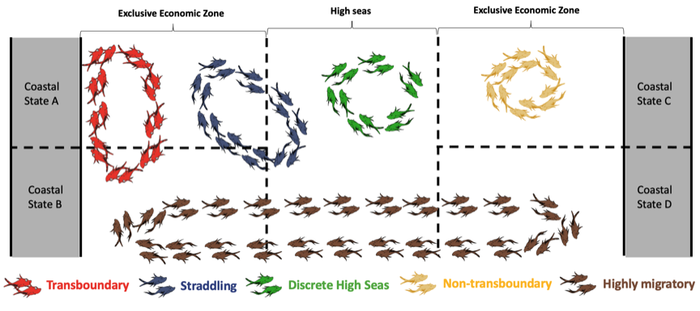

Figure 6.1: Schematic representation of the different types of shared stocks as defined by the United Nations’ Food and Agriculture Organization (FAO). Adapted from FAO (<http://www.fao.org/figis/servlet/IRS?iid=2665>). Fish images from Dr. Seuss. 1960. One fish, two fish, red fish, blue fish. Penguin Random House LLC.

Forty years after the implementation of UNCLOS, the scale and status of all transboundary species and their fisheries in the world ocean is still not accurately characterized. Caddy (1997) estimated that there could be up to 1,500 transboundary fish stocks in the world. However, such estimation was not explicitly informed by the biogeography of marine species (Caddy 1997). More recently, Teh and Sumaila (2010) estimated that 206 exploited species could be considered shared stocks, accounting for a total catch of 34.2 million t and an estimated landed value of USD 30.7 trillion (in 2006 value). While the estimates by Teh and Sumaila (2010) were based on a literature review of shared species, the estimates likely represented the lower limit of the number of shared species and the scale of their fisheries because many shared species may not be reported in the literature. Particularly, recent research highlighted the ecological and spatial interconnection of marine species (Ramesh et al. 2019), suggesting that the number of shared species may be more than previous estimates. A bottom-up approach that estimates the number of shared stocks based on the biogeography of exploited marine species may thus be accurate.

In Chapter 2 of this dissertation, using information from species’ biogeography, I aim to estimate the number of exploited marine species shared by neighboring countries and determine their contribution to global and regional catch and fisheries revenue. However, as climate change is causing a shift in the biogeography of marine species (Chapter 3), it adds complexity in understanding and managing transboundary fisheries (Chapter 4).

## 6.2 Climate change and its effect on marine species

By 2017, greenhouse gas emissions from human activities are estimated to have warmed the Earth’s surface by $1±{0.2}^{o}C$ above pre-industrial levels causing changes in ocean conditions (IPCC 2018) (Figure 6.2).

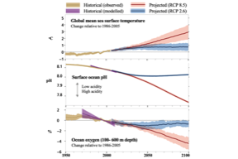

Figure 6.2: Past and future changes in sea surface temperature, surface ocean pH and oxygen content (100-600 m depth). Adapted from IPCC (2019)

The ocean has absorbed 93% of heat produced from greenhouse gas emissions since 1970 (Rheim et al. 2013, IPCC 2019). As a consequence, global sea surface temperature (SST) has increased by 0.63 $​^{o}$ C relative to 1850-1900 (IPCC 2019). Also, an assessment by the Intergovernmental Panel on Climate Change (IPCC) has concluded that marine heatwaves have become more frequent (Frölicher et al. 2018), and ice sheets and glaciers have lost mass at an average rate of 220 $±$ 30 Gt $yr^{–1}$ between 2006 and 2015 (IPCC 2019). The ocean has also sequestered about 30% of the carbon dioxide ($CO_{2}$) emissions from the atmosphere since the late 1980’s, causing a pH decrease of 0.1 unit that corresponds to a 26% increase in acidity (Ross et al. 2011, IPCC 2019). Moreover, increasing stratification of oceanic waters, changes in ventilation and biogeochemistry have led to a 0.5 to 3.3% loss of oxygen content in the upper layer (1000 m) of the open ocean between 1970 and 2010. During the same period, oxygen minimum zones have expanded by 3 to 8% in volume (IPCC 2019).

There are substantial regional variations in the $CO_{2}$-induced changes in ocean properties. For example, the Southern Ocean accounted for 35 to 43% of the total heat gain in the upper 2000 m layer of the global ocean between 1970 and 2017, and 25% of the global oxygen decline between 1970 and 1992 (IPCC 2019). Large reductions in oxygen have also been recorded for the north Pacific (IPCC 2019). In terms of pH, the largest declines between 1991 and 2011 were in the Indian Ocean (–0.027 units decade $​^{–1}$), eastern Equatorial Pacific (–0.026 units decade $​^{–1}$) and the South Pacific subtropical oceans (–0.022 units decade $​^{–1}$) (IPCC 2019).

Ocean properties are expected to continue to change in the ${21}^{st}$ century, although the intensity of these changes depends on the decisions’ society will take in the future in relation to carbon mitigation (Gattuso et al. 2015, IPCC 2019). The IPCC assessed the future climate using scenarios of greenhouse gas concentration in the atmosphere. These scenarios, known as Representative Concentration Pathways (RCPs), range from a “strong climate mitigation” (RCP 2.6) scenario to a “no mitigation” scenario where society has no effective greenhouse gases mitigation policies (RCP 8.5). Under RCP 2.6, radiative forcing increases 2.6 $W/m^{2}$ by 2100 relative to pre-industrial conditions while RCP 8.5 leads to a radiative forcing of 8.5 $W/m^{2}$ (Vuuren, Stehfest, et al. 2011). Under RCP 2.6, SST is projected to increase by 1.6C (CI[1]: 1.1 - 2.0C) by 2031 - 2050 relative to 1850-1900, maintaining this trend (1.6 $​^{o}$ C; CI: 0.9 - 2.4 $​^{o}$ C) towards the end of the ${21}^{st}$ century. In contrast, following RCP 8.5 would result in an increase of 2 $​^{o}$ C (CI: 1.5 - 2.4 $​^{o}$ C) by 2031 - 2050 reaching 4.3 $​^{o}C$ (CI: 3.2 - 5.4 $​^{o}$ C) by the end of the ${21}^{st}$ century relative to the same time period (Riahi et al. 2011, IPCC 2019). In addition, the IPCC considers two intermediate scenarios, RCPs 4.5 and 6.0. While RCP 4.5 leads to a radiative forcing of 4.5 $W/m^{2}$ by 2100 relative to pre-industrial conditions and RCP 6.0 leads to 6.0 $W/m^{2}$ (Masui et al. 2011, Thomson et al. 2011). Here, I focus on RCP 2.6 and RCP 8.5 to capture the lower and upper range of climate change impacts on shared fish stocks and fisheries.

The ocean is projected to become warmer, less oxygenated and with lower pH in the ${21}^{st}$ century relative to the present day (e.g., 1986-2005) under all RCPs (IPCC 2019). Specifically, by 2050, global mean SST is expected to increase by 0.65 $​^{o}$ C (CI: 0.33 to 0.96 $​^{o}$ C) under RCP 2.6 and 0.95 $​^{o}$ C (CI: 0.60 to 1.29 $​^{o}$ C) under RCP 8.5. The largest SST warming will be in the North Pacific, the tropical East Pacific, and in parts of the Arctic (Gattuso et al. 2015). At the same time, surface pH will be reduced by -0.072 (CI: –0.072 to –0.072) units under RCP 2.6 and 0.108 (CI: –0.106 to –0.110) units under RCP 8.5, with the Arctic experiencing the largest decrease (Gattuso et al. 2015, IPCC 2019). Dissolved oxygen within the first 600 m will also be reduced by -0.9% (CI: -0,3 to -1.5) under RCP 2.6 and -1.4% (CI: –1.0 to –1.8) under RCP 8.5 (IPCC 2019). The subsurface layer of mid-latitude regions is prone to see the largest changes in dissolved oxygen (Gattuso et al. 2015). By the end of the ${21}^{st}$ century under RCP 8.5, ocean surface will be 3.2 $​^{o}$ C warmer, –0.4 pH units lower, and have 3.9% less dissolved oxygen relative to the pre-industrial level. In contrast, under RCP 2.6, ocean surface will be 1.2 $​^{o}$ C warmer, pH will be –0.14 units lower and oxygen will be about 1% less than the pre-industrial level (Gattuso et al. 2015, IPCC 2019).

In responses to the change in ocean properties, marine species are altering their productivity, distribution, and phenology (Scheffers et al. 2016). The type and magnitude of the responses will vary depending on the oceanic region, taxonomic group and life history and ecological characteristics of the organisms (Gattuso et al. 2015, Poloczanska et al. 2016, Scheffers et al. 2016). Changes in maximum sustainable yield (MSY) of 235 populations of 162 species have been related to increasing water temperature. Between 1930 and 2010, MSY decreased by 4.1% (1.4 million tons) with some ecoregions (e.g., East Asia) experiencing losses of up to 35% (Free et al. 2019). Future projections suggest that by the end of the ${21}^{st}$ century, 41 and 91% of global fish stocks will see a decline in MSY relative to 2012 under RCP 2.5 and 8.5 respectively (Gaines et al. 2018). Moreover, shifting distributions has been the most widely documented response of marine species to ocean warming (Gattuso et al. 2015, Poloczanska et al. 2016). Marine species, from phytoplankton to top predators have shifted their distribution ranges, mostly poleward, by an average of 72.0 $±$ 13.5 km per decade (Poloczanska et al. 2016). These shifts are consistent with projections from species distribution models and are expected to continue in the ${21}^{st}$ century, even under a low emission scenario (RCP 2.6) (Cheung et al. 2010, Barange et al. 2014, Garcia-Molinos et al. 2015). Warming and less oxygenated waters have also been related to changes in size of marine fishes (Audzijonyte et al. 2020, Forster et al. 2012, Oke et al. 2020). Overall, fish body size is expected to decrease under a warming ocean (Cheung et al. 2012, Pauly and Cheung 2017, 2018) with variations between regions and species (Audzijonyte et al. 2020).

Shifts in exploited marine species abundance, distribution and phenology will consequently impact the economics of fisheries (Lam et al. 2016, Sumaila 2019, Sumaila et al. 2019) and food security (Golden et al. 2016, Bell et al. 2017) of communities that depend on them. It was estimated that in 2010, global fish landings were about 100 million tonnes (most of it destined to direct human consumption) generating about USD 150 billion (Tai et al. 2017). Estimates under RCP 8.5 suggest that global catches and revenue from fisheries could drop by 8 and 10%, respectively by 2050 with large regional differences (Lam et al. 2016). For example, under RCP 8.5, the Exclusive Economic Zone (EEZ) of many tropical countries are expected to see >50% reductions in both catch and revenue (Lam et al. 2016). This is the case of many Pacific Islands nations like the Philippines where fish represents a high proportion of animal-sourced food (Bell et al. 2017, Asch et al. 2018, FAO 2018a). On the contrary, high latitude EEZs such as the Russian in the north and the Chilean in the south could see increases of up to 30% (Lam et al. 2016). Similarly, societal vulnerability to climate change impacts on fisheries will not be the same across coastal communities. For example, indigenous fishing communities that rely on marine resources for food security and wellbeing are particularly vulnerable to climate change due to reduced access to resources (Cisneros-Montemayor et al. 2016, Weatherdon et al. 2016). Reducing greenhouse gas emissions to limit warming to a 1.5 $​^{o}$ C increase by the end of the ${21}^{st}$ century (RCP 2.6) could increase fisheries catch potential by up to 30% (Cheung, Reygondeau, et al. 2016). This would result in a USD 4.6 billion annual revenue increase benefiting 75% of coastal nations from which ~90% represent developing countries (Sumaila et al. 2019).

## 6.3 Transboundary fisheries management under climate change

Current transboundary fisheries management might not be adapted to cope with shifts in species distributions under climate change (Pinsky et al. 2018, Chapter 4). When a fish stock shifts from one EEZ to another due to climate change, fisheries in the states that lose the resource may opt to maximize the exploitation of the fish stock. In contrast, the states that benefits from an increasing share of the fish stock may have more incentive to conserve it because of its increasing stake on the state’s fisheries resources (Diekert and Nieminen 2017). As climate change continues to drive shifts in biogeography of exploited species, fish stocks are expected to expand into EEZs they did not occupy before. In some cases, abundance will decrease in the lower latitudinal range of the species potentially exacerbating conflicts over stock’s ownership and quota allocation (Pinsky et al. 2018, Oremus et al. 2020). Despite historical and projected changes in species distributions, today, many treaties concerning on the management of shared stocks are not well equipped to respond to stock shifts (Cullis-Suzuki and Pauly 2010, Pinsky et al. 2018, Sumby et al. 2021, Chapter 4). Specifically, some basic fisheries management strategies, such as quota allocations, are based on historical catch proportions, or stock’s historical distribution, and could become outdated as stocks shift to cope with a changing ocean (Beaugrand et al. 2011, Chapter 4, Pinsky and Mantua 2014). Lack of or insufficient adaptation of management of shared stocks to changing ocean conditions and stocks distributions will impact their effectiveness in ensuring the sustainability and benefits from the fisheries (Sumaila et al. 2020).

Both the magnitude and pattern of range shifts are important to characterize the risk and impacts of shifting shared stocks on transboundary fisheries management (Link et al. 2010, Pinsky and Fogarty 2012). The distribution of a fish stock can change in multiple ways. For example, the stock range can shift from one EEZ to another while approximately maintaining its total range size. Also, the distribution of the stock can contract from or expand into a neighboring EEZ, resulting in a decrease or increase in range size, respectively (Figure 6.3). The magnitude and characteristics of range shifts of shared stocks will have different consequences to their management (Link et al. 2010). Historically, such shifts have caused conflict between neighboring nations and compromised the sustainability of diverse shared stocks. Prominent examples include the 1980’s conflict over Pacific salmon between the United States (US) and Canada (Miller and Munro 2004, Song et al. 2017b).

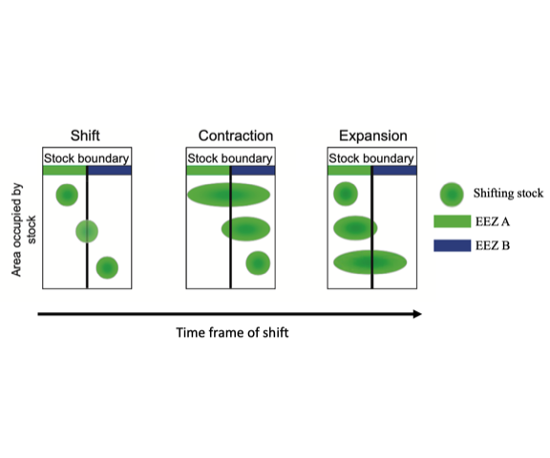

Figure 6.3: Schematic representation of different pattern of distribution shifts in shared stocks. Adapted from Link et al. (2010)

In addition to the magnitude and pattern of range shifts, it is important to understand the time frame at when the shifts and their impacts on fisheries will become apparent (Hawkins and Sutton 2012, Pinsky and Mantua 2014). The IPCC Special Report on the Ocean and Cryosphere in a Changing Climate used the concept of “time of emergence” (ToE) to discuss the challenge of changing ocean conditions, marine ecosystems and their challenges to ocean governance. As defined by the IPCC (adopted from Hawkins and Sutton, 2012), ToE is the moment in time when an anthropogenic change signal (e.g., future trend) rises above the background noise of natural variability (e.g., historical variation) (IPCC 2019). The premise behind ToE is that we can only be confident that a significant change has been detected when the signal of anthropogenic climate change is larger than the background of natural climate variability (Hawkins and Sutton 2012). The concept of ToE has been extensively used to determine the time by which diverse oceanic variables (e.g., temperature, oxygen, CO2) have raised above natural variability (e.g., emerged) in the global ocean (Mahlstein et al. 2011, Hawkins and Sutton 2012, Keller et al. 2014, Rodgers et al. 2015, Frölicher et al. 2016). However, this concept has not been widely used on studies related to climate change and fisheries, until a recent study investigating the impacts of marine heatwaves in selected fisheries of the northeast Pacific (Cheung and Frölicher 2020). The concept ToE is useful to elucidate the impacts of climate change on transboundary fisheries and the consequences for their governance. For example, in the US, the arrival of the jumbo squid *Dosidicus gigas* to Washington state in 2009 created a new fishery under a *de facto* open access regime due to a lack of existing regulation. The time it took policy to be implemented was too long, and the fishery was over-exploited (Pinsky and Mantua 2014). Moreover, since 2007 when Atlantic mackerel (*Scomber scombrus*) extended its distribution to Iceland’s EEZ, the European Union (EU) and Norway, and Iceland have been in dispute over fishing rights and quota allocation (Spijkers and Boonstra 2017).

## 6.4 Research objectives

The goal of this dissertation is to understand the impacts of climate change on transboundary fish stocks and fisheries and their management, thereby informing international fisheries governance to prepare and respond to climate change. Specifically, my dissertation is guided by the following questions:

* What are the existing transboundary species, and what is their importance to global fisheries in terms of catch and revenue?
* How will climate change affect the distribution of shared stocks between neighbouring nations?
* What are the consequences of climate change-driven distribution shifts to the management of transboundary stocks?

The dissertation is divided in three main data chapters and a conclusion chapter (Figure 6.4). In Chapter 2, I present a global estimation of the current transboundary species and their importance to fisheries catches and revenue. Chapter 3 looks at the consequences that climate change will have to the management of shared stocks, more specifically, how are changes in species’ distributions going to affect the proportion of shared stocks between neighboring countries. In Chapter 4, I use two case studies of shared management between Canada and the United States to look at the policy implications of such shifts. Finally, in the conclusion chapter (Chapter 5), I provide an overall synthesis of the impacts of climate change to the management of shared stocks, not only highlighting the identified challenges informed by the previous chapters but also suggesting solutions to cope with a changing world. The methods of my dissertation are broadly based on numerical modelling and combination and synthesis of multiple datasets. In terms of modelling the methods relay on coupled species distribution models and Earth system models’ simulations to project future changes in transboundary species distribution in the ${21}^{st}$ century under two climate change scenarios.

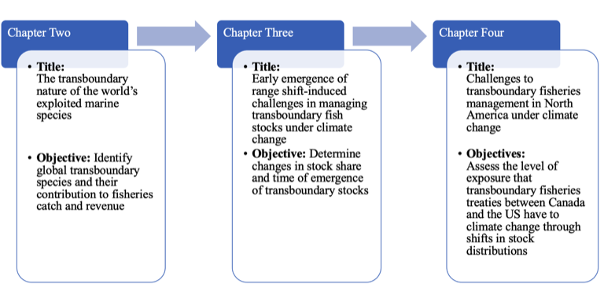

Figure 6.4: Schematic diagram illustrating the structure of this dissertation. It starts with a global identification of transboundary species. It then proceeds to assess the climate change impacts on transboundary stocks of the identified transboundary species. Finally, it uses two case studies to explore the management implications of climate change to the joint management of transboundary stocks

# 7 The transboundary nature of the world’s exploited marine species

## 7.1 Introduction

Distributions of marine species around the world are not constrained by human-made boundaries; rather they are shaped by biotic and abiotic factors as well as species’ evolutionary history (Hutchinson 1957, Nelson et al. 2016). A species can be widely distributed (cosmopolitan) or endemic (Nelson et al. 2016). Fisheries management is predicated on the definition of “stocks”, delineated, in most cases by human-made spatial boundaries that often do not correspond to biologically-meaningful population units (Song et al. 2017a, Fredston-Hermann et al. 2018). The development of Exclusive Economic Zones (EEZs) under Part V of the United Nations Convention on the Law of the Seas (UNCLOS) in the early 80s (United Nations 1986), for instance, extended political boundaries from 12 to 200 nautical miles to give coastal nations property rights over marine resources (Østhagen 2020). However, EEZ boundaries cut across the distribution of many species, creating shared stocks between nations (United Nations 1986). Shared stocks can be classified into four non-exclusive categories; “transboundary” - stocks that cross the EEZs of two or more bordering coastal states; “straddling” - stocks that cross neighboring EEZs and the adjacent high seas; and “highly migratory” - stocks that cross non-neighboring EEZs and the high seas (mainly tunas), and finally “discrete” - stocks that are only present in the high seas (Munro, Van Houtte, et al. 2004). My study focuses on the “transboundary” nature of shared species exploited by fisheries operating within EEZs.

Theory and empirical evidence have shown that fisheries targeting resources that straddle political boundaries complicate fisheries management and potentially reduce the effectiveness of policies to achieve their stated objectives (Miller and Munro 2002, Englander 2019). For instance, climate-driven changes in species distributions have led to conflicts between nations, driven, at least partly, by changes in the proportion of captures (Miller and Munro 2002), quota allocation, and fishery newcomers (Spijkers and Boonstra 2017). Moreover, climate change is likely to exacerbate such conflicts and presents new challenges for political relations between neighboring countries (Pinsky et al. 2018) and fisheries management (Miller et al. 2013). Therefore, having an accurate understanding of the distribution and scale of transboundary and straddling fish stocks as well as associated fisheries is important to inform their sustainable management, particularly under climate change.

Forty years after the formal adoption of UNCLOS (United Nations 1986) and the subsequent 1995 United Nations Fish Stock Agreement for the cooperation on the management and conservation of straddling and highly migratory resources (United Nations 1995), accurate estimates of the number of exploited marine species shared by neighboring nations are still unavailable. An informed guess, based on limited biogeographical data, suggested that there are approximately 500 to 1500 exploited transboundary stocks (Caddy 1997). A recent literature review included 344 shared taxa and their historical contributions to fisheries (Teh and Sumaila 2015). However, these studies did not consider species’ biogeography in the quantification of transboundary stocks. Here, I aim to estimate the number of exploited marine species shared by neighboring countries and determine their contribution to global and regional catches as well as fisheries revenue. Moreover, I categorize species according to their catch trends while identifying differences among species based on habitat preference. I hypothesize that the methodological constraints of previous studies resulted in an underestimation of the number of transboundary species and their contribution to global catch and revenue.

I overlaid the known distribution of 938 commercially valuable marine species responsible for an average of 96.5% of global EEZ catches between 2005 and 2014, and 280 EEZs of 198 coastal countries (See Methods). I define a ‘stock’ unit as a species in an EEZ, instead of a genetically or morphological distinct unit (Nelson et al. 2016), due to the lack of such biological information being available for almost all the species included in this study (Teh and Sumaila 2015). While I acknowledge that species could have multiple stocks within an EEZ, many fisheries within a country or EEZ are managed at the species instead of stock level (or even as groups containing multiple species). For example, shrimp (e.g., *Litopenaeus stylirostris* or *Farfantepenaeus californiensis*) along the Pacific coast of Mexico (Diario Oficial de la Federación (DOF) 2018) and hammerhead shark (*Sphyrna zygaena*) in Peru (MAP 2017) are managed at the species level, yet include multiple populations exploited by each country’s fisheries. Moreover, recent research shows connectivity across fish stocks through larval dispersal (Ramesh et al. 2019) and adult migration (Levin et al. 2018, Dunn et al. 2019, Popova et al. 2019), although considerable level of uncertainty exists at different life stages (Archambault et al. 2016, Kaplan et al. 2016). For this analysis, I only considered shared species between neighboring EEZs, rather than the species’ extended distribution (e.g., I did not include the high seas). I rely on multiple data sources including occurrence, distribution models and catch data, and only consider a species to be present in a grid cell if all data sources showed positive occurrence (see Methods).

## 7.2 Materials and methods

### 7.2.1 Databases of species’ geographic distribution

The Sea Around Us has reconstructed global fisheries catches from 1950 to 2014, identifying commercial marine fish and invertebrates as well as fishing regions (Zeller et al. 2016). I used the Sea Around Us reconstructed species list to determine the number of transboundary marine species exploited by fisheries within each of the world’s EEZs. The total number of species analyzed was 938, representing 67% of identified species by the Sea Around Us and accounting for 96.52% of the catch identified at the species’ level. To determine the current distribution of exploitable marine species, I used four data sources of species-distributions: (i) occurrence data, (ii) an Ensemble Environmental Niche Model (ENMs), (iii) a life-history-based distribution model, and (iv) fisheries catch data (Table 2.1). Each source represents a different method of estimating the distribution of a given species, thus providing a more robust result than an analysis focused on a single data source. Only commercially fished species with data from all four sources were included in my analysis.

Table 2.1 Summary of data sources to estimate species' distributions. All data has a resolution of 0.5 degrees latitude x 0.5 degrees longitude. All data is publicly available, see references for details

|  |  |  |  |
| --- | --- | --- | --- |
| Source | Abbreviation | Main Method | Sources |
| Occurrence data | Occurrence | Occurrence data from multiple sources | Reygondeau, 2019 |
| Ecological niche model | ENM-Nereus | Environmental niche model based on environmental variables and different model algorithms | Asch et al., 2017 & Reygondeau, 2019 |
| Species distribution model | SDM-SAU | Species distribution model based on species traits | Palomares et al., 2016 |
| Catch data | Catch-SAU | Spatial catch allocation based on country-by-country reconstructions | Zeller et al., 2016 |

#### 7.2.1.1 *Occurrence data*

Occurrence data was collected by Reygondeau (2019) from five publicly available repositories: FishBase (<http://fishbase.org>), the Global Biodiversity Information Facility (GBIF; <https://www.gbif.org/>), the Ocean Biogeographic Information System (OBIS; <https://obis.org/>), the Intergovernmental Oceanographic Commission (IOC; <http://ioc-unesco.org>), and the International Union for Conservation of Nature (IUCN; <https://www.iucn.org/technical-documents/spatial-data>) (Reygondeau 2019).

#### 7.2.1.2 *Distribution models*

In addition to occurrence data, I used two different methods to estimate species distributions, hereafter referred to as Ecological Niche Model-Nereus (ENM-Nereus) and Species Distribution Model-SAU (SDM-SAU). Although they use the same occurrence and environmental data, the models are structurally different complementing each other and providing robustness to my results.

The ENM-Nereus consists of a multimodel approach based on a Bioclim and a Boosted Regression Tree model (Thuiller et al. 2009), a Maxent model (Phillips et al. 2006), and a Non-Parametric Probabilistic Ecological Niche Model (Beaugrand et al. 2011). Environmental variables utilized in the models include sea surface temperature, surface pH, surface oxygen concentration, and vertically integrated (0–100 m) net primary production (NPP) (Asch et al. 2018). Global environmental conditions were average for the 30-year climate normal period of 1970-2000 and averaged for three Earth System Models developed by the Geophysical Fluid Dynamics Laboratory (GFDL- <https://www.gfdl.noaa.gov/earth-system-model/>), the Institute Pierre Simon Laplace (IPSL- www.icmc.ipsl.fr/), and the Max Planck Institute for Meteorology (MPI- www.mpimet.mpg.de/en/science/models/). See Asch *et al.* (2018) and Reygondeau *et al.* (2019) for model details.

The SDM-SAU model follows a five-step process based on species-specific life history data, rather than environmental variables (Close et al. 2006, Pauly and Zeller 2016). For each commercial marine species, the model first uses the FAO major fishing areas and countries’ EEZs to determine a broad distribution. It then uses life history information to delimit its range within the FAO fishing area (e.g., thermal preference, depth limit). The range is delimited even further by expert-review polygons and compared with distributions from AquaMaps (Kaschner et al. 2016), as well as OBIS and GBIF occurrence data. The model then determines a species’ habitat-preference based on the assumption that the relative abundance of a species is determined by the number of habitats in a grid cell and the species’ distance to each habitat, as well as the importance of the habitat to the total size of the species distribution. Finally, the species equatorial submergence (e.g., the latitudinal region where a species is not seen in between poles) is estimated for each species. See Close *et al.* (2006) and Pauly *et al.* (2016) for model details.

#### 7.2.1.3 *Catch data*

The previous models combine observational data with a series of biotic and abiotic data to determine the probability that a species will be found in a given space at a given time. However, this does not mean that the species in question will actually be there. While the models do use approaches to double-check species occurrences (e.g., ENM-Nereus uses four different species distribution algorithms and SDM-SAU undertakes validation by means of other models), I used a fourth data set to corroborate the models’ outputs. The Sea Around Us estimates total reconstructed catches - catches based on all publicly available information sources and including discards, as well as unreported and illegal catches that are not included in available FAO data - for each country. Catches are also spatially allocated on a ${0.5}^{∘}$ x ${0.5}^{∘}$ latitude longitude grid (Zeller et al. 2016). Roughly, the Sea Around Us method consist of the following steps. First, it takes each country’s officially reported catch data (e.g., National, FAO or RFMO). Secondly, it uses literature (e.g., peer review, grey literature) to identify missing components (e.g., species, gears) and sources of alternative information for missing components. It then derives country estimates for missing data and creates time series interpolation. Finally, the estimated and official data are aggregated, making up the total reconstructed catch data (see Pauly *et al* (2019) and Zeller *et al.* (2016) for catch reconstruction and spatial allocation details). I used the Sea Around Us catch reconstruction database from 2005 to 2014 as the fourth dataset to estimate transboundary species and to estimate their catch contribution within EEZs. I selected this time frame to investigate the recent (my time frame includes the last decade of available data) contribution of transboundary fisheries to catches and revenue from fisheries and to reduce the uncertainty embedded in the reconstruction process (see Key Uncertainties). Note that in call cases, I report the average catch from 2005 to 2014.

### 7.2.2 Determining transboundary species trait

I developed a three-criteria methodology to determine whether or not a species can be considered transboundary. Only species that met all criteria at least once were considered as “transboundary”, while species that did not meet the criteria for any EEZ analyzed were considered as “discrete”. Note that in cases where a species met all criteria for some EEZs, but not for other EEZs, these species were still considered as “transboundary”.

#### 7.2.2.1 Criteria 1; Neighboring EEZs

As mentioned above, I define transboundary species as those marine species that occur within the EEZs of two or more neighboring countries. Hence, according to this criterion a species was only considered as transboundary if it was shared between two neighboring countries, regardless of the species extended distribution. The analysis was undertaken only within the boundaries of the EEZs of coastal states using the Sea Around Us shapefile (updated 1 July 2015, available from <http://www.seaaroundus.org>) - noting that it subdivides the EEZs of 198 coastal states into 280 regions (e.g., Mexico’s EEZ is divided in Mexico Pacific and Mexico Atlantic), including islands territories - and determined the intersections between polygons using the R package sf (Pebesma et al. 2018). When estimating transboundary species, I filtered out those shared by EEZs sub-regions (e.g., US Gulf of Mexico and US Atlantic), and when aggregating results by country, species that occurred in more than one sub-region were only accounted for once. Species that were present in EEZs that were non-continental territories neighboring other countries were kept as separate (e.g., Argentina and Falkland Islands), but removed in cases where the non-continental territory belonged to the same nation (e.g., Brazil and Fernando de Noronha). Associated states like Puerto Rico and New Caledonia were not considered separately (e.g., Puerto Rico was grouped with the United States and New Caledonia with France).

#### 7.2.2.2 Criteria 2; Data agreement

I used the occurrence database, the ENM-Nereus model, and SDM-SAU model to determine the presence of each species within each of the world’s ${0.5}^{∘}$ x ${0.5}^{∘}$ marine grid cells. All analyses only considered cases with agreement across all databases to obtain a more conservative estimate of transboundary species. Moreover, I assumed that a species was only present in a given grid-cell if it was reported in the Sea Around Us database. Therefore, all species that were not reported as caught in any single year between the reference years (2005 to 2014) in a given grid-cell were dropped. This rule assumes that if a commercial species is projected within the EEZ of any fishing country, such a species would have been fished, and thus likely reported at some point over the last decade of data (2005 - 2014), thereby validating the models and selecting “currently” shared species. I acknowledge that this criterion might limit the global distribution of species therefore resulting in a conservative estimate of transboundary species.

#### 7.2.2.3 Criteria 3; Spatial distribution

Finally, to have a more robust result and not categorize a species as transboundary based on its presence in a single ${0.5}^{∘}$ x ${0.5}^{∘}$ grid cell within an EEZ, I computed an Area Index. The Area Index represents the proportion of a given species’ overarching shared distribution between neighboring EEZs accounted for by each individual EEZ. I classified a species as transboundary if both neighboring EEZs enclosed over 25% of the species joint shared distribution. While a species that has less than the selected threshold is not considered transboundary in this chapter, this threshold can be lowered for a more relaxed result or increased for a more conservative estimate (Figure 11.2).

### 7.2.3 Fisheries trends

I estimated the economic contribution in 2019 real USD of transboundary species for each country using global ex-vessel price data (Tai et al. 2017). The database I draw from includes ex-vessel price derived from multiple sources and a structured interpolation method (e.g., similar countries, species) to fill in data gaps (Sumaila et al. 2015). The dataset is harmonized with the Sea Around Us catch data to estimate yearly fishing revenue (as ex-vessel price) for all species and EEZs considered in this study (<http://www.seaaroundus.org/data/#/feru>). I report average fishing revenue derived from fishing activity within global EEZs between 2005 to 2014. I did not include revenue from areas beyond national jurisdiction. I used the monthly average US Consumer Price Index (CPI) according to the U.S. Bureau of Labor Statistic (<https://www.bls.gov/cpi/>) to standardize the original 2010 real USD value to 2019 real USD.

I used catch data as described above to determine the catch trend of each species within an EEZ. Although this method has previously been used to estimate stock status (Grainger and Garcia 1996), the categories presented here are intended to represent catch trends, and not fishing status for each species as many environmental and social-economic factors (e.g., temperature, markets, fishing policies, and fishing effort) affect catches (Branch 2008, Pauly et al. 2013). I only assessed species within each EEZ for which at least ten years of data were available between 1951 and 2014 and with at least five consecutive years of data. Three final categories were drawn up for each species depending on catch volume within each EEZ (e.g., present, maximum, and minimum EEZ’s historical catch) and the year (e.g., year of maximum historical catch of the species within that EEZ) (Table 2.2) (Kleisner and Pauly 2011). Accordingly, Category A represents fisheries that are registering increases in catch (“increasing”); Category B, species that have a constant catch rate (“constant”); and Category C, species that have registered declines in catch over the last 10 years (“decreasing”). Finally, I report the predominant category over the time period considered.

Table 2.2 Rules to determine the category of each transboundary species

|  |  |
| --- | --- |
| Categories | Rules |
| A - Increasing trend | (Year of Catch > Year Post Max. Min. & Post Max Min Catch < (Max Catch*0.10)) & (Catch > (Max Catch*0.10) & Catch < (Max Catch*0.50)) or Year of Catch < Year of Max. Catch & Catch <= (Max Catch*0.50) or Year of Max Catch = Last Year of data) |
| B - Constant trend | Catch > (Max Catch*0.50) |
| C - Decreasing trend | Year of Catch > Year of Max. Catch & (Catch > (Max. Catch*0.10) & Catch < (Max. Catch*0.50) or Catch < Max. Catch*0.10 |
| No Status | None of the above rules applied |

### 7.2.4 Statistical analysis

All analyses were run using the statistical software R version 3.5.2 (2018-12-20) with the packages data.table (Dowle et al. 2019), janitor (Firke et al. 2018), wesanderson (Ram et al. 2018), rfishbase (Boettiger et al. 2019), R.matlab (Bengtsson et al. 2018), sf (Pebesma et al. 2018), sp (Pebesma et al. 2019), tidiverse (Wickham 2017), tidytext (De Queiroz et al. 2019), and zoo (Zeileis et al. 2019). All code is available at <https://github.com/jepa/FishForVisa>. All maps were made with Natural Earth data available at <https://www.naturalearthdata.com/>. I performed a series of one-way analysis of variance (one-way ANOVA) and Multivariate analysis of variance (MANOVA) to determine statistically significant differences between the means of different groups (e.g., geographical regions, species, catch trends) of transboundary species and their contribution to catch and fishing revenue (Krzanowski 1990, Chambers et al. 1992). I used the standard R functions for the ANOVA and MANOVA after testing for assumptions. In cases where the ANOVA assumptions were not clearly met, I ran the non-parametric version Kruskal-Wallis Rank Sum Test to confirm results (Hollander and Wolfe 2013).

### 7.2.5 Key uncertainties

I have identified four key uncertainties in the method utilized that may affect the estimation of transboundary species. Firstly, as I ran the analysis at the species level due to limited spatial-specific data on species sub populations (stocks), I am not able to identify transboundary stocks within EEZs. While I acknowledge that a species could have multiple stocks within an EEZ, many fisheries within a country or EEZ are managed at the species instead of stock level. Also, recent research suggests strong connectivity between some stocks, even when separated by thousands of kilometers (Ramesh et al. 2019) providing additional ecological ground for my analysis (Dunn et al. 2019, Popova et al. 2019). However, it is important to acknowledge that there is considerable uncertainty associated in determining levels of connectivity across time and space for marine populations at different life stages, from larvae (Kaplan et al. 2016) to adults (Archambault et al. 2016). This is of special concern, but-not-limited-to (Archambault et al. 2016), highly migratory species whose ranges span multiple jurisdictions and the high seas, such as tunas (Moore et al. 2020), billfishes (Sepulveda et al. 2019) and sharks (Vandeperre et al. 2014) challenging management decisions based on meta-populations (Moore et al. 2020). Here, I limited the definition of “transboundary” to include species spanning only adjacent countries (e.g., the US and Canada), excluding countries that were separated by another nation (e.g., Canada and Mexico) and/or the high seas (e.g., Canada and Spain). Consequently, my results likely provide a conservative estimate of transboundary species, as I did not cover all marine taxa in the world (Reygondeau 2019) and only analyzed species present in all four data sources. Nevertheless, my results are representative of a substantial proportion of the world’s marine catches and revenue from economically important marine fisheries. Secondly, the predicted species’ distribution is affected by the uncertainties of the environmental data and models used for such predictions. Structural differences within Earth System Models result in variations of oceanic conditions, which undoubtedly affect the ENM-Nereus. I averaged results from the three models in an effort to capture the structural variation across models. Natural climate variability is a major driver of marine species’ distributions, potentially removing a species from an EEZ for long periods (e.g., anchovies and sardines’ “regimes” in the Eastern Pacific are strongly influenced by water temperature decal oscillations (Chavez et al. 2003). Thus, a species’ distribution can potentially be reduced or shifted in such a way that it only covers one EEZ until oceanic conditions change again and the associated species’ distribution expands. To account for such climate variability, I derived the ENM-Nereus results as an average of oceanic conditions between 1970 and 2000. This is not an issue for the SDM-SAU as it does not directly require environmental variables (Pauly and Zeller 2016). Thirdly, I assumed that if the Sea Around Us reconstructed data recorded a species as caught in any given grid cell, then the species was present within that grid cell. While catch data are not exempt of uncertainty, in most cases, differences between the Sea Around Us and the FAO self-reported data are smaller towards the end of the time series (Pauly and Zeller 2019). Thus, I limited the catch data reference period in my analyses to between 2005 and 2014, the last ten years of data available. Likewise, the spatial allocation of the catch is subjected to imprecision, mainly produced by differences in the spatial scale of the original data and the method employed by the Sea Around Us. Finally, this chapter’s results only considered species for which all datasets agreed on presence and had an Area Index of at least 25% (e.g., the species shared distribution was at least 25% in each EEZ). Therefore, again, my approach presents a relatively conservative estimate of the number of transboundary species in the world. Using a smaller Area Index will result in more transboundary species (Figure 11.2).

## 7.3 Results and Discussion

I identified 633 exploited transboundary species worldwide (67.5% of the 938 species analyzed), almost double previous estimates (Teh and Sumaila 2015). Between 2005 and 2014, national fleets targeting these transboundary species within EEZs caught an annual average of 48.5 million tonnes, representing 82.3% of EEZ-derived catches reconstructed by the Sea Around Us at the species level (Figure 7.1a). These catches generated a yearly average of USD 77,591 million in fishing revenue (78.5% of global fishing revenue) over the same time period. My findings are considerably higher than the previous estimates of 34.2 million tonnes in catches and USD 40,187 million (in 2019 value) in fishing revenue from shared stocks (Teh and Sumaila 2015). When I re-estimated transboundary species’ catches using data consistent with those used in previous studies (FAO global reported data in year 2006), the 633 transboundary species identified here accounted for 40.4 million tonnes of annual catches (i.e., 18% higher than previously estimated). My results suggest that the contribution of transboundary species to global catch and fishing revenue might previously have been underestimated due to an incomplete understanding of the transboundary nature of marine fished species. The 305 non-transboundary species (termed as ‘discrete’ species here, see Methods - Determining transboundary species trait) accounted for a much smaller proportion of total catch and revenue; 2.8 million tonnes and USD 4,282 million annually respectively, on average, between 2005 and 2014. These results underscore the importance of transboundary species at the global level.

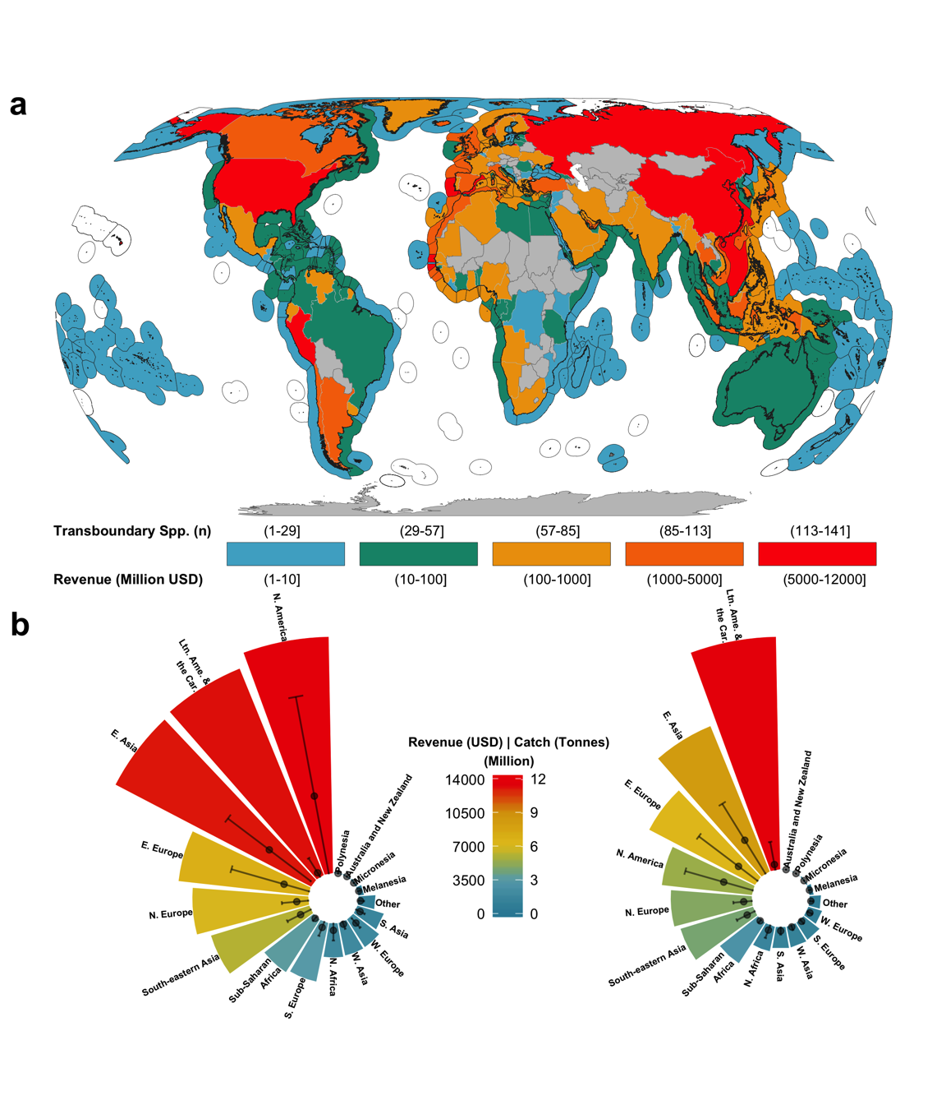

Figure 7.1: Number of transboundary species and their contribution to global fisheries catch and revenue. a) The number of species and amount of revenue are represented by color coding of EEZs and land polygons, respectively. b) Contribution of transboundary species to regional revenue (left) and catch (right). Regions classified according to the United Nations sub-regions. Points = mean ± sd. Revenue in 2010 real USD

In many cases, according to my categorization criteria, a transboundary species can be distributed in multiple EEZs but only counted as transboundary in a subset of EEZs (see Methods). For example, the distribution of Peruvian anchoveta (*Engraulis ringens*) spans the EEZs of Peru, Chile, and Ecuador. However, my study only considered the stocks in Peru and Chile as transboundary (Cashion et al. 2018). Anchoveta in Ecuadorian waters only include a small proportion of the shared distribution range (spatial threshold between Ecuador and Peru < 10%; see Methods - Criteria 3) and thus do not meet my criteria for consideration as a transboundary stock. A situation similar to the example of Peruvian anchoveta in Ecuadorian waters is common amongst the transboundary species identified in this study. Overall, 590 of the 633 transboundary species have stocks in EEZs that do not meet my criteria for consideration as transboundary stock. The annual average contribution from all excluded stocks of transboundary species to fisheries (e.g., Ecuador’s anchoveta catch) between 2005 and 2014 was 10.8 million tonnes, representing USD 19,243 million in fishing revenue over the same time period.

At a regional level, I found that transboundary species are particularly economically important for Northern America (average country revenue = USD 4,680 $±$ 6,000 million) and Eastern Asia (USD 3,779 $±$ 3,093 million) (Figure 7.1b). The estimated per country revenues from transboundary species in these two regions is significantly different from other regions (one-way ANOVA; DF(16,165) = 5.081, p < 0.001, $α$ = 0.05). China (USD 7,284 million) and the USA (USD 11,604 million) contribute 55% and 82% to the annual average revenue from 2005 to 2014 in Eastern Asia and Northern America, respectively. In addition to China and the USA, Russia (USD 7,379 million), Peru (USD 6,044 million) and Japan (USD 3,907 million) were among the top five countries with the most fishing revenue generated from transboundary species between 2005 and 2014 (Figure 7.1a). These five nations were responsible for 41% of the yearly global fisheries revenue from transboundary species.

Peru and Russia, having the two largest fisheries by total catch in the world (FAO 2018a), were each responsible for over 5.8 million tonnes of transboundary species catch annually, on average, between 2005 and 2014 (Figure 11.1). Peru’s catches consisted mainly of Peruvian anchoveta (*Engraulis ringens*) and accounted for 79% of the national transboundary species production. Peru and Chile recently signed an agreement to work towards standardized stock assessments through coordinated management of the southern anchoveta stock (UNDP 2016). A similar management agreement was signed by Russia, Japan and the USA over shared Alaskan pollock (*Theragra chalcogramma*) in the Bering Sea in 1988 (NOAA FIsheries 2019). Transboundary species also make large contributions to fisheries in Eastern Asia (one-way ANOVA; DF(16,158) = 2.265, p = 0.005, $α$ = 0.05). China, the world’s top fish producer (FAO 2018a), obtains one third (5.1 million tonnes) of its total catches from transboundary species, followed by Japan (1.8 million tonnes) and South Korea (1.06 million tonnes). Differences in the regional importance of transboundary fisheries can also be illustrated in terms of catch-revenue over the area ($km^{2}$) of the EEZ (Figure 7.2). As an example, the aggregated EEZ area for all Northern European countries where transboundary species are present is 3.3 million $km^{2}$, the $6^{th}$ smallest of the 17 groups analyzed (Table A2.1. However, it had the second highest average revenue (USD 26.1 thousand per $km^{2}$) and the highest average catch (19.9 tonnes per $km^{2}$) of transboundary species per EEZ area between 2005 and 2014. At the country level, countries from Western Europe accrued significantly more revenue from transboundary fisheries per $km^{2}$ than any other country (one-way ANOVA, DF(16,165) = 3.267, p < 0.001, $α$ = 0.05; Tukey’s post hoc test p $≤$ 0.05; Figure 7.2).

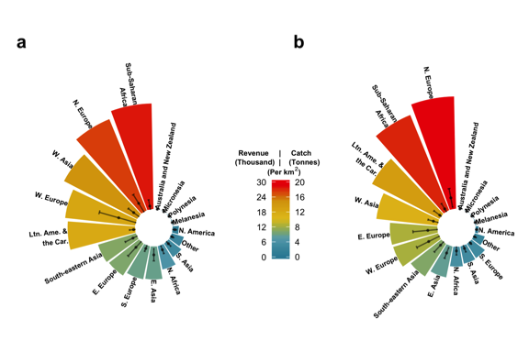

Figure 7.2: Weighted benefits of transboundary species by km2 and UN sub-region. a) Revenue in thousand 2019 USD. b) Catch in tonnes. Points = sub-region mean ± s.d. by country.

I determined the catch trend of each species within each EEZ, classifying them as increasing (Category A), constant (Category B) or decreasing (Category C) (Figures 7.3; A2.2). While previous studies have demonstrated that catch trends may be used to infer whether a stock is healthy, re-building, over-exploited or collapsed (Kleisner and Pauly 2011), several factors can influence stock status. My intention here is to examine where the catch trends of transboundary species differ from non-transboundary species between 2005 and 2014 relative to historic catch since 1951 (see Methods). I found significant differences for all catch trend categories for transboundary species (one-way ANOVA, DF(2,459) = 47.94, p < 0.001, $α$ = 0.05; Tukey’s post hoc test p $≤$ 0.001), and no significant differences in catch trend categories for discrete species (one-way ANOVA, DF(2,106) = 1.885, p = 0.157; $α$ = 0.05). I also found significant differences in catch trends when directly comparing transboundary to discrete species categories (MANOVA, DF(2,459) = 19.001, p < 0.001). Overall, transboundary species only targeted by one country are generally less likely to have a decreasing catch trend compared to instances where the shared species is fished by neighboring countries (Table A2.2).

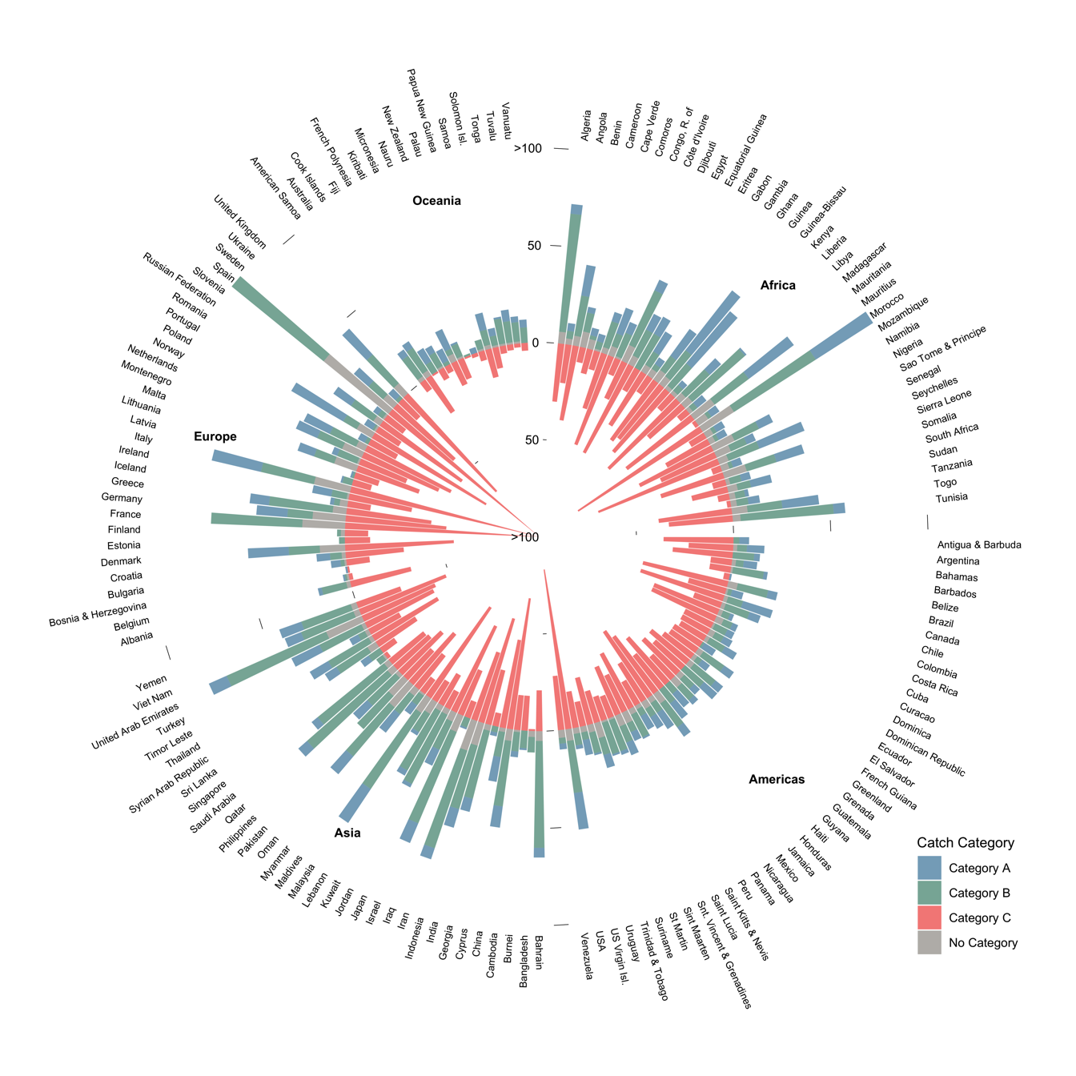

Figure 7.3: Number of transboundary species by catch trend and EEZ. Category A, Increasing; Category B, Constant; Category C, Decreasing. “No Category” reflects species with less than 10 years of catch data and/ or less than 5 consecutive years of catch data. Only showing first 100 species.

Empirical analysis suggests that in most cases, management of transboundary species will yield better outcomes in terms of fish catches when nations cooperate (Miller and Munro 2002). Yet, cooperation can be a complex process (Jensen et al. 2015), and in specific cases joint management might not be the best strategy (Munro 2015). Examples of successful joint management include agreements between Norway and Russia over Atlantic cod (*Gadus morhua*) (Eide et al. 2013) and Namibia and South Africa over hake (*Merluccius spp*) (Sumaila et al. 2003). Lack of collaboration over shared stocks may threaten stock sustainability, reduce the future profitability potential of the fishery, and result in conflict between neighboring nations (Clark 1980, Spijkers and Boonstra 2017).

Transboundary fisheries are important to a number of countries with notorious fisheries-related conflicts, including Canada, the USA, the European Union (EU) and Russia (Spijkers et al. 2019). For example, since 2007, the EU, Norway, Iceland, and the Faroe Islands (Denmark) have been at odds over the size and relative allocation of the total allowable catch for Atlantic mackerel (*Scomber scombrus*) due to the species’ climate-driven shift in distribution (Spijkers and Boonstra 2017). Atlantic Mackerel is a transboundary species that straddles into the high seas. Among the countries involved in the 2007 fisheries dispute, Atlantic mackerel contributed an annual average (between 2005 and 2014) of 598 thousand tonnes (8%) in total catch and USD 850 million (7%) in total fishing revenue.

Climate change is expected to continue changing the distribution and shared proportion of fish stocks among countries, resulting in the emergence of new transboundary species (Pinsky et al. 2018, Chapter 4), and disappearance of some species from EEZs (Oremus et al. 2020). Exploring the detailed effects of climate change on the distribution of shared species is key to the development of local adaptation methods that can anticipate negative impacts to sustainability. For example, understanding how climate change will modify the proportion of transboundary species shared by neighboring EEZs, the time-frame over which such changes will happen (Chapter 4), and the economic consequence of such effects can inform the development of more anticipatory and climate-resilient international treaties improving fisheries management (Sumaila et al. 2020).

Most marine fish species occur in tropical and subtropical waters around the world (Nelson et al. 2016, Reygondeau 2019), from highly migratory species associated with pelagic-oceanic ecosystems like tunas (*Thunnus sp.*), to less mobile reef-associated species like greater amberjack (*Seriola dumerili*), and species found in demersal ecosystems like gilthead seabream (*Sparus aurata*). Species associated with pelagic-oceanic ecosystems are the only group whose EEZ range (i.e., the number of EEZs where the species occur as transboundary) is significantly different from other groups (one-way ANOVA; DF(5,597) = 53.82, p < 0.001, $α$ = 0.05; Tukey’s post hoc test p < 0.05), with a median of 40 EEZs per species. The median for species of all other ecosystem preferences is close to, or less than, 20, as many of these species have a narrower distribution or are less mobile (Figure 7.4a). This result is likely an effect of the broad distribution that many of the species with preference for pelagic-oceanic ecosystems have. Many pelagic-oceanic species are highly migratory and straddle across EEZs while crossing the high seas. Thus, the number of non-neighboring EEZs sharing a highly migratory species can be over 100, as in the case of bigeye tuna (*Thunnus obesus*) (Figure 7.4a). Due to their vast migration patterns and presence in areas beyond national jurisdiction, many highly migratory species are managed by Regional Fisheries Management Organizations (RFMOs).

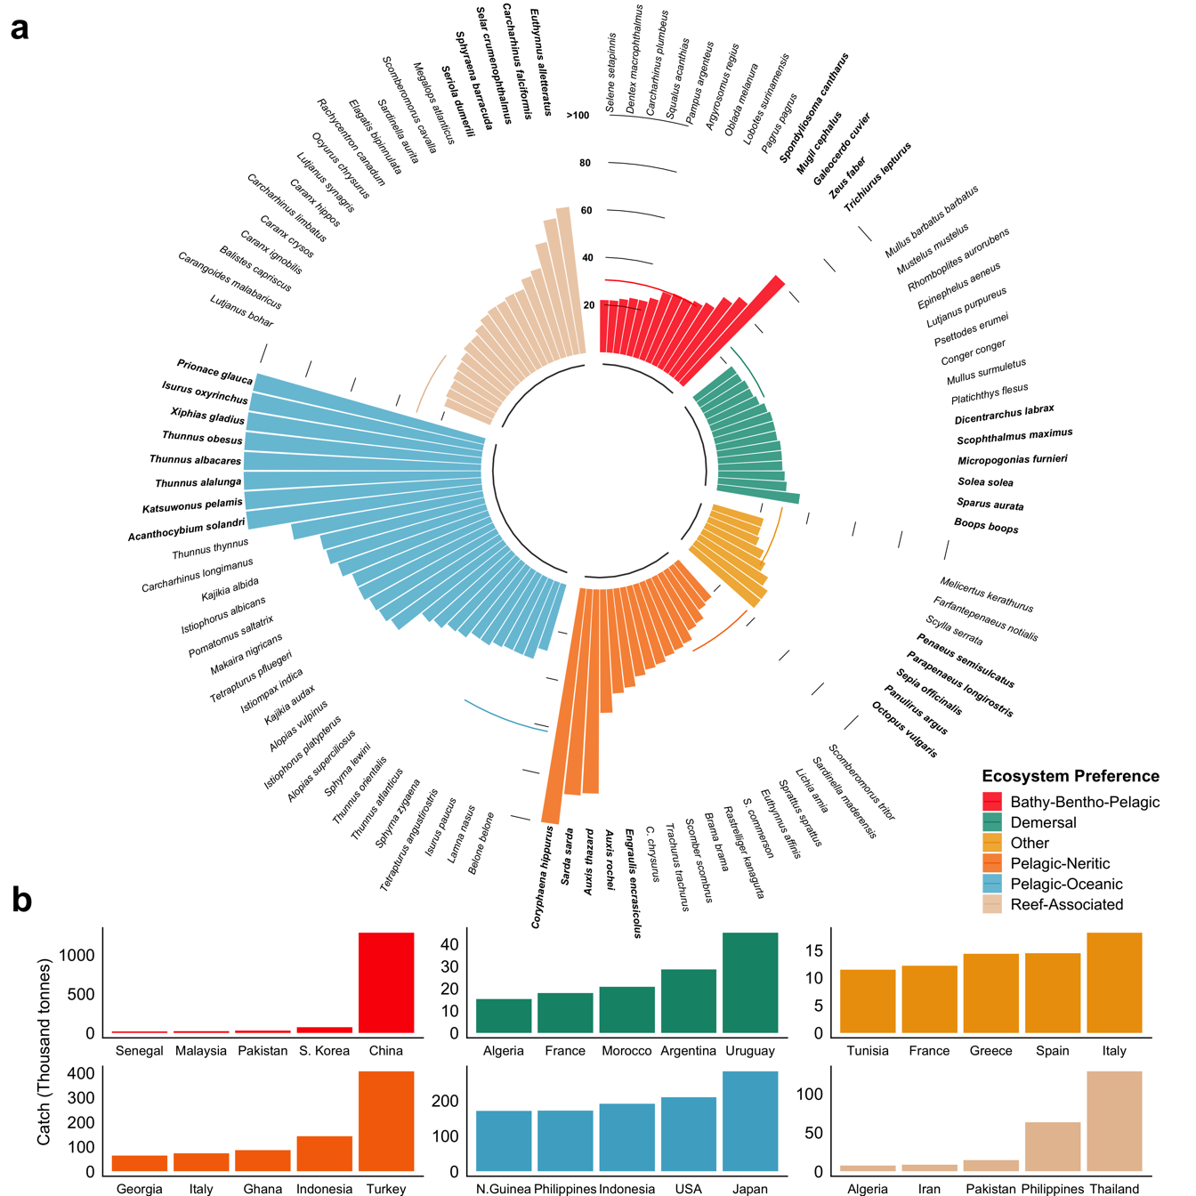

Figure 7.4: Number of EEZs shared by transboundary species. a) Number of EEZs by species organized according to ecosystem preference as defined by FishBase. Showing only species that share > 20 EEZs. b) Average catch between 2005 and 2014 for top five countries capturing the top five shared species for each ecosystem preference category (color coding is as shown in legend in a). Note that there could be > 5 species due to similar sharing values. The category “Other” consists of species that have no ’ecosystem preference’ classification in FishBase

Many transboundary species are not considered highly migratory but are still shared by numerous neighboring EEZs (e.g., garfish *Belone belone*) (Figure 7.4a). In addition, many fish stocks have meta-populations that are connected through larval dispersal with ‘source’ populations potentially supporting ‘sink’ populations thousands of kilometers away (Ramesh et al. 2019). For example, while coral reef-associated species were found to share fewer neighboring EEZs than other species (Figure 7.4a), coral regions often share multiple species through larval connectivity (Schill et al. 2015) and adult movement. However, it is important to acknowledge the uncertainty in the connectivity of marine populations at different life stages from larvae (Kaplan et al. 2016) to adults (Archambault et al. 2016). In some areas like the Caribbean and the Western Indian Ocean, among other regions, transboundary marine protected areas have been identified as potential tools to support fisheries and conservation goals (Levin et al. 2018, Perez et al. 2019). The effective management of coral reef species is critical to many coastal communities, as they tend to be highly dependent on subsistence fishing for food and nutrition security as well as livelihoods (Cisneros-Montemayor et al. 2016, Hanich et al. 2018). For instance, a number of countries with the largest catches of transboundary reef and pelagic-oceanic associated species (Figure 7.4b) are also associated with some of the highest rates of fish consumption (FAO 2018a). In the Philippines, both pelagic and reef fishes contribute substantially to both local food and nutrition security, as well as livelihoods (Cabral and Geronimo 2018).

## 7.4 Conclusions

In this chapter, I identified species currently shared by neighboring coastal nations and highlights the importance of these species’ contribution to global catch and revenue derived from wild fisheries. My results show that captures and revenues from shared species are substantially higher than previously estimated (Teh and Sumaila 2015) and also much greater than catches and revenues obtained from discrete species. This result highlights the importance of transboundary fisheries and their potential contribution to food and nutrition security, as well as livelihoods. Moreover, I show significant differences in the catch trends of transboundary and discrete species, suggesting a need to improve the management of transboundary fisheries. Previous work has highlighted that collaboration is key to better outcomes for shared marine resources (Miller and Munro 2002). Identifying existing transboundary species is the first step towards cooperative joint management frameworks that are precautionary, strive for sustainability, and can be flexible to accommodate the uncertain future driven by climate change.

# 8 Early emergence of range shift-induced challenges in managing transboundary fish stocks under climate change

## 8.1 Introduction

Over the last century, human activities have altered the physical and biogeochemical conditions of the ocean, including warming, acidification and reducing oxygen content (IPCC 2019). Distributions of marine species are closely related to the environment and the species’ preferences to environmental conditions (e.g., temperature, oxygen, salinity) (Hutchinson 1957, Nelson et al. 2016)). As a result of climate change, many marine species have changed their distributions towards higher latitude, deeper water or have followed local temperature gradients (Poloczanska et al. 2016). Biogeography of marine species is projected to continue to shift as ocean conditions are changing in the ${21}^{st}$ century under climate change (Cheung et al. 2010), impacting fisheries production and compromising our capacity to reach international sustainability goals such as Sustainable Development Goal 14 - life below water (Barange et al. 2014, Singh et al. 2017, United Nations 2018). The projected risks of impacts can be reduced through improving the effectiveness of current fisheries management (Cheung et al. 2018, Gaines et al. 2018), including the fisheries management of species that cross international borders, i.e., shared stocks (Gaines et al. 2018, Pinsky et al. 2018).

The concept of shared stocks was developed following the ratification of the United Nations Convention on the Law of the Sea (UNCLOS) and the claiming of Exclusive Economic Zones (EEZs) by States (United Nations 1986). As defined by the United Nations’ Food and Agriculture Organization (FAO), shared stocks can be classified into four non-exclusive categories: (i) transboundary stocks, those that cross neighboring EEZs; (ii) straddling stocks, that, in addition to neighboring EEZs, also visit the adjacent high seas; (iii) highly migratory stocks, mainly tunas and bill-fishes, that migrate across vast oceanic regions including both the high seas and EEZs; and finally (iv) discrete stocks that are only present in the high seas (Munro, Van Houtte, et al. 2004). This chapter focuses on transboundary stocks exploited by fisheries operating within EEZs. While countries are responsible for the management of stocks within their EEZs, under UNCLOS, States are encouraged to cooperate when stocks are shared (United Nations 1986). In the previous chapter, I estimated that there are 633 transboundary fish species globally, representing 67% or the identified fished taxa, yielding an annual average of 48.5 million tonnes of catch and USD 78 billion in fishing revenue (between 2005 and 2010).

The effectiveness of fisheries management for transboundary stocks is challenged by the shifts in marine stocks distribution under climate change (Pinsky and Mantua 2014, Pinsky et al. 2018). In many cases, catch or fishing effort quotas for transboundary stocks are based on historical records (Baudron et al. 2020) and do not necessarily consider the biogeography of the stocks (Fredston-Hermann et al. 2018), nor the effects of climate change on the fish stocks and fisheries (Sumby et al. 2021, Chapter 2). Misalignment between fisheries resources allocation and stocks’ distributional shifts have previously resulted in unsustainable harvest and international disputes (Miller et al. 2013, Song et al. 2017b, Spijkers and Boonstra 2017), patterns that are expected to be exacerbated by intensifying climate change (Pinsky et al. 2018). With future shifts in species distributions under climate change, the challenges for the management of fisheries targeting transboundary stocks will continue to increase during the 21st century. It is important to constrain when climate change will affect the dynamics of transboundary stocks and the intensity of the resulting impacts in order to prepare ocean governance to meet the resource management challenges arising from shifting transboundary stocks, (Link et al. 2010, Chapter 2, Pinsky et al. 2018).

The timing and intensity of climate impacts on managing transboundary fish stocks can be quantitatively examined through the concepts of ‘time of emergence’ (ToE) and ‘threat point’ (TP). Time of emergence is defined as the moment in time when a signal (e.g., future anthropogenic trend) emerges from the background noise of natural variability (e.g., historical natural variation) (Hawkins and Sutton 2012) and has been applied to multiple oceanic physical and biogeochemical variables (Keller et al. 2014, Rodgers et al. 2015, Frölicher et al. 2016, Henson et al. 2017, Schlunegger et al. 2019, 2020, Cheung and Frölicher 2020). The premise behind the time of emergence is that we can only be confident that a significant change has been detected when the signal of anthropogenic climate change is larger than the background noise of natural climate variability (Hawkins and Sutton 2012). The concept of threat point comes from game theory and is defined as the minimum payoff a player is willing to receive to cooperate in a game theoretic model (Nash 1953). Game theory has been widely used to investigate and manage transboundary stocks (Sumaila 2013), including the impacts of climate change on the economics of transboundary stocks between Canada and the United States (Sumaila et al. 2020).

Here, I estimate the time of emergence and threat point of the share distribution of transboundary stocks worldwide. I employ a species distribution model driven by outputs from a comprehensive Earth System Model with ten ensemble members to project the distribution of 663 transboundary species (Chapter 2) across 280 EEZs of 198 coastal countries under a high greenhouse gas emissions scenario RCP 8.5 (see Methods). I treated each species in an EEZ as a single stock due to the lack of more spatially resolved data to delineate the boundary of a population (Chapter 2) and only considered shared stocks between neighboring EEZs (i.e., transboundary stocks that exclude the high seas). I find that the distribution of many transboundary stocks has already shifted from historical natural variability and exceeded their share threat point in most neighboring EEZs, posing a threat to their sustainability and the resilience of international treaties.

## 8.2 Materials and methods

### 8.2.1 Databases and species selection

This analysis includes 633 exploited marine transboundary species previously identified to account for 80% of the catch taken from the world’s EEZs between 2005 and 2014 (Chapter 2). Each time a species was shared by a pair of neighbouring EEZs it was considered a transboundary stock (Teh and Sumaila 2015, Chapter 2), resulting in a total of 9,132 transboundary stocks in this analysis. Using the transboundary species Atlantic cod (*Gadus morhua*) as an example, and based on the definition of transboundary stock in this chapter, the United States and Canada share a stock of Atlantic cod, and Canada and Greenland share another stock of Atlantic cod, but the United States and Greenland do not share a stock of this transboundary species. I defined the boundaries of the world’s EEZs using the Sea Around Us spatial division (updated 1 July 2015, available from <http://www.seaaroundus.org>), noting that it subdivides the EEZs of 198 coastal states into 280 regions (Figure A3.1) including island territories. I determined the intersections between polygons using the R statistical software package sf (Pebesma et al. 2018). Each EEZ was categorized by geopolitical region according to the United Nations (<https://population.un.org/wpp/DefinitionOfRegions/>) and biome location (Reygondeau 2019). The habitat association of each species was determined following the classification in FishBase for fish species (<http://www.fishbase.org>) and SeaLifeBase for invertebrates (<http://www.fishbase.org>). For each stock and EEZ, I used the Sea Around Us data to estimate catch and fishing revenue from fishing activities within global EEZs. I report both average catch and revenue for the last decade (2005-2014) (Sumaila et al. 2015, Zeller et al. 2016, Tai et al. 2017). The monthly average US Consumer Price Index (CPI) according to the U.S. Bureau of Labor Statistic (<https://www.bls.gov/cpi/>) was used to standardize all monetary values to 2019 real USD.

### 8.2.2 Projecting species distributions under climate change

I projected the distribution of marine species using a dynamic bioclimatic envelope model (hereafter called DBEM) (Cheung et al. 2010, Cheung, Jones, Reygondeau, et al. 2016). The DBEM represents species’ physiology, habitat suitability, depth and latitudinal ranges, and spatial population dynamics as well as preferences for sea temperature, salinity, oxygen content, sea ice extent (for polar species) and bathymetry. For pelagic species, the model uses environmental variables at the surface whereas demersal species distribution is driven by ocean bottom variables. The DBEM then estimates species abundance and maximum catch potential (a proxy of maximum sustainable yield) over a ${0.5}^{∘}$ x ${0.5}^{∘}$ grid (see Cheung et al. (2010, 2016) for model details). Importantly, DBEM is able to project catches for the world’s large marine ecosystems and changes in catches by EEZs that are consistent with observational-based estimates of catch from 1950 to 2016 (Cheung, Jones, Reygondeau, et al. 2016, Cheung et al. *in revision*).

The DBEM was forced with simulated ocean conditions from a ten-ensemble member simulation of the Geophysical Fluid Dynamics Laboratory Earth system model (GFDL-ESM2M) to project the distributions of the 633 species from 1951 to 2100 (John et al. 2012, 2013, Rodgers et al. 2015). The GFDL-ESM2M was run under historical forcing until 2005 and followed the high greenhouse gas emissions scenario, the Representative Concentration Pathway 8.5 (RCP 8.5) over the 2006-2100 period (Riahi et al. 2011). Because the main approach of this chapter relies on understanding the spatial and temporal variation of a stocks’ distribution, I have to understand distribution variability during both the historical and the future periods, to infer differences between time frames. I do this by following an ensemble member approach where each member constitutes a different realization of the Earth system variability condition (Frölicher et al. 2009, Rodgers et al. 2015). Thus, for my experiment, each of the ten GFDL-ESM2M ensembles were started from infinitesimally small differences in Earth system initial conditions in year 1950 resulting in a unique atmosphere and ocean state at each point in time after about three years for surface waters and eight years for subsurface waters (Frölicher et al. 2020). By design, variations among ensemble members are then solely due to natural variability. This approach allows us to estimate the natural internal variability (e.g., background noise) and isolate the forced anthropogenic climate signal of a stock’s distribution by averaging the secular trend over all ten ensemble members.

### 8.2.3 Calculating an index of transboundary range shift

I developed an index to evaluate range shifts in transboundary stocks under climate change (TI). This index was based on the shifts in the distribution centroid of a transboundary stock relative to the centroid of the neighboring EEZs that share this stock (Figure A3.2). The centroid of a transboundary stock was determined by the average (µ) latitude ($lat_{ts}$) and longitude ($lon_{ts}$) across the grid cells with the highest abundance within the neighboring EEZs sharing the stock e.g., Pacific halibut (*Hippoglossus stenolepis*) that is transboundary between the United States and Canada. Therefore,

$$\begin{matrix}lat_{ts}=μ(lat_{per}) \\ lon_{ts}=μ(lon_{per})\end{matrix}$$

where $lat_{per}$ and $lon_{per}$ are the latitudes and longitudes of the grid cells holding the $per^{th}$ percentile of the projected transboundary stock abundance. To focus on areas where transboundary stocks are more abundant and fishing activities are more likely to take place, I included grid cells where the projected stock abundance within the neighbouring EEZs sharing the stock was above the top 95th percentile (e.g., per = 95%). A sensitivity analysis was ran using a subset of species (n = 34) for all EEZs under different abundance levels (per = ${20}^{th}$, ${50}^{th}$ and ${90}^{th}$ percentile) and examined the effects of different thresholds on the calculated index value (Figure A3.3). The centroid of each EEZ was estimated using the st package in R (Figure A3.4). For each ensemble member, neighboring EEZs and transboundary stock, I computed the distance between centroids assuming the earth is a perfect sphere and ignoring geographic barriers using the geosphere package in R;

$$D_{ens}=acos(sin(lat_{eez})*sin(lat_{ts})+cos(lat_{eez})*cos(lat_{ts})*cos(lon_{eez}-lon_{ts}))$$

where $lat_{eez}$ and $lat_{ts}$ are the latitudes of the EEZ and transboundary stock centroids, respectively and $lon_{eez}$ and $lon_{ts}$ are the respective longitudes. Then, for each year I calculated the transboundary index as follows:

$$TI=(\frac{D_{A,t}}{sd(D_{A,th})}-\frac{D_{B,t}}{sd(D_{B,th)}})^{2}$$

where $D_{A}$ and $D_{B}$ represent the distance between the distribution centroids of a stock and the centroid of the pair of neighbouring EEZs (A and B) sharing the stock for each time step from 2006 to 2100 (*t*); and *sd* is the standard deviation of the historical (*th*, 1951 - 2005) centroid distribution for $D_{A}$ and $D_{B}$. Thus, a higher TI means that a shared stock becomes more or less abundant relative to its neighbouring EEZs that is beyond what the fisheries experienced historically. From the perspective of a State’s fisheries, higher TI indicates an increase in the challenges to effective management and sustainability of the shared stock’ fisheries. In contrast, a smaller TI suggests that the sharing of the stocks between neighbouring EEZs is becoming relatively more stable; a condition that favors effective management and sustainability of the shared stocks’ fisheries. The index was smoothed to a 10-year average to reduce interannual variability.

#### 8.2.3.1 Calculating the time of emergence of the transboundary index

Knowing the point in time (e.g., year) at which the distribution of a shared stock will diverge from its natural internal variability is important for informing the lead-time to which climate adaptation needs to be implemented (Link et al. 2010). Here, I defined time of emergence as the time when the stock shared between neighbouring EEZs exceeded the historical natural internal variability as follows:

$$\begin{matrix}EmergenceTIndex=\frac{μ_{TI[t]}}{SD_{TI_{th}}} \\ ToE=ToE_{t}>1s.d.\end{matrix}$$

where $μ_{TI}$ is the yearly mean TI ($μ$) across all ten ensemble members in year *t* and $SD_{TI}$ is the standard deviation of the smoothed (10-year moving average) TI across the ensemble members for the historical (*th*) reference period (1951 - 2005). I set a threshold of TI above which I considered a shared stock to have emerged from the historical internal variability of the TI. The threshold was set as one standard deviation of the variability ($SD_{TI}$) (i.e., Equation (??)), representing a probability of 68% that the transboundary index has emerged from historical variability). I tested the sensitivity of the calculated emergence index to a higher emergence threshold of two times the standard deviation (i.e., representing a probability of 95% that the index has emerged).

### 8.2.4 Estimating the threat point of transboundary stock share

In game theory, cooperation over a shared resource will more likely result in a better overall outcome for the sharing parties than those operating on a non-cooperative basis (Munro 1979). However, the benefits that each player gets from a cooperative strategy must be above a minimum payoff i.e., “threat point” (Sumaila 2013). Here, I defined the threat point as the minimum required proportion of a shared stock present within an EEZ for a country to engage in cooperative management with their sharing neighbor (Chapter 2, Sumaila et al. 2020). Any proportion below the defined threat point of a country would result in a unilateral management of the shared stock.

First, I estimated the stock share ratio (SSR) of each transboundary stock shared by neighbouring nations between 1951 and 2100. I did this by aggregating the number of ${0.5}^{∘}$ x ${0.5}^{∘}$ grid cells in which the stock is present across neighboring EEZs, and then calculated the proportion of the catch held within each EEZ (Chapter 2). Second, I averaged the calculated proportion of stock within an EEZ held into three time periods to reduce the effects of variability. The first time period ($SSR_{th}$) spans 1951 to 2005 and was chosen to match the historical period in the GFDL ESM2M simulations, over which the model was forced with observation-based greenhouse gas, aerosol and natural external forcing (John et al. 2012, 2013). It was assumed to represent the historic baseline of shared distributions for each stock. I then selected two future periods; the early ${21}^{st}$ century as the average of 2021 to 2040 ($SSR_{te}$), and the mid ${21}^{st}$ century as the average of 2041 to 2060 ($SSR_{tm}$). I chose these time periods to match the challenges of achieving fisheries-related UN-SDGs such as SDG 14.4 (end overfishing), SDG 2.4 (ensure sustainable food production systems) or SDG 1.2 (poverty reduction), to be achieved by 2030 (Singh et al. 2017). The analysis was replicated for projected stocks distributions from each of the ten ensemble members and results were averaged across ensemble members. Third, I defined a threat point for each EEZ’s stock as $SSR_{th}±σ$, where $σ$ is the standard deviation of $SSR_{th}$. This way, a change of SSR beyond an EEZ’s threat point happened when the future SSR exceeded one standard deviation of the historical variations of the SSR i.e when $SSR_{te}≧(SSR_{th}+σ)$ or $SSR[t]_{e,m}≦(SSR_{th}-σ)$. Finally, I estimated the percentage change in the SSR ($ΔSSR$) of each future time period ($SSR_{f}$) relative to the historic time period ($SSR_{th}$) for each stock whose share ratio overpassed the threat point following (See Chapter 4 - Methods),

$$ΔSSR_{e,s}=\frac{(SSR_{f}-SSR_{th})}{SSR_{th}}*100$$

### 8.2.5 Statistical analysis

The time of emergence results were tested for normality (e.g., skewness, kurtosis) and performed two non-parametric Kruskal–Wallis test by ranks (Hollander and Wolfe 2013) to investigate geopolitical and ecological differences in the ToE of transboundary stocks. Specifically, I tested if the habitat association of transboundary species and the geographic location of EEZs would have any effect on the time of emergence of transboundary stocks. For both cases, my null hypothesis was that there were no significant differences in the time of emergence across habitat association nor EEZs. All analyses were run using the statistical software R version 3.5.2 (2018-12-20; Eggshell Igloo) with the packages data.table (Dowle et al. 2019), janitor (Firke et al. 2018), rfishbase (Boettiger et al. 2019), sf (Pebesma et al. 2018), sp (Pebesma et al. 2019), tidiverse (Wickham 2017), tidytext (De Queiroz et al. 2019), gmt (Magnusson 2017) and zoo (Zeileis et al. 2019), ggrepel (Slowikowski 2020), zeallot (Teetor 2018), viridis (Garnier 2018), cowplot (Wilke 2019), moments (Komsta and Novomestky 2015) and pgirmess (Giraudoux 2018). All code is available at <https://github.com/jepa/TransEmergence>

## 8.3 Results

### 8.3.1 Time of emergence of transboundary stocks

The average time of emergence of the transboundary index across the emerging stocks in all EEZs analyzed is projected to be 2029 $±$ 26 years (Figure 8.1). This means that on average, the distribution of transboundary stocks will diverge from their natural internal variability by 2029. In total, the projected transboundary index of 5,745 stocks (63% of the studied stocks) will emerge from their historical variability between 2006 and 2100. Fish stocks with transboundary index that first emerged from their historical variability in each EEZ is projected to be as early as 2006 and the last one in 2100. About 55% (n = 3,154) of those emerging stocks are projected to have their transboundary index emerged between 2006 and 2020 (e.g., Peruvean anchoveta - *Engraulis ringens* - shared by Chile and Peru emerged in 2010). The number of EEZs with emerging stocks is projected to increase steeply from 87% in 2006 to 96% in 2020. After the mid-2020s, the rate of increase in the number EEZs slows from a 1% to an average of 0.7% per year. By 2081, all of the EEZs analyzed here will have at least one emerging stock (Figure 8.1). Moreover, 96% of the world’s EEZs saw at least one stock having their distribution shifts between 2006 and 2020 and around one fifth (19%) of the EEZs have an average time of emergence of the transboundary index across stocks prior to 2020. Shifts in stocks’ distributions will continue to exceed historical limits steadily towards the end of the ${21}^{st}$ century (Figure 8.1). I based the transboundary index on a transboundary stock’s centroid defined as the average grid cells that present the higher stock’s abundance (see Methods - Calculating an index of transboundary range shift). Results from the sensitivity analysis suggest that this method of estimating the time of emergence of the transboundary index is robust to the abundance level (e.g., the top 95%) of the stock (Figure A3.5).

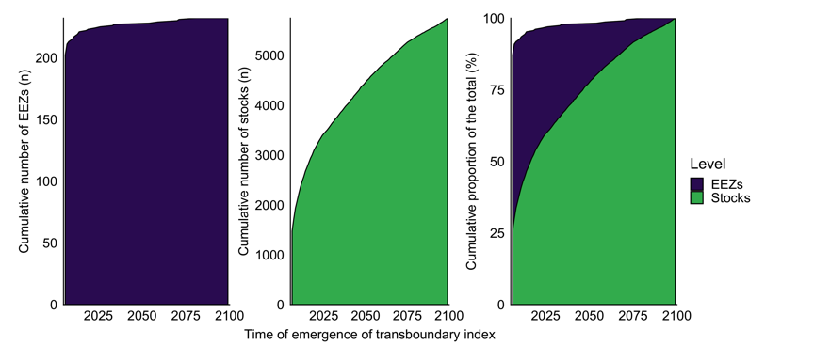

Figure 8.1: Time of emergence of the transboundary index by Exclusive Economic Zone (EEZ) and transboundary stock

The median time of emergence of the transboundary index of stocks varies significantly according to the geographic region of the neighboring EEZs (Kruskal-Wallis, $X^{2}$ = 287.23, DF = 93, p < 0.001; Figure 8.2A). Overall, most tropical EEZs will see an earlier time of emergence with the EEZs of Latin America and the Caribbean and Polynesia having significantly earlier times of emergence (p < 0.05; see Table A3.1 for test statistics) than almost all other regions e.g., Ecuador (ToE = 2013) and Papa New Guinea (ToE = 2018) (Figure 8.2B). In contrast, EEZs located in temperate regions like northern Europe and eastern Asia have significantly later times of emergence (p < 0.05; see Table A3.1 for test statistics) than the rest of the world, e.g., Ireland (ToE = 2067) and North Korea (ToE = 2058). However, notable exceptions to these broad patterns exist, with tropical EEZs displaying a later average time of emergence across stocks including the Pacific EEZ of Honduras (ToE = 2071) and Panama (ToE = 2070) and despite being outside the tropics, Belgium (ToE = 2015) and Norway (ToE = 2019) display a relatively early average time of emergence (Figure 8.2A). There are only a few cases where the transboundary index of a stock does not emerge between 2006 and 2100. In the Arctic EEZs of Canada and the US, the present chapter included three stocks: capelin (*Mallotus villosus*), saffron cod (*Eleginus gracilis*), and Pacific herring (*Clupea pallasii*). In the case of Brazil, I included four transboundary stocks, all shared with Uruguay (Chapter 2): Argentine menhaden (*Brevoortia pectinata*), Argentine shortfin squid (*Illex argentinus*), Argentine shrimp (*Pleoticus muelleri*), and pink shrimp (*Penaeus paulensis*). However, on all cases, I find that the transboundary index of these stocks did not emerge before 2100 relative to the historic (1951-2005) distribution (Figure 8.2A).

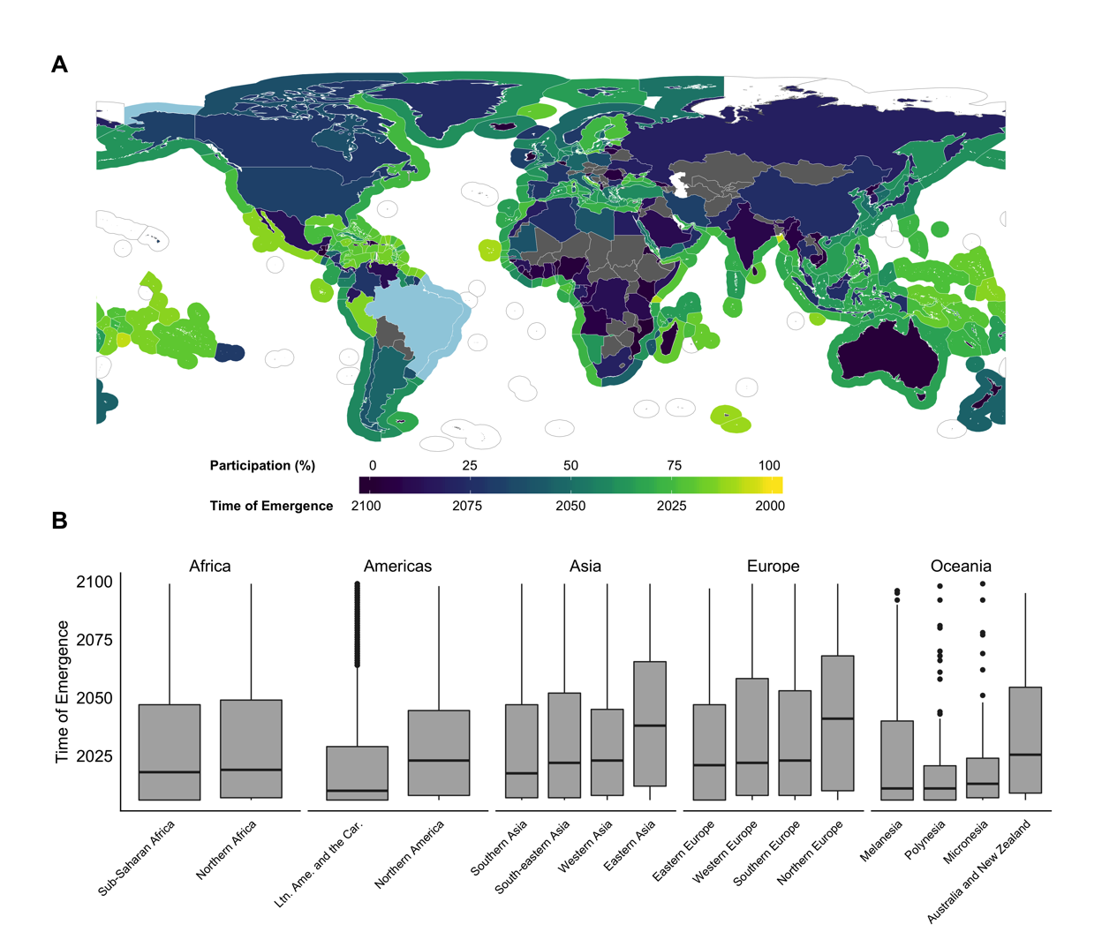

Figure 8.2: Average time of emergence of stocks’ transboundary index. A) Land polygon shows the participation of the emerging stocks in the country’s total fishing revenue from transboundary stocks. Exclusive Economic Zone polygon represents the average time of emergence of the transboundary index across all stocks. Aqua color represents EEZs with no time of emergence between 2006 and 2100. B) Time of emergence of the transboundary index according to the United Nations sub-regions. Whiskers represent 1.5* interquartile range. Box represents interquartile range as distance between first and third quartiles. Line represents median, and black points represent outliers with values exceeding of 1.5 times the interquartile range.

My analysis suggests that most (n = 47) countries responsible for 75% of the yearly revenue generated from transboundary stocks between 2005 and 2010 will see the distribution range of their stocks shift beyond historical variabilities between 2025 and 2040 (Figure 8.3). In some cases, like Indonesia (ranked $8^{th}$ in terms of revenue from transboundary stocks), Thailand (ranked $7^{th}$ in terms of revenue from transboundary stocks) and the United States (ranked $4^{th}$ in terms of fishing revenue from transboundary stocks), the range shift of transboundary stocks will emerge by around 2030. The 47 countries that make up the bulk of the global fisheries revenues also have more transboundary stocks with range shifts emerging from historical variability, such as Spain (n = 122), France (n = 85), China and Portugal (both n = 73) and Senegal (n = 66), which are the top 5 leading countries in terms of number of transboundary stocks emerging from historical variability.

On average, stocks that see their transboundary index emerge by 2100 represent 27% $±$ 23% of the revenue generated by fisheries that target transboundary stocks within their EEZs between 2004 and 2010. However, large variation exists in the contribution of stocks with emerging transboundary index to the current revenue participation across EEZs. In some cases, like El Salvador and New Zealand, stocks with emerging transboundary index represent less than 1% of the revenue generated from transboundary fisheries in their respective EEZs between 2004 and 2014. On the contrary, stocks with emerging transboundary index from the Marshall Islands and Tokelau represent over 90% of the revenue generated from fisheries targeting transboundary stocks within their respective EEZs during the same time period (Figure 8.2A). In addition, some EEZs are projected to have a few emerging stocks that represent a large proportion of revenue from transboundary stocks like Peru and Finland (with 10 and 5 emerging stocks representing 86% and 78% of average fishing revenue between 2004 to 2010, respectively). Overall, Morocco and Malaysia are the only two countries amongst the top 10 countries with the larger number of stocks with emerging transboundary index (n = 56 and 53, respectively) where the contribution of such stocks to fishing revenue is less than 20%. This indicates that, despite having a large proportion of transboundary stocks emerging, the economic contribution of these stocks are relatively small to the overall revenue generated by fisheries targeting transboundary stocks in these countries.

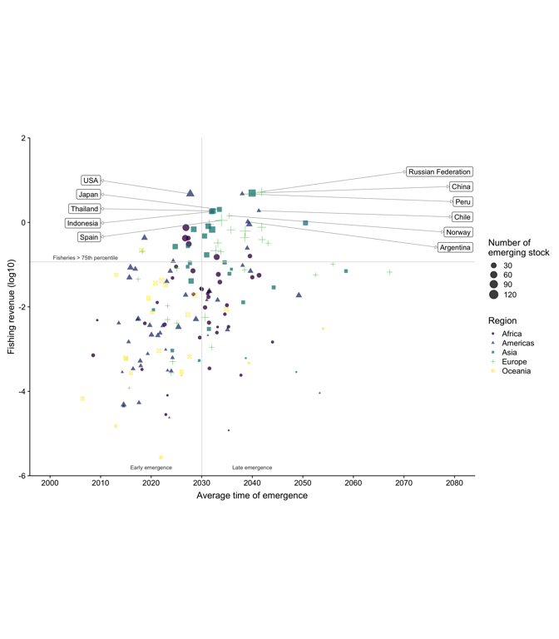

Figure 8.3: Average time of emergence of stocks’ transboundary index per fishing entity, aggregated by colour and shape according to region. Fishing revenue on a logarithmic scale. Showing country names for the top 90th percentile of annual fishing revenue.

I set an arbitrary threshold of 1 s.d. (67% confidence) to determine the time of emergence of the transboundary index and the change in stock share ratio below the threat point (see Methods). I tested the sensitivity to a larger threshold for the time of emergence (e.g., 2 s.d for a 95% confidence) and the global average time of emergence of the transboundary index considering a 2 s.d threshold was 2036 $±$ 28, a difference of about 7 years relative to the 1 s.d. threshold (Figure 11.5). In total, 4,119 transboundary stocks would emerge between 2006 and 2100 considering a more conservative metric.

I compared stocks time of emergence within EEZs by the species’ habitat association (Figure 8.4). Each species is assigned to be associated to one of the seven habitat types based on information available from FishBase and SeaLifeBase for fish and invertebrates, respectively (see Methods). I found significant statistical differences in the time of emergence of stocks range shifts by their habitat association (Kruskal-Wallis, $X^{2}$ = 286.48, DF = 93, p < 0.001). Specifically, the time of emergence of the transboundary index of species that are associated with pelagic-oceanic and reef habitats were significantly different than other habitat preferences (See Table A3.2). On average, species associated with pelagic oceanic habitats e,g, tunas (*Thunnus sp.*), bathy-pelagic habitats e.g., blue whiting (*Micromesistius poutassou*) and corals (e.g., Bigeye snapper *Lutjanus lutjanus*) are projected to have an earliest time of emergence (Figure 8.4). Species associated with bathydemersal habitats such as Alaska plaice (*Pleuronectes quadrituberculatus*) generally have an average time of emergence of range shifts that is later than 2025 (Figure 8.4).

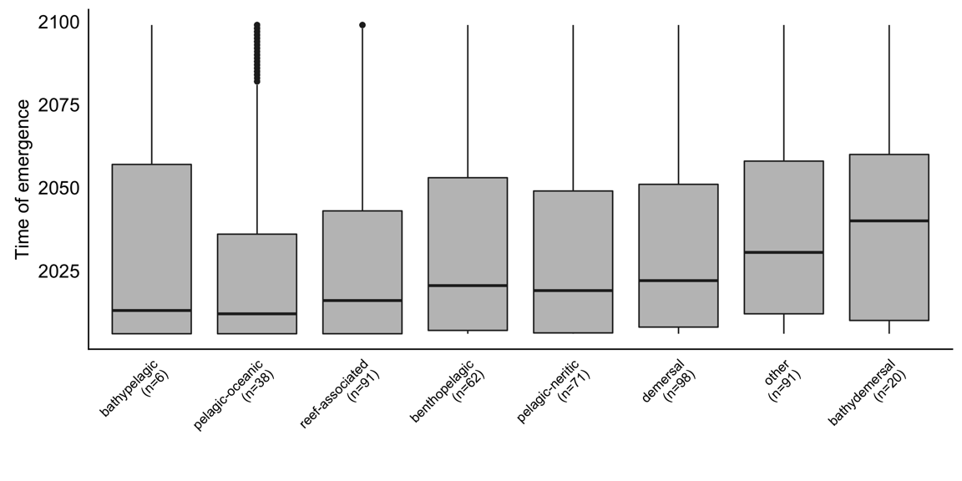

Figure 8.4: Comparison of regional time of emergence of shared stocks’ range shifts by species’ habitat association. Classification is based on the habitat preference information obtained from FishBase and SeaLifeBase (see Methods). The number of species included in this analysis for each habitat type is noted in parenthesis. Whiskers represent 1.5* interquartile range. Box represents interquartile range as distance between first and third quartiles. Line represents median, and black points represent outliers with values exceeding 1.5 times the interquartile range.

### 8.3.2 Changes in the stock share ratio of transboundary stocks

I have identified the stocks that are projected to have changes in stock share ratio beyond an EEZ’s threat point and estimated the changes in the stock share ratio by the early (2020-2040) and the mid ${21}^{st}$ century (2040-2060), relative to the recent past (1951-2005) (see methods – Equation (??)). By the early ${21}^{st}$ century, the global average proportion of transboundary stocks that are projected to change their stock share ratio beyond the EEZ’s threat point is 18% $±$ 15% (Figure 8.5A). The changes in stock share ratio are expected to increase slightly towards the mid ${21}^{st}$ century (Figures 11.7 and 11.8). However, changes in stock share ratio for specific stocks and in some EEZs are projected to be exceptionally high. For example, Guatemala shares *Panulirus gracilis* stock with Mexico, and Guatemala’s share is projected to increase by >50%, that is from 12% to 26% by the early ${21}^{st}$ century. Towards the mid ${21}^{st}$ century, changes in stock share ratio per EEZ will not be substantial (Figure 11.8) relative to the early ${21}^{st}$ century but are expected to increase in intensity (Figure 11.7). My results suggest that 87% (n = 238) of the world EEZs will experience changes in stock share ratio beyond a country’s threat point by the early ${21}^{st}$ century (Figure 8.5A). These EEZs will have changes in the stock share ratio beyond the threat point in one third (33% $±$ 21%) of their transboundary stocks (Figure 8.5A). Particularly, Brazil, French Guiana, Guam, Kergelen and Pitcairin are projected to have changes beyond the threat point for all of the transboundary stocks analyzed, while Venezuela (6%), Bonaire (9%), China (10%) and Vietnam (10%) are the only countries with less than 10% of stocks changing beyond the threat point.

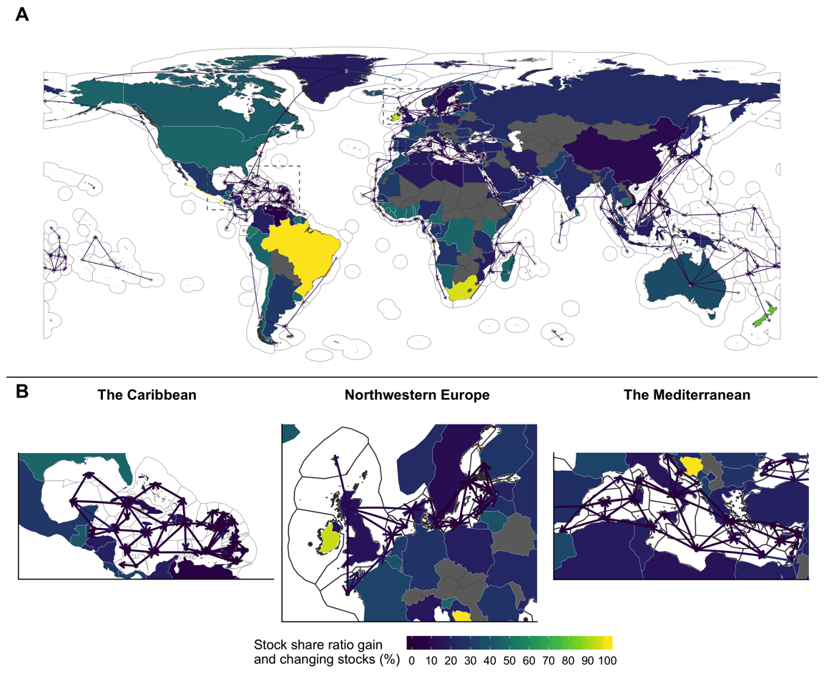

Figure 8.5: Changes in stock share ratio below each country’s threat point by 2030 (2021-2040) relative to 1951-2005. Lines represent the average gain of transboundary stock share ratio with arrows going from EEZ with decreasing stock share (point) to those that are gaining shares (arrowhead). Land polygons represent the percentage of stocks that are projected to change their stock share ratio beyond the identified threat point. Panel B zooms in to specific areas shown within the grey dashed line boundaries in A.

Changes of stock share ratio are largely related to regional changes in biogeography and the geometry of the EEZs (Figure 8.5). In some cases, like the Atlantic and Pacific coasts of Northern and Southern America and the Atlantic coast of Southern Africa, the stock share ratio is expected to follow the projected poleward shift of transboundary species under climate change. However, central America Pacific and West African coasts follow an equatorial direction as range shifts of transboundary stocks follow local oceanographic gradients, with relatively lower temperature waters in lower latitude (Clarke et al. 2020). Moreover, regions where EEZs are relatively small and have multiple borders are expected to have a particularly complex exchange of stock share ratio with no established pattern, as in the Caribbean, Mediterranean and northwestern Europe (Figure 8.5B).

## 8.4 Discussion

In this chapter, I investigate the timing and intensity of changes in the sharing of transboundary stocks between countries. My findings highlight the early emergence of transboundary distribution shifts from historical variations for most of the shared stocks in the world. Such early emergence of range shifts indicates the urgency of addressing the challenges that climate change is posing on international fisheries management. Moreover, I identify regional patterns of high climate risk to important fish stocks and associated fisheries at the present-day that will require immediate responses from transboundary fisheries management. Finally, I show that in many instances around the world, countries’ fisheries will experience changes in the sharing of many transboundary stocks to levels below of that needed to encourage cooperative resource management between countries. Adaptation measures are therefore needed to reduce the impacts of species range shifts on current international transboundary fisheries treaties.

### 8.4.1 High present-day climate risk of on transboundary fisheries management

My projections for the emergence of distribution shifts of transboundary stocks in the early ${21}^{st}$ century concur with previous studies that have detected and attributed changes in marine catch composition (Cheung et al. 2013). For example, in the early 2000s, Humboldt squid (*Dosidicus gigas*) substantially expanded its geographic range poleward, reaching the coast of Washington state (US). A new fishery targeting Humboldt squid was developed quickly following its range expansion (Zeidberg and Robison 2007, Pinsky and Mantua 2014). In the northeast Atlantic, the Atlantic mackerel (*Scomber scombrus*) fisheries are multi-laterally managed by the EU, Norway, Iceland, Russia, and Denmark (on behalf of the Faroe Islands and Greenland) through the North-East Atlantic Fisheries Commission (NEAFC). However, a range expansion of Atlantic mackerel into Icelandic waters in 2007 resulted in Iceland capturing 6% of the total fishery catch and a further 18% capture in 2008, without consultation with NEAFC and threatening the sustainability of the stock (Spijkers and Boonstra 2017). Such changes resulted in disputes between Iceland and the Faroes Islands, as well as the NEAFC member states (Spijkers and Boonstra 2017). As climate change impacts on transboundary stocks continue to emerge from historical variability in the coming years, mal-adapted fisheries management and international disputes like that of Atlantic mackerel are likely to increase in frequency (Pinsky et al. 2018).

The projected range shifts of large number of transboundary stocks emerging from historical variability since the early 2000s can be partially attributed to the parallel emergence of several environmental variables (e.g., temperature and oxygen) that influence their distribution (Mahlstein et al. 2011, Keller et al. 2014, Rodgers et al. 2015, Frölicher et al. 2016). Marine organisms have a thermal tolerance that limits their habitable temperature range (IPCC 2019), which then explains the sensitivity of the animal to warming and is a main driver of any distributional change (IPCC 2019). Oxygen plays a similar role to that of temperature (Clarke et al. 2020), especially for tuna species that require large amounts of dissolved oxygen for their metabolism (IPCC 2014). It has been estimated that since the early 2000s, increased sea surface temperature (SST) and decrease in subsurface oxygen have emerged from historical variability for 79% and 23% of the global ocean, respectively, and that by 2080, SST is projected to emerge from historical variability in 90% of the global ocean while the area affected by lower $O_{2}$ will have doubled under a high greenhouse gas emissions scenario (RCP 8.5) (Rodgers et al. 2015). Moreover, before 2100, surface acidification, nitrate content and net primary production, also important variables for species distributions, will have emerged from the historical variability of 1861-1900 in 30% and 60% of the ocean under a low (RCP 2.6) and strong (RCP 8.5) climate change scenario, respectively (IPCC 2019). These oceanographic changes are important drivers of change in species distributions as represented in the DBEM (Cheung, Jones, Reygondeau, et al. 2016, Lefevre et al. 2017).

Regional differences in the time of emergence of many transboundary stocks are attributed to the variations in environmental conditions, species’ climate vulnerability, and the characteristics of political boundaries. Specifically, my findings are consistent with results from previous studies that show tropical species are already shifting their distributions since the last few decades (Poloczanska et al. 2016). The tropics are among the most species-rich biomes (Reygondeau 2019) and have potentially experienced some of the highest levels of warming relative to natural internal variability (Roemmich et al. 2015, IPCC 2019). In the tropics, marine species also live close to their thermal tolerance, making them highly vulnerable to warming (IPCC 2014). Consequently, species have to move towards deeper or sub-tropical waters as a result of climate change (Poloczanska et al. 2016), although in some regions species follow local temperature gradients towards the equator or shallow waters (Clarke et al. 2020). Moreover, tropical species are expanding their range into sub-tropical biomes (Fogarty et al. 2017) and catch-data analysis shows a reduction in sub-tropical species catches in tropical waters between 1970 and 2006 (Cheung et al. 2013). In addition to species natural traits and the environmental pressure from climate change, the tropics comprise areas with relatively small EEZs that border with multiple countries (e.g., the Caribbean). These tropical areas are projected to have the highest number of transboundary stocks’ distribution shifts emerging in the incoming years.

### 8.4.2 Hotspot of climate risk on transboundary fisheries management

My results underscore regional ‘hotspots’ of climate risk for transboundary fisheries management that will require the prompt adaptation of management plans (Figure 8.2). For example, Polynesia and Micronesia are the only regions where the average time of emergence of transboundary stocks’ distribution across all EEZs emerged before 2022 (Figure 8.5). Moreover, countries in these hotspot regions are highly dependent on pelagic-oceanic (e.g., tunas and bill fishes; (Johnson et al. 2017)) and reef-associated transboundary stocks (Cabral and Geronimo 2018) for both food security and profits (Cisneros-Montemayor et al. 2016, Hanich et al. 2018). On the other hand, “coldspots” of climate risk exist for transboundary fisheries, like the Northeast Atlantic and Northwest Pacific, where stocks are expected to emerge later in the ${21}^{st}$ century. Assuming that these countries already have adequate transboundary management to deal with historical and current variations in fish stocks’ distribution e.g., the Pacific Salmon Treaties (Miller and Munro 2004), management agencies are likely to have more time to prepare for emerging stock shifts.

In cases where climate driven changes in stocks are emerging, or have already emerged, from historical variability adaptation policies are urgently needed to address the potential impact on important fisheries (Burden and Fujita 2019). Currently, fisheries targeting shared tuna stocks in the South Pacific Islands region operate under the Vessel Day Scheme, which because it takes into account shifts in stocks and catches makes it a good example of a management system that is somewhat anticipatory (Aqorau et al. 2018). However, even strategies that take into consideration the shift of the stock within the party’s area will likely also have to deal with the ‘newcomer issue’ that NEAFC is currently facing regarding Atlantic mackerel (Spijkers and Boonstra 2017, Pinsky et al. 2018). As the climate trend in stocks distribution emerges from their historical variability since 2006, regional management bodies must revise their management actions as most are not currently equipped with strategies to cope with shifting species distributions (Oremus et al. 2020, Sumby et al. 2021). This is of specific concern for those management bodies located in the emerging “hotspots” here identified.

Some EEZs lack stocks with emerging transboundary index because of a combination of their shape, climate projections, and a reduced number of transboundary stocks. For example, there are 59 commercial fish stocks fished in the Arctic with the vast majority on the Barents, Bering and Norwegian seas, with limited knowledge about the species biology (Christiansen et al. 2014). However, the Arctic has been warming faster than many other regions, resulting in a sea-ice reduction (Douglas 2010) consequently increasing the potential for occupation by species not previously present (IPCC 2019). As a result, the biomass of Arctic marine animals (Bryndum-Buchholz et al. 2019) and catch and revenue of local fisheries (Lam et al. 2014, Tai et al. 2019) are expected to increase in the incoming years, although substantial uncertainty exists on the magnitude of change (Bryndum-Buchholz et al. 2019). Moreover, projections suggest a larger increment on transboundary stocks in the coming years in the Arctic (Pinsky et al. 2018) as climate change pushes sub-polar species further north (Frainer et al. 2017, Morley et al. 2018). In the specific case of Brazil, in addition to having few transboundary stocks (only four shared with Uruguay in this chapter), the large difference in the EEZs lengths could also be influencing the results.

### 8.4.3 Changes in stock share ratio will be ubiquitous

Changes in stock share ratio beyond a country’s threat point will be seen across the world, suggesting that climate change impacts on transboundary stock management is a global problem (Figure 8.5). Poleward shifts in stock share ratio are expected in regions of the world with relatively long EEZs and few boundaries, like the northeast Pacific and the southeast Atlantic. However, despite observations and modelling work indicating that climate change is generally shifting species distributions poleward (Cheung et al. 2010, Poloczanska et al. 2016, Fogarty et al. 2017, IPCC 2019), some regions like the eastern tropical Pacific and eastern tropical Atlantic Oceans will experience a shift in distribution towards the equator. Specifically, in the eastern tropical Pacific, the direction of shift is expected to be from Mexico to Ecuador with northern EEZs losing stock share ratio to their southern neighbors. Such range shifts towards the equator reflect movements to cooler habitats characteristic of equatorial upwelling systems (Clarke et al. 2020) and are consistent with regional modeling studies suggesting that by the mid $21st$ century, marine species will move between 50 and 100 km southward of Mexico’s EEZ towards Peru under a high emission scenario (Clarke et al. 2020). Moreover, regions characterized by multiple political boundaries, like the Caribbean and the northeast Atlantic, will see a complex network of changes in stock share ratio with no clear pattern (Figure 8.5B). These regions are known for being highly connected by both fish adult migration (Levin et al. 2018) and dispersal of larvae (Ramesh et al. 2019) supporting the implementation of joint management plans (Burden and Fujita 2019) and the call for new implemented shared policies (Levin et al. 2018). However, game theory predicts that the greater the number of negotiating parties, the harder it is for parties to reach an agreement (Sumaila 2013), thus, making it particularly challenging for countries in these regions to coordinate the management of shifting shared stocks.

Changes in stock share ratio beyond the threat point of countries sharing a common resource could instigate international conflict and hinder bi-lateral agreements (Miller et al. 2013, Sumaila et al. 2020). Lessons learned from historic distributional shifts of shared stocks suggest that treaties that are not prepared to respond to such shifts will be less resilient to changes in transboundary fish stocks share ratio due to climate change (Miller et al. 2013, Sumaila et al. 2020). For example, disputes over Pacific salmon between Canada and the US arose in the 1990s when a climate-related shift in stock abundance favoured Alaska’s salmon fisheries over Canada’s (Miller and Munro 2002, Miller et al. 2013, Song et al. 2017b). The conflict lasted over ten years until Canada and the US agreed on a mutual conservation fund where the US would contribute the larger proportion to support scientific research, habitat restoration and enhancement of wild stock production in transboundary rivers (Miller and Munro 2002). Identified strategies to cope with changes in the share proportion of transboundary stocks include the incorporation of side payments (Tunca 2019), increased international cooperation (Miller et al. 2013) and dynamic ocean management (Pinsky et al. 2018). Side payments are mechanisms that can provide a solution to the inequality produced by shifts in the stock’s distribution (Miller and Munro 2004, Tunca 2019). These can be monetary (e.g., the stock-“winning” state compensates the stock-“losing” state for the proportional shift) or other methods like the Pacific salmon case (e.g., a conservation fund paid mainly by one party) (Miller and Munro 2004, Miller et al. 2013). Strengthening current international cooperation will be required as stock distribution will move to neighboring jurisdictions, requiring combined efforts to generate information and set proper management rules (Miller et al. 2013). Finally, flexible management rules might be more appropriate to capturing t distributional shifts. For example, a quota allocation based on the stock’s current distribution like that for Pacific halibut (*Hippoglossus stenolepis*) managed by Canada and the US (Sumaila et al. (2020); Chapter 2) would be more agile than one based on a fixed-historical proportion like the case of the EU (Baudron et al. 2020).

## 8.5 Caveats and uncertainties

There are two main sources of uncertainty in my analysis. First, I rely on the combination of a single Earth system model (GFDL-ESM2M), fish and fisheries model, and climate change scenario (RCP 8.5). The use of multiple ESMs can capture the structural uncertainty of the models (Frölicher et al. 2016, Lotze et al. 2019), however, exercises looking at changes in fish biomass with multiple models show an overall agreement between models in terms of direction of change but variable in magnitude. Further research that includes multiple ESMs and species distribution models could elucidate a broader range structural uncertainty of the climate, fish and fisheries models (Lotze et al. 2019). Secondly, due to limited biological and spatially-specific data on stocks sub-population structure of transboundary species, my analysis uses political boundaries (EEZs) to delineate a stock that does not necessarily align with biologically-defined sub-populations within an EEZ. On the other hand, in many EEZs, fisheries are often managed at the species level (Chapter 2) and sub-populations are potentially interconnected (Ramesh et al. 2019), thus, providing additional ecological ground for my analysis (Dunn et al. 2019, Popova et al. 2019). However, reproducing my analysis locally, where spatially explicit stock data is available would allow to produce more certain results in changes in both time of emergence and stock share ratio of transboundary stocks, and potentially identity different types of shared stock shifts within meta-populations level (Link et al. 2010, Archambault et al. 2016, Kaplan et al. 2016). Addressing these uncertainties systematically can serve as a roadmap for future studies to provide additional information to inform policy towards sustainable and equitable international fisheries management under climate change.

## 8.6 Conclusion

The global community has set the ambitious goal to manage all fisheries sustainably (SDG 14 – Life below water) by 2030; achieving this goal would have clear effects on multiple others (Singh et al. 2017, United Nations 2018). Preparing anticipatory policy to species on the move is key to achieve these sustainable development goals and effective governance of the world’s fisheries (Pinsky et al. 2018). Here, I have addressed two fundamental steps to achieve sustainable international fisheries in a changing world (Link et al. 2010). I have identified the transboundary stocks that will see a significant shift compared to their historical average in shared distribution, the year in which their distribution will undergo such a shift, as well as the degree of change. My results have direct implications for ocean governance as the data provided can inform and be used by regional management bodies and countries to anticipate the potential complications brought about by climate change to international fisheries management. While future studies, specifically at more localized scale, will provide valuable nuance in designing effective policies, my results provide an important baseline on which to build when preparing ocean governance for species on the move (Pinsky et al. 2018, Gaines et al. 2018, Chapter 2). To address the issues raised in this chapter, international fisheries management will require coordination between nations to generate adaptive, collaborative and equitable management strategies to address the uncertainties of a changing world.

# 9 Challenges to transboundary fisheries management in North America under climate change

## 9.1 Introduction

In 1982, the United Nations Law of the Sea Convention (UNCLOS) formalized the concept of exclusive economic zones (EEZs) creating the concept that we know today as shared stocks (United Nations 1986), i.e., stocks that migrate between countries EEZs (known as transboundary stocks) or between EEZs and the high seas (also called straddling stocks) (Song et al. 2017a). Today, an estimated 347 (Teh and Sumaila 2015) to 633 (Chapter 2) fish stocks have distributions that cross national borders, some of them jointly managed by two or more countries. These species are responsible for more than 70% of these countries total fish catches (Chapter 2). Under Article 63, UNCLOS incentives actions to cooperate on the management of shared stocks (United Nations 1986) as management success often depends on effective cooperation between parties (Miller and Munro 2002, Sumaila 2013). Since the definition of shared stocks, game theory has been one of the most common approaches used to analyze the management of these type of stocks. However, shared stocks’ management can be convoluted due to the participation of several fishing “players”, different countries and sometimes jurisdictions within a country, the migration patterns of the stock, and their abundance fluctuation within space and time (Miller and Munro 2002, Engler 2020). In addition, international treaties might not be prepared to address the effects that climate change will bring to shared fish stocks (Engler 2020, Koubrak and VanderZwaag, 2020).

The ocean is getting warmer (Rheim et al. 2013), less oxygenated (Schmidtko et al. 2017), and increasing in acidity (Ross et al. 2011, IPCC 2019). To cope with these changes in ocean biophysical properties, marine species, including shared fish stocks, have been shifting their distribution towards the poles and/or deeper waters (Poloczanska et al. 2016). As climate change reshapes the ocean’s environment worldwide (Gattuso et al. 2015), shared fisheries’ governance is threatened as new migration patterns may arise (Miller et al. 2013, Pinsky et al. 2018), historic distribution and abundances might shift (Cheung et al. 2010), and species basic natural traits may modify (Pauly and Cheung 2017). Catches of shared stocks like tunas, have significantly increased in some regions such as the subtropical Atlantic and western Pacific Oceans and are projected to continue (Monllor-Hurtado et al. 2017, Erauskin-Extramiana et al. 2019). Multiple shared species in North America have been observed to shift in distribution following, in part, changes in optimal conditions such as sockeye salmon (*Oncorhynchus nerka*) (McDaniels et al. 2010, Miller et al. 2013, Song et al. 2017b), Atlantic cod (Pershing et al. 2015), and flounders (Pinsky and Fogarty 2012). Moreover, these shifts are projected to continue towards the end of the ${21}^{st}$ century (Cheung 2018). As a result, some countries or management jurisdictions may see more shared fisheries and their catches shifting into their waters while others will stand to lose (Pinsky et al. 2018, Chapter 3, Oremus et al. 2020). Nevertheless, management rules for shared stocks (e.g., quota or spatial delimitation) are often determined based on current and/or historic knowledge of the stock’s distribution and do not consider future shifts in distributions (Fredston-Hermann et al. 2018).

The shifts in distribution of shared fish stocks will impact the economics of their fisheries (Pinsky and Fogarty 2012, Sumaila 2019, Sumaila et al. 2020), and create international disputes between countries (Miller and Munro 2002, Spijkers and Boonstra 2017, Pinsky et al. 2018). Canada and the US share important transboundary stocks of salmon (*Oncorhynchus spp.*), Pacific halibut (*Hippoglossus stenolepis*), and Atlantic cod (*Gadus morhua*) offering a unique lens to understand the extent to which climate-induced distributional shifts will challenge the future sustainability of transboundary fisheries. These countries have a long history of fisheries cooperation participating in diverse, jointly managed, commercial transboundary stocks through various fisheries management organizations (NOAA 2018). Furthermore, climate-related fluctuations in stocks’ distribution have historically created disputes between Canada and the US, increasing international conflict and threatening the health of diverse transboundary stocks (Miller and Munro 2002, CIA 2017).

It is expected that climate induced shifts in stocks’ distribution will affect the rules in place that keep international treaties alive. Therefore, the main objective of this article is to assess the level of exposure that bi-lateral transboundary fisheries treaties between Canada and the US have to climate change through shifts in stock distributions. Specifically, I rely on a species distribution model and scenario planning to project the changes in the distribution of selected fish stocks jointly managed by Canada and the US focusing on two case studies (the International Pacific Halibut Commission and a fisheries arrangement for the Gulf of Maine) Finally, I explore similar situations around the world and identify opportunities to improve the adaptability of transboundary stocks management to climate change in North America. Despite an overall expectation of species following a poleward shift, important geographic constraints (e.g., Gulf of Alaska representing a latitudinal block) (Kleisner et al. 2016), geo-political features (e.g., the localization of Alaska in reference to Canada and the contiguous states), and management rules (e.g., quota allocations, spatial management rules) may play an important role in the redistribution of benefits. Understanding these stocks shifts will shed a light on future conditions and inform decision-makers on the paths to follow under a changing climate.

## 9.2 Materials and methods

### 9.2.1 Study area and fisheries

In this chapter, I used the International Pacific Halibut Commission (IPHC) and the Gulf of Maine arrangement (hereafter referred as GoMa) as case studies to discuss the implications that climate change could have in the management of transboundary stocks. For the IPHC, I used the most updated spatial regulatory data along its 12 regulatory areas (IPHC and Gustafson 2017, IPHC 2019). For this specific case, I considered Alaska as a separate entity, the US contiguous states as a second one (Washington, Oregon and California), and lastly British Columbia (Canada). For the GoMa, I used the Northwest Atlantic Fisheries Organization’s (NAFO)[2] divisions 5Y, 5Ze, and 4X within latitudes 46.2°N and 41.5°S, and longitudes -72°W and -64°E (Figure 9.1). It is worth mention that, while NAFO’s divisional zones were used in this study for domestic management, NAFO does not manage fisheries within the EEZs of Canada and the United States. Fisheries data for the projections was gathered from the Sea Around Us from 1951 to 2014 (Zeller et al. 2016).

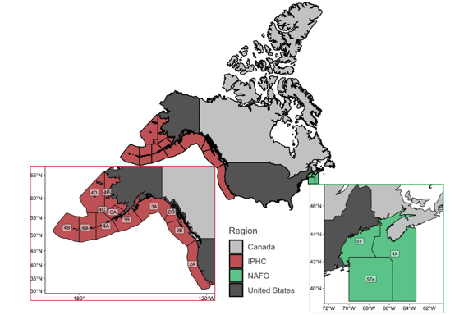

Figure 9.1: Map of Canada and the US with the regulatory areas of the International Pacific Halibut Commission and the NAFO sub-divisions containing the Gulf of Maine arrangement

### 9.2.2 The International Pacific Halibut Commission

The IPHC was established in 1923 by Canada and the US to oversee the management of Pacific halibut (*Hippoglossus stenolepis*) (IPHC 2014). There are 12 regulatory areas from which 3AB holds 51.2% of the stock, followed by regions 2ABC and 4ACDE with 23.1% and 20.4%, respectively, and lastly region 4B with only 5.2% of the stock distribution (IPHC and Gustafson 2018). In terms of management, the IPHC implements a total allowable catch (TAC) based on a yearly sampling of the Convention area in addition to a series of regulations to control fishing effort (IPHC and Gustafson 2018). The TAC is divided between recreational, subsistence and commercial fishery, with a portion set aside for bycatch of other fisheries (IPHC 2019). The commercial fishing season starts in March ending around November with restrictions allowing only set line gear with J-type hooks targeting individuals over 81.3 cm of total length (IPHC 2019).

### 9.2.3 The Gulf of Maine Arrangement

Since 1998 Canada and the US have used a “Resource Sharing Understanding” to inform the management of Eastern George Bank’s Atlantic cod (*Gadus morhua*), haddock (*Melanogrammus aeglefinus*) and yellowtail flounder (*Limanda ferruginea*) (Pudden and VanderZwaag 2007, TRAC 2016, Song et al. 2017b). From 2010 onward, the GoMa suggests catch-limits based on a weighted method where 10% represents the stocks’ historical distribution (from 1967 to 1994) and 90% current distributions as determined by quarterly surveys and catch (TRAC 2016). Since its introduction, the average quota allocation for each species proposed by the GoMa has been (Table 4.1; Atlantic cod 77% Canada and 23% US, haddock 55% Canada and 45% US, and yellowtail flounder 34% Canada and 66% US (TRAC 2015a, 2015b, 2015c, 2018a, 2018b, 2018c, Lake 2019). However, because this is an unofficial agreement, Canada and the US ultimately take single management decisions (Soboil and Sutinen 2006). In terms of management, the US has a multi species harvest control rule with area and season closures, mesh sizes, effort control, and mobile gear vessels that use bottom otter trawl gear (Soboil and Sutinen 2006). In contrast, Canada has a quota system in addition to limited-entry licensing, fleet allocations, and mesh and fish size regulation, among other input controls. Canada inshore vessels fish cod with longline and gillnet while haddock is mainly caught with bottom otter trawl gear (Soboil and Sutinen 2006).

### 9.2.4 Projecting future species distributions

I used a Dynamic Bioclimatic Envelope Model (DBEM) to project the distribution of species from 2015 to 2100 under two scenarios of climate change (Cheung et al. 2010, Cheung, Jones, Reygondeau, et al. 2016). The DBEM algorithm integrated ecophysiology and habitat suitability with spatial population dynamics of exploited fishes and invertebrates to project shifts in abundance and potential fisheries catches under climate change. The algorithm predicted species distribution based on depth and latitudinal range, habitat preferences and an index of species association with major habitat types to estimate changes in abundance distribution over a ${0.5}^{∘}$ x ${0.5}^{∘}$ grid of the world ocean. For each grid cell and time step, the model then calculated species carrying capacity according to sea surface temperature, salinity, oxygen content, sea ice extent (for polar species) and bathymetry, as well as the species preferences to these conditions. It then incorporated the intrinsic population growth, settled larvae, and net migration of adults from surrounding cells using an advection-diffusion-reaction equation. Finally, the model also simulated the effects of changes in temperature and oxygen content on growth of individuals (Cheung et al. 2013, Cheung, Jones, Reygondeau, et al. 2016). Ultimately, the model simulated spatial and temporal population dynamics, and estimated a proxy of maximum sustainable yield (MSY) by applying fishing at MSY level for each grid cell, hereafter referred as maximum catch potential (MCP).

I projected the DBEM using three Earth system models (ESM), the Geophysical Fluid Dynamics Laboratory Earth System Models 2M (GFDL)[3], the Institute Pierre Simon Laplace Climate Model 5 (IPSL-CM5)[4], and the Max Planck Institute for Meteorology Earth System Model (MPI)[5]. Each model was downscaled to match the DBEM ${0.5}^{∘}$ x ${0.5}^{∘}$ grid using the nearest neighbor method, and in some cases, bilinear interpolation (Cheung, Jones, Lam, et al. 2016). Finally, I used the model outputs for two scenarios of the Intergovernmental Panel on Climate Change (IPCC)-Representative Concentration Pathways (RCP) 2.6 and 8.5 representing a low greenhouse gas emission (strong mitigation) and a high greenhouse gas emission (week mitigation) scenario, respectively (IPCC 2014). To estimate model robustness and capture the structural uncertainty build within ESM models, I averaged the DBEM results for all three models ($μ±σ$) and marked regions where at least one ESM disagree in direction with the rest.

### 9.2.5 Estimation of Maximum Catch Potential change

For estimating the percentage change of MCP at the regional scale, I first aggregated the yearly mean MCP of all grid cells per region ($X_{yr}$) and period:

$$X_{yr}=\sum_{s=1}^{n}{\hat{MCP_{s}}}$$

where *y* is year, *r* is region, *s* is grid, *n* is total number of grids in the region, and $\hat{MCP}$ is the MCP of each stock. In the case of the GoMa, region was defined as the ${0.5}^{∘}$ x ${0.5}^{∘}$ grid-cell within the specific NAFO divisional zones. For the IPHC analysis, region was defined as the Commission’s regulatory areas (Figure 9.1). I then averaged the values in three time periods (*t*) to reduce temporal model sensitivity. Thus, I computed the regional percentage change in MCP ($ΔMCP$) as follows:

$$ΔMCP_{r}=-(1-\frac{X_{t}}{X_{t_{0}}})*100$$

where $X_{t}$ is the future average MCP for each of the two time periods analyzed in this study and $t_{0}$ is the present averaged MCP ( $μ$ 2005-2014). Note that in cases where $X_{0}$ = 0 and $X_{t}$ > 0, then ($ΔMCP$) = 100%, consequently, the opposite case would give a -100% result. This way, equation (??) shows the percentage change in MCP by mid ${21}^{st}$ century when $X_{t}$ = $μ$ 2041-2060, and end of ${21}^{st}$ century when $X_{t}$ = $μ$ 2080-2099, relative to today ($t_{0}$). The rationale between choosing these time periods was to provide a relative short-term projection (mid-century) that would be more policy-relevant but also show the long-term trend (end of the century).

In addition, I borrowed the concept of “threat point” from game theory defined as the minimum payoff that a player is willing to receive in order to cooperate with other players (Sumaila et al. n.d.). Thus, I estimated the change in the ($ΔMCP$) (threat point) that each country (players) would have for each stock (hereafter referred as stock-share ratio), for both the IPHC and the GoMa. The stock-share ratio can be seen as the proportion of the stock’s distribution within the study area that each country has. For this, I first modified equation (??), to estimate the aggregated yearly mean MCP of each stock per region. I then averaged the results by the same previously motioned periods (present, mid and end of the ${21}^{st}$ century). Next, for each stock I estimated the stock-share ratio ($α_{s}$) that each region had during each time period:

$$α_{s}=\frac{θ_{rt}}{δ_{rt}}$$

Where $θ_{rt}$* is the stock’s aggregated $\hat{MCP}$ of each region at time period *t*, and $δ_{ts}$ is the stock’s aggregated $\hat{MCP}$ of the whole stock’s distribution within the study area at the same time period. Finally, I estimated the percentage change in stock-share ratio substituting $X_{t_{0}}$ and $X_{t}$ by $α_{t0}$ and $α_{t}$, respectively in equation (??). The process was carried out for each ESM and results presented as average $±$ standard deviation (sd). All of the analysis was done in the statistical software R version 3.5.2 (2018-12-20) with the associated packages, data.table (Dowle et al. 2019), ggrepel (Slowikowski et al. 2019), gridExtra (Auguie 2017), knirt (Xie 2020), RColorBrewer (Neuwirth 2014), sf (Pebesma et al. 2018), and tidyverse (Wickham 2017). All code is available at <http://www.github.com/jepa/OC_Transboundary>.

## 9.3 Results

### 9.3.1 Projected change to stocks managed by the IPHC

At least one third of the IPHC regulatory areas will see a reduction in MCP of Pacific halibut by 2050 relative to current MCP, regardless of the climate change scenario (Figure 9.2). It is likely that the stock shift from the US. contiguous states towards Canada will offset the shift of the later towards northern regions, resulting in undetectable changes in Canadian area 2B and Alaskan 2C under both climate change scenarios. The potential movement of halibut westward will increase the MCP of regulatory areas 3B (under a low emission scenario) and 4ABCE along the Aleutian Islands and Bering Sea. Regions 4DE, the most poleward regulatory areas of the IPHC, are expected to gain MCP by mid (Figure 9.2) and end of the ${21}^{st}$ century (Figure 11.10) under a high emission scenario due to the expansion of halibut suitable habitat as sea ice retreats (Figure 11.12). In contrast, under a low emission scenario, sea ice is expected to stabilize towards mid 21st century, thus providing less “new” suitable habitat for Pacific halibut and resulting in undetectable changes in MCP for the region (Figure 9.2B) and decreasing even more towards 2100 (Figure 11.10).

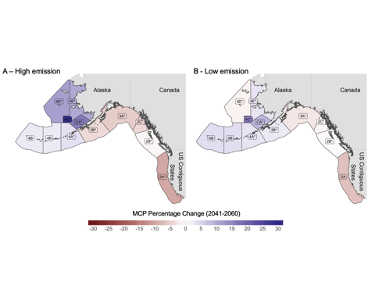

Figure 9.2: Percentage change of MCP for stocks managed by the IPHC for mid 21st century (2041-2060) relative to present 2005-2014 under a A) high emission scenario and B) low emission scenario. Labels marked with * represent regions where models do not agree in direction of change.

The same poleward trend is expected in the change of Pacific halibut stock-share ratio with the average proportion increasing up to 25% in some northern regions and decreasing by 10% in southern regions, relative to the present proportion (Figure 9.3). Maintaining emissions to lower levels through 2050 would potentially leave unchanged the stock-share ratio of three regulatory areas (3AC, and 4D) and negatively change regulatory area 2A. On the other hand, failing to achieve such target will decrease the stock-share ratio in the most productive regulatory areas (2AC, 3AB).

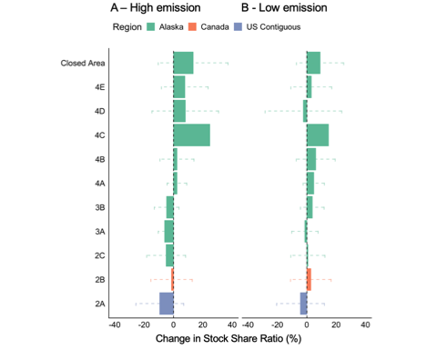

Figure 9.3: Percentage change of stock-share ratio for IPHC under A) high emission scenario and B) low emission scenario for mid 21st century (2041-2060) relative to present 2005-2014. Values represent the mean of 3 ESM; error bars represent ± sd.

### 9.3.2 Projected change to stocks managed under the Gulf of Maine arrangement

While some regulatory areas of the IPHC will see an incremental increase in Pacific halibut MCP, the results for the Gulf of Maine show an overall decrease in MCP by 2050, regardless of the climate change scenario or ESM (Figure 9.4), intensifying by the end of the ${21}^{st}$ century (Figure 11.11). For cod and haddock, MCP will decrease within the whole Gulf with no apparent win for any country in reference to the current period (Figure 9.4). For yellowtail flounder, despite an overall reduction, some discrete areas are expected to increase with no particular pattern and high uncertainty, as ESMs in these regions do not agree in the direction of change (Figure 11.14). Despite the overall reduction in MCP for all three stocks in comparison to current values, there is a benefit of achieving a low emission scenario as reductions intensify under the high emission scenario.

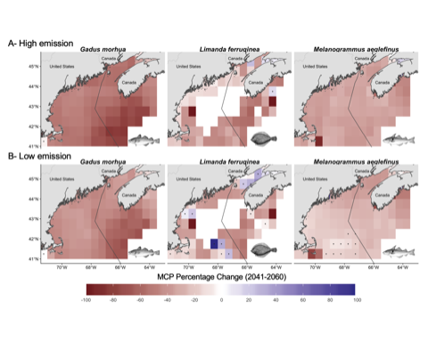

Figure 9.4: Percentage change of MCP in the Gulf of Maine under, A) high emission scenario; and B) low emission for the mid 21st century (2041-2060) relative to present (2005-2014). Points represent regions where models do not agree in direction of change.

Despite the expected decrease in MCP for the region, changes in the stock-share ratio of stocks within the Gulf of Maine show different outcomes dependent on the climate change scenario and stock in question. Following a high emission path will negatively affect mostly Canada’s share of yellowtail flounder and in less degree haddock, with an increase of cod share. Under the low emission scenario, haddock and cod share patterns intensify, while yellowtail flounder’s share approaches almost no change (Figure 9.5). Such pattern is likely due to the combination of the bathymetry or the Gulf, the warming gradient, and the stock’s distribution (see Discussion).

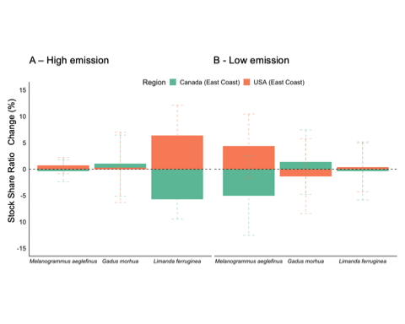

Figure 9.5: Changes in MCP stock-share ratio for Gulf of Maine under (A) high emission; and (B) low emission scenarios for mid 21st century (2041-2060) relative to present (2005-2014). Values represent the mean of 3 ESM; error bars represent ± sd.

## 9.4 Discussion

The results of the present chapter suggest that climate change will alter the MCP of jointly managed transboundary fish stocks in North America consequently altering Canada’s and the US’s stock’s stock-share ratio, regardless of the climate change scenario. These results are aligned with regional (Morley et al. 2018) projections suggesting that climate change will push marine species towards the poles and deeper water (Pinsky et al. 2013) in search of their ecological niche (Poloczanska et al. 2016). Moreover, IPHC data[6] suggest that some of these shifts are already happening. For example, since 2010, the distribution proportion of Pacific halibut has increased from 9% to 11% in region 2B, from 7.5% to 13% in region 2C, and from 12.3% to 13.5% in region 4CDE. On the other hand, regions 3A and 3B have seen the largest decreases in the IPHC regulatory areas since 2010, from 35.3% to 30.6% and 20.6% to 15.9%, respectively. Similarly, in the Gulf of Maine, the projected stock-share gain of yellowtail flounder and haddock by the US (Figure 9.5) follows a historical trend where in 2019, Canada’s stock-share decreased from 35% to 32% and 60% to 40% relative to 2010, respectively (Lake 2019).

Geographic barriers (Cheung et al. 2015, Kleisner et al. 2016), local temperature gradients (Pinsky et al. 2013), species interactions and human activities (Serpetti et al. 2017) might change the rate and direction of species shifts. For the IPHC, geographic barriers might induce a westward increase of stock-share in IPHC regions where the stock can only migrate northward into the Arctic Ocean through the Bering Sea and Bering Strait (Cheung et al. 2015) (Figure 9.3). In the Gulf of Maine, future projections could be a response to a temperature gradient shift combined with geographic barriers as southern waters are deeper and warming slower than northern waters according to the ESMs (Figure 11.13). Moreover, Maine has seen its landings of yellowtail flounder increase at the expenses of southern states (Pinsky and Fogarty 2012). This could be influencing the US gain in MCP in the GoMa in relation to Canada as stocks shift their distribution from lower latitudes naturally reaching the US (lower) region first. As the effects of climate change endure, even with high mitigation, joint plans should prepare to face changes in the stock-share ratio of transboundary stocks along both coast of North America.

The shifts in the distribution of transboundary stocks can jeopardize management objectives such as conservation measures and gear operation. Fish moving out of fishing grounds and into protected areas could result in a pressure increase to open such area to fishing. Moreover, overlapping shifting stocks could interfere in gear-limitation management rules of multiple fisheries generating conflicts between fleets (Van Der Voo 2016). The effectiveness of the IPHC-Closed Area (“CA” in Figure 9.2) in terms of protecting juveniles has been historically questioned as trawling for other species is still allowed in the area (Karim et al. 2010, IPHC 2017). In 2015, for example, 97% of the trawl by-catch in areas 4CDE and the Closed Area were juveniles (IPHC 2017). Consequently, the Alaskan trawl fisheries has been closed before reaching annual quota due to the attainment of Pacific halibut bycatch quota limits (Karim et al. 2010). Thus, the commission has been asked to open the closed area for Pacific halibut fishing, under the premise that the expansion of the trawl fishery is likely reducing any conservation goal for juvenile Pacific halibut (IPHC 2017). Although not assessed in this study, some trawling target species like Pacific cod (*Gadus macrocephalus*), flathead sole (*Hippoglossoides elassodon*), and Alaskan plaice (*Pleuronectes quadrituberculatus*) have already shifted their distributions due to warming waters (Stram and Evans 2009) and some are expected to continue shifting in similar direction as Pacific halibut (Pinsky et al. 2013). The overlap of target species could be addressed by applying ecosystem-based management and dynamic management tools (Hazen et al. 2018) to manage these fisheries and reduce potential loss of sustainable harvest for both the halibut and the trawl fisheries.

Quota allocation ruled by historic distributions will most likely be outdated incentivizing maladaptation (Miller et al. 2013, FAO 2018b, Gaines et al. 2018). In Europe, for example, the EU Common Fisheries Policy quota allocation is based on historic reference period of the 70’s (Harte et al. 2019). However, climate change has shifted the distribution of multiple European commercial stocks (Baudron et al. 2020), outdating the fixed quotas and thus compromising the sustainability of European fisheries (FAO 2018b, Baudron et al. 2020). Management regimes that include a dynamic harvest control (e.g., adjusting the quota based on the stocks distribution) have the potential of increasing fish biomass, harvest and profits under climate change (Gaines et al. 2018). In North America, poleward shifts of Pacific halibut along the coast of Oregon, Washington and British Columbia have been previously addressed by the IPHC resulting in the adoption of a dynamic quota allocation method (McCaughran and Hoag 1992). By allocating quotas based on yearly surveys along the Convention area, the IPHC should be able to capture shifts in Pacific halibut distribution due to climate change, reducing the chances of over exploitation of the stock due to these shifts (Miller et al. 2013). Similarly, for the Gulf of Maine, since the GoMa’s method to estimate quota allocation is weighted based on stocks distribution (90%) and historical catch (10%) (TRAC 2016). This process is especially important for cod and haddock due to their distribution variation within the Gulf (Soboil and Sutinen 2006, TRAC 2016). However, since 2010, when the weighted method was implemented, the quota allocation has favored the US over Canada, especially in terms of haddock and yellowtail flounder (Lake 2019). A perpetuation of this trend with no mitigation policy could jeopardize the arrangement as Canada’s quota reduction could disincentive cooperation (Sumaila et al. 2020). Previous international action suggests that shifts in transboundary fish stocks distributions for fisheries with relatively low catch or economic value could lead to international disputes in quota allocation. For example, Atlantic mackerel (*Scomber scombrus*) represents a small proportion of the total catch of the EU, Norway, and the Faroe Islands (Denmark) who share the stock. Yet, they have all been in dispute with Iceland over quota allocation and rights since the stock shifted in 2017 reaching Icelandic waters [@Spijkers:2017ij, Chapter 2]. Similarly, Peru has recently signed an agreement with Chile to manage the southern stock of Anchoveta (*Engraulis ringens*) which is substantially smaller than the northern Peruvian stock [@Cashion:2018cg; @UNDP:2016wp]. These examples highlight the need for adaptation of transboundary fisheries management to climate change for all a broad range of species in order to reduce the risk of international conflict and unsustainable fisheries development. Naturally, no strategy to mitigate climate change impacts will be beneficial if a fishery is exploited to extinction, however, reformulation of fisheries management could actually offset many of the negative effects of climate change [@Gaines:2018sg]. Thus, the impacts and solutions presented here need to be align with sustainable fisheries management.

Side payments have been previously used to address changes in stock’s distribution, including cases caused by environmental forcing. In game theory, a side payment is received by a player as a compensation from the other player in a shared resource agreement, with the premise that cooperation will result in a better overall outcome (Bjørndal and Munro 2012, Sumaila 2013). Side payments do not have to be in monetary form and are widely used in transboundary stocks around the world. For example, Norway and Russia have implemented a quota swap strategy for jointly managed stocks of cod, haddock and capelin (*Mallotus villosus*) in the Barents Sea (FAO 2020). Similarly, species’ quota swaps are allowed, up to a degree, within regulatory areas of the European union (Baudron et al. 2020). Specifically, for northern European spring spawning herring (*Clupea harengus*), Norway, Iceland, Faroe Islands, Russia and the EU reached an agreement to manage the stock after its collapsed, partially due to climate variations (Miller et al. 2013). Among the implemented rules, the agreement established a dynamic quota allocation, allowing members to fish part of their quota within Norway’s EEZ, and land the catch in Norwegian ports. In North America, Canada and the US have previous history with the utilization of side payments when in the 70’s Pacific salmon shifted its distribution resulting in large interceptions of Canada’s salmon by Alaskan fisheries (Miller et al. 2013, Song et al. 2017b). The conflict was resolved by the implementation of a conservation fund that worked as a side payment for both Canada and the state of Alaska (Miller et al. 2013, Song et al. 2017b). The potential adaptation of side payments in terms of quota swaps or allocating EEZ-fishing rights across the Gulf of Maine EEZs could be a potential solution as stocks shift due to climate change.

Transboundary fisheries management have to be prepared for the uncertainty that comes with a changing world. Future climate change will depend on the path society as a whole will take, and thus I rely on scenario planning to account for the uncertainty build in future decision making (Vuuren, Edmonds, et al. 2011). In these results, the “winners and losers” of climate change, and the intensity of the change, will be scenario dependent. For instance, stock-share of yellowtail flounder under a high emission scenario will be larger for the US while Canada’s gain of cod stock-share will be larger under a low emission scenario (Figure 9.5). Applying previously described strategies (e.g., quota swaps or EEZ-fishing rights) could increase the resilience of treaties by preventing members from leaving the agreement due to a shift in threat points, as happened in the Pacific salmon case (Miller et al. 2013).

Models are attempts to represent reality (in this case a future reality) based on observational data, previously established theory, and future scenarios, and are thus, subjected to different degrees of uncertainty (Payne et al. 2016). An ensemble of models is a way to present a more robust result that accounts for differences in the structural composition of each model (Cheung, Frölicher, et al. 2016). In here, I used three ESMs to project future changes in species maximum catch potential. The levels of uncertainty related to the ESMs differ among case studies. Overall, results for the Gulf of Maine agree with a reduction in MCP of all three stocks. However, some discrete areas show a positive change for yellowtail flounder by mid ${21}^{st}$ century (Figure 9.3), mainly driven by the GFDL model (Figure 11.14). Potential model artifacts could also be contributing to the results, especially in the northern part of the study area (Bay of Fundy) as most disagreeing grids are covered by land, which could be influencing the results. In contrast, considerable uncertainty exists in the change of MCP along the IPHC Convention area shown by a disagreement between ESMs (Figure 11.15). Off the coast of British Columbia, increasing temperature trends are consistent among ESMs, however, other processes such as acidification and deoxygenation are still not well understood from British Columbia to the Gulf of Alaska (Talloni-Álvarez et al. 2019). Moreover, considerable uncertainty exists along the Bering Sea (Douglas 2010) and Antarctic Pacific regarding the extent and intensity of future sea-ice reduction under climate change (Steiner et al. 2015, IPCC 2019). Regarding the DBEM, its structural uncertainty has been previously tested for agreement against commonly used species distribution algorithms such as Maxent (Phillips et al. 2006) and AquaMaps (Ready et al. 2010, Kaschner et al. 2011) resulting in no qualitative differences in trends between algorithms (Cheung, Jones, Reygondeau, et al. 2016). Finally, is worth mentioning that future changes to species distributions could be influenced by factors not captured by my model such as interactions between species (Pecl et al. 2017), adaptation of species to environmental changes, and anthropogenic factors (Serpetti et al. 2017). However, these factors are expected to increase the rate of range-shifting of the species making my results conservative (Cheung et al. 2010, Serpetti et al. 2017).

## 9.5 Conclusions

Shifts in stocks distribution due to climate change have the potential of creating local extinction of economically important stocks while enhancing fisheries in areas where they were not present before. In this chapter, I have explored the potential impacts of climate change in the joint management of selected transboundary stocks managed by Canada and the US. I found that, transboundary stocks are likely to shift in the upcoming years changing the proportion of the catch of jointly managed fisheries of Canada and the US. Lessons from other countries can provide solutions to such challenges. More specific, side payments, dynamic management, and interchangeable quotas were identified as potential solutions for North American region. While not directly addressed in this chapter, socio-economic impacts of shifting transboundary stocks could add an extra layer of complexity to the problem. Addressing shifts in stocks distribution sooner rather than latter could avert the so called “fish wars”, improve sustainability of jointly managed stocks, and secure the livelihood of thousands of families that depend on stocks that move freely between national jurisdictions. Finally, preparing for an uncertain future is key to achieve sustainable fisheries.

# 10 Synthesis and Conclusion

## 10.1 Synthesis and Conclusion

In this dissertation, I endeavored to understand the impacts of climate change on transboundary fish stocks and their fisheries, with the objective of informing international fisheries management to prepare and respond to species on the move. Specifically, my dissertation focused on fish stocks that are shared between neighbouring Exclusive Economic Zones (EEZs). Managing such fish stocks often present a unique set of challenges for international fisheries management compared to other types of transboundary fisheries (Chapter 1). In this chapter, I synthesize the main findings from Chapters 2, 3, and 4, and provide a critical reflection on the importance of these findings and their uncertainties. Based on these findings, I identify a set of strategies for international fisheries management to cope with the changing climate. Finally, I propose some future research directions regarding climate change impacts on the management of transboundary marine stocks.

### 10.1.1 Research contributions

Substantial uncertainty exists in the number of transboundary species since the delineation of EEZs by UNCLOS in the early 1980s (United Nations 1986, Miller and Munro 2002). Previous estimates range from 1500 stocks based on an informed guess (Caddy 1997), to 344 taxa based on a literature review (Teh and Sumaila 2015). Thus, to understand the impacts of climate change on transboundary fish stocks, I first determined what exploited marine fished species are actually transboundary, and more specifically, those that are shared by neighboring EEZs. In Chapter 2, I developed a methodology and collated and analyzed global ecological and fisheries data sets to provide a more robust estimate of the number of transboundary species that is based on available information on the biogeography and fisheries of exploited marine species. Such analysis identified a substantially higher number of global transboundary species compared to previous studies and suggested that we may have previously underestimated the importance of transboundary species to global fisheries catch and revenue. The updated estimates of the number of transboundary species and their importance in global and regional fisheries will contribute to the foundational knowledge for discussing fisheries management policies to achieve ocean sustainability under climate change.

While substantial attention has been placed over the impacts of shifting stocks distributions to the management of marine resources (Pinsky et al. 2018, Oremus et al. 2020), many questions remain unanswered regarding the risks of impacts of shifting transboundary stocks on their fisheries and the effectiveness of their management under climate change. In Chapter 3, I explored two specific aspects of the risks of impacts of shifting transboundary stocks: (1) the changes in the sharing of transboundary stocks between countries and (2) the time frame and intensity in which such changes will occur. These aspects of shifting transboundary stocks can help understand the challenges that climate change will bring to the management of transboundary fisheries (Link et al. 2010, Gaines et al. 2018). I applied integrated climate-ocean-fish stock models and analyzed the model outputs through the lens of game theory in economics. I found that virtually all EEZs would experience at least one transboundary stock emerging by 2006 relative to the historical distribution (1951 - 2005). Consequently, the sharing proportion of several stocks have already shifted in at least one EEZ border. Moreover, the results highlight the high risk of impacts of climate change on transboundary management of the highly productive and economically important fisheries in small tropical EEZs. The results from this chapter can support international fisheries management anticipate the social-ecological consequences of shifting transboundary stocks and better prepare ocean governance in the face of climate change.

The risk of impacts of climate change on the management of transboundary fisheries will depend on the existing policies and specific international treaties (Pinsky and Mantua 2014, Chapter 3). Policies and treaties on transboundary fish stocks that lack a proper framework to address the consequences of shifting distributions of the fisheries resources can lead to international dispute and conflict, and drive unsustainable fishing activities (Miller et al. 2013, Song et al. 2017b, Spijkers and Boonstra 2017, Sumaila et al. 2020). In Chapter 4, I studied specifically two bi-lateral fisheries agreements between Canada and the United States: The International Pacific Halibut Commission that manages Pacific halibut (*Hippoglossus stenolepis*) and a resource sharing arrangement in the Gulf of Maine for cod (*Gadus morhua*), haddock (*Melanogrammus aeglefinus*) and yellowtail flounder (*Limanda ferruginea*). First, I examined the projected changes in relative sharing of these fish stocks under climate change (through the calculated stock share ratio described in Chapter 4). Second, I assessed the potential management consequences of the shifts in stock sharing. Finally, I explored examples of international fisheries governance that could potentially work in each of these two case study fisheries agreements. I showed that by 2050, the proportions of the catch of some of the jointly managed fisheries between Canada and the US are likely to change. Specifically, by 2050 Pacific halibut is expected to have moved poleward along the northeast Pacific coast and westward from the Gulf of Alaska to the Aleutian Islands and up to the Bering Sea under RCP 8.5. In the Gulf of Maine, climate change is expected to overall reduce the catch potential of cod, haddock and yellowtail flounder by 2050, regardless of the RCP. Here, changes in the stock share ratio will have different outcomes dependent on the climate change scenario and stock in question. For example, RCP 8.5 will affect Canada’s share of yellowtail flounder and haddock and increase cod share. From an ecological perspective, some frameworks seem to be more resilient to changes in fish stocks than others (i.e., quota is allocated following yearly samples and areas are closed to fishing). I identified that dynamic management that compensates fisheries in States with decreasing share of fish stocks through direct payment and/or interchangeable quotas are amongst the potential solutions for the adaptation of transboundary fisheries management under climate change in the North American region.

### 10.1.2 Strategies for transboundary fisheries management under climate change

Based on the findings from this dissertation, I have identified a set of potential solutions to address the impacts of shifts in transboundary stocks distributions on their management under climate change. Overall, all of the identified solution options for international fisheries management will require cooperation between neighboring nations to generate adaptive, collaborative and equitable management strategies to address the uncertainties of a changing world (Link et al. 2010, Miller et al. 2013, Pinsky et al. 2018, Oremus et al. 2020). As I show below, dealing with shifting transboundary stocks to adjacent areas can be summarized in three main steps: (1) determine if distribution shifts of transboundary stock have occurred, (2) gather sufficient data on the stock’s distribution and abundance, and (3) implement fisheries management that is adaptive to changing stocks, such as dynamic quota allocation and harvest controls (Link et al. 2010, Miller et al. 2013, Twiname et al. 2020).

#### 10.1.2.1 Determining distributional shifts

Detecting distribution shifts of transboundary stocks requires monitoring of the populations, the environmental conditions of their habitats, and the fisheries that are exploiting these stocks (Link et al. 2010, Twiname et al. 2020). A multi-disciplinary and multi-institutional monitoring program is needed to gather data information on the biophysical, social-economic and governance aspects of transboundary fisheries (Bonebrake et al. 2017).

Approaches to identify shifts in distributions of transboundary stocks include fisheries- independent and dependent surveys, citizen science, and monitoring of fishing activities. Fisheries-independent scientific surveys of fish stocks such as those undertaken by the IPHC are standardized and allow researchers to gather specific biological and oceanic information (IPHC 2019, Chapter 4). Moreover, scientific monitoring programs can help detect shifts in stocks biogeography, such as identifying range expansion of stocks to new areas (Fogarty et al. 2017). However, scientific surveys are often expensive (e.g., the IPHC survey costs about USD $4 million annually), limiting the temporal and spatial coverage of such surveys. Many regions or countries also do not have the financial and technical capacity to undertake regular fisheries-independent scientific monitoring programs. In contrast, catch data analyses have been used to analyze shifting stocks among global EEZs as well as European regulatory areas (Cheung et al. 2013, Baudron et al. 2020). Catch-data analyses are cheaper and provide longer time series and broader geographic range (e.g., FAO official catch statistics start in 1951 and include most coastal nations). However, the quality of catch data is affected by biases from the reporting methods, lack of specific geographic information and are dependent on fishing activities (Pauly et al. 2013, Zeller et al. 2016).

Other methods of monitoring through interviews and “citizen science” can also provide information on shifting transboundary stocks. For example, in the East coast of the US, fishers have manifested the need to travel further into other States waters to “chase the fish” providing valuable information on shifts in stocks distribution by collecting information about fishing activities (Pinsky and Fogarty 2012). Moreover, in Australia, data collected by citizen science has been used in species distribution models to quantify range shifts (Champion et al. 2018). Engaging in community-based monitoring such as citizen science, partnering up with fishing industries, and considering other disciplines as well as incorporating local ecological knowledge can provide valuable information to validate models and identify distributional shifts in transboundary fish stocks.

#### 10.1.2.2 Sharing data for resilient treaties

Having reliable, standardized, stock-level data is crucial to achieve sustainable fisheries management (Hilborn and Ovando 2014). Particularly, transboundary fish stocks management requires countries to monitor and share data about the fish stocks (Miller et al. 2013, Pinsky et al. 2018). The effectiveness of such data sharing will be facilitated by protocols to standardize data collection and processing across EEZs. However, gaps in knowledge and capacity in monitoring fish stocks and fisheries between countries may pose barriers for the harmonization of data collection across countries. Such barriers are particularly apparent in the case of transboundary fish stocks shared between countries with different capacity e.g., Pacific sardine between Mexico and the US (Cisneros-Montemayor et al. 2020). Fostering more equitable international treaties that include support for capacity building and knowledge transfers between countries can help reduce such barriers in data sharing. Examples of international cooperation on knowledge and data transfer include regular international meetings such as the Mexico - US “Mexus” meetings (NOAA 2018) and collaboration in the collection and sharing of data between neighboring countries such as the case between Canada and the US in the Gulf of Maine (Miller et al. 2013, Chapter 4)

### 10.1.3 Adaptation of joint management to shifting stocks

Cooperation in the management of transboundary fish stocks is most likely to improve its effectiveness in achieving sustainable outcomes (Bailey et al. 2010, Sumaila 2013). However, the management of shared stocks requires countries to coordinate data collection, management actions, align conservation and extraction policies, and effectively implement the agreed policies (Bailey et al. 2010, Sumaila 2013). However, a recent analysis looking at total biomass over biomass required at maximum sustainable yield suggests that transboundary stocks are in worse shape than stocks that are only exploited in one EEZ (Liu and Molina n.d.). Climate change-induced stock distribution shifts will add additional challenge to the management of shared marine stocks (Chapters 2 and 3). Currently, most international treaties on transboundary fisheries management lack the mechanism to account for the shifts in stocks’ distributions and the associated responses by the fisheries (Oremus et al. 2020, Sumby et al. 2021). Creating alternative mechanisms that compensate one country by the other when shared stocks shift can motivate collaboration and improve the adaptability and resilience of current treaties (Miller et al. 2013, Gaines et al. 2018, Pinsky et al. 2018, Oremus et al. 2020).

Fisheries management need to be more dynamic in nature to accommodate the increased uncertainties associated with the futures of fish stocks and fisheries under climate change (Frölicher et al. 2016) and be flexible enough to reduce the chance of causing international disputes caused by disagreement in managing fish stocks that are shifting their distributions (Miller et al. 2013, Song et al. 2017b, Spijkers and Boonstra 2017). Dynamic management is defined by Maxwell *et al.* (2015) as “management that changes rapidly in space and time in response to the shifting nature of the ocean and its users based on the integration of new biological, oceanographic, social and/or economic data in near real-time.” Some examples of dynamic management identified along this dissertation include yearly estimations of quota allocation, exchangeable quotas, MPAs with moving boundaries and changes in fishing areas (Chapters 3 and 4).

Quota allocation of shared stocks based on a fix-historical proportion like the case of the EU will be outdated as species shift their distribution (Baudron et al. 2020). On the contrary, allocation strategies based on periodical estimations of stock distribution such as that of the IPHC for Pacific halibut (IPHC 2018) or a mix of historical and current distributions like in the Gulf of Maine (Chapter 4), should be able to adapt to shifts in stocks distributions. Similarly, cases like that of Norway and Russia in the Barents Sea where a portfolio of stocks (and quota) can be exchangeable provide a way to deal with shifts in the distribution of shared stocks (FAO 2020). Marine Protected Areas are among the most popular tools in marine spatial management (Song et al. 2017a). However, their design mostly consists in fixed borders that ignore the stock’s biogeography nor shifts (Fredston-Hermann et al. 2018, Cashion et al. 2020). Solutions to this problem include the incorporation of dynamic protected areas like the fishing refuges in Mexico (Refugio Pesquero) where specific areas are temporary banned to fishing (e.g., 1 to 5 years) with the possibility of further expansion, re-location, and changes in protection level (Pescando Datos 2020). Different designs of MPAs like mobile, networks (Cashion et al. 2020), and transboundary (Molina and Costello 2020) have also been identified as potential solutions for shifting stocks, and consequently, transboundary stocks management. However, more empirical evidence is needed to understand the potential of these tools (Fredston-Hermann et al. 2018, Cashion et al. 2020). Other strategies of dynamic ocean management potentially applicable to transboundary stocks include programs that use real time (i.e., satellite) data tracking and align them with management, stock movement, and fisheries to aid in bycatch reduction (Howell et al. 2008, Hobday et al. 2010, Maxwell et al. 2015, Hazen et al. 2018).

In addition to dynamic management, current agreements will need to become (more) resilient to the consequence of climate change to avoid discontinuity (Miller et al. 2013). Setting the framework to include compensation methods (e.g., side payments) for when stocks shift between EEZs is one way to prepare for the uncertainty of the effects of climate change to stock’s distributions (Miller et al. 2013, Sumaila et al. 2020). Moreover, including criteria for newcomers to the fishery when the stock expands to new areas can also reduce the potential of conflict and undesired harvest levels (Pinsky et al. 2018). While new and existing agreements will need to be adaptable, so that fisheries management can anticipate potential issues caused by shifting stocks or be more effective in dealing with disagreement between resource users.

### 10.1.4 Limitations and uncertainties

Overall, this dissertation relies on global databases, climate change and species distributions projections, and climate change scenarios. These aspects contribute to the main sources of uncertainties associated with the analysis. In this section I describe the uncertainties related to these aspects while providing the general approach taken to address them.

#### 10.1.4.1 Data and scale uncertainty

This dissertation uses data from diverse sources that have different inherent uncertainties and biases. Particularly, fisheries reconstructed catch data from the Sea Around Us and the ex-vessel price data form Tai et al. (2017) relies on several assumptions creating uncertainties in the estimations (Zeller et al. 2016, Tai et al. 2017, Pauly and Zeller 2019). Regarding the Sea Around Us Catch database, while reconstructions address negative bias in reported catch, the estimation of such non-reported catch implies some level of uncertainty (Pauly and Zeller 2019). For example, when data is not available for a year or a whole EEZ, the catch reconstruction method will extrapolate from previous years or estimates from parts of the EEZ. While this is not ideal, the method parts from the principle that “a best estimate is better than zero” when a fishery is known to exist (Pauly and Zeller 2019). Similarly, price estimates are assigned by species within a country and when not available, similar species or neighbouring countries. Thus, it is not ideal to use this database for specific stocks, but rather large-scale regional and global analyses as I do in Chapters 2 and 3 (Tai et al. 2017).

In total, I analyzed 938 marine species with different habitat preference and life history. Despite all of these species being marine, some of them are considered anadromus, that is, species like salmons (*Oncorhynchus sp.*) that spawn in fresh water (e.g., rivers) but spend most of their adult life in the ocean. In these cases, the models I used captured the oceanic life stage of the species but not the freshwater component. A recent study looking at climate change impacts on Chinook salmon (*Oncorhynchus tshawytscha*) at all life stages found that the freshwater stages of Chinook salmon is relatively resilient to climate change while large climate impacts are found in its marine stage (Crozier et al., 2021). Thus, for some of the anadromous species, while my study did not consider the freshwater stage of these species, my results have captured the marine life stage where large climate impacts are expected to happen and where these impacts challenge transboundary management (Crozier et al., 2021, Miller et al. 2013, Song et al. 2017b).

In this dissertation I define a “fish stock” as a species within an EEZ (e.g., meta-population). Thus, I am not able to identify characteristics of transboundary stocks at finer resolutions (e.g., within an EEZ a species could have multiple stocks with only a subset of them transboundary; Chapter 2). This is important since management decisions based on conclusions from meta-populations could be erroneous as they could be ignoring key characteristics of sub-populations (Archambault et al. 2016, Kaplan et al. 2016). This resolution affects mainly Chapters 2 and 3. Results from these chapters should be taken as a guidance to the potential impacts of climate change to transboundary fisheries management. More detailed research (e.g., at sub-stock level) will allow for less uncertain results better suited for management plans (See Future directions).

#### 10.1.4.2 Modeling uncertainty

This dissertation integrates different modeling techniques to project species distributions under climate change. Models are representations of the reality that are based on available information and knowledge about the subject that the models represent. Therefore, models are subjected to uncertainties associated with assumptions, structure and data. My dissertation employed species distribution models (SDMs) as a main analytic tool. SDMs are numerical ways to determine associations between species geographic distributions and the environment, as well as the relationship of such association (Peterson et al. 2012). Uncertainties associated with marine SDMs have been previously studied (Araújo and Guisan 2006, Beale and Lennon 2012) with some of them specific to their applications to study the impacts of climate change on species’ biogeography (Araújo and Luoto 2007, Wiens et al. 2009, Goberville et al. 2015, Heikkinen et al. 2016). The uncertainties associated with SDMs that are particularly relevant to this dissertation include: the lack of or insufficient representation of the effects of species interactions (Pecl et al. 2017), evolutionary and/or epigenetic adaptation to environmental change, and other non-climatic anthropocentric factors (Serpetti et al. 2017).

My dissertation’s findings are also affected by uncertainties associated with the climate change projections from Earth system models. These uncertainties can be categorized into three main sources: *i*) model structure, *ii*) internal climate variability, and *iii*) different carbon emission scenarios (Hawkins and Sutton 2012, Frölicher et al. 2016).

(*i*) Model uncertainty is produced by the different ways models address fundamental environmental processes, in this case, regardless of the radiative forcing (Bopp et al. 2013, Frölicher et al. 2016). As a result, different models can have divergent projections for a determined environmental variable (Chapter 4). Model uncertainty is examined in Chapters 2 and 4 by using projections from three ESMs.

(*ii*) Internal climate variability refers to the natural climate variation embedded in the Earth climate system (e.g., without considering radiative forcing). Such variation is mainly produced by large-scale events like El Niño-Southern Oscillation or the Atlantic Multidecal and Pacific Decadal Oscillations, although small-scale processes are also included (Frölicher et al. 2016). In ESMs, climate variability is addressed by running multiple ensemble members, each one representing an initial condition of the Earth system (Frölicher et al. 2009, Rodgers et al. 2015). Thus, the ESMs used in Chapters 2 and 4 represent the average of each ESM ensemble members. However, for Chapter 3 I used ten ensemble members of the GFDL ESM (i.e., ten runs of the same ESM). This allowed me to identify the climate change signal within the internal climate variability (See Chapter 3 Methods - Projecting species distributions under climate change).

(*iii*) Carbon emission scenarios represent the future pathways society can take in mitigating greenhouse gas emissions considering unknown technological and social factors (Frölicher et al. 2016). These are commonly known as RCPs used by the IPCC to represent distinct potential futures of radiative forcing (Gattuso et al. 2015, IPCC 2019). The RCPs considered by the IPCC range from a “strong climate mitigation” (RCP 2.6) scenario to a “no mitigation” (RCP 8.5) scenario where society mainly relaxes greenhouse gases mitigation policies (See Introduction). In Chapter 4, I base my results on RCP 2.6 and RCP 8.5 capturing the main spectrum of future pathways currently considered by the IPCC. In Chapter 3, I only use outputs for RCP 8.5 scenario meaning that my results represent a “worst case” future scenario under climate change and that, any mitigation effort could reduce the intensity of the results.

### 10.1.5 Future directions

I have identified neighbouring countries managing shared stocks (e.g., Norway and Iceland) with some cases of addressing environmental-driven shifts in species distributions (e.g., Canada and the U.S.). However, there is no complete database of management plans for shared stocks. Oremus *et. al.* (2020) developed a database of international treaties capturing 127 agreements in tropical waters. Building on the effort by Oremus et al. (2020), expanding the database to non-tropical regions while including key information such as managed species, the countries included in the treaty as well as the management rules placed could help answer key questions regarding the management of transboundary fisheries. Some of these key questions include the status of the stocks and its relationship to differences in level of cooperation in managing shared stocks between States, and the extent to which existing management plans are resilient to climate change resilience. This will allow us to have a better understanding of the current state of transboundary stocks and what management tools are potentially effective to address changes in stock distributions under climate change.

More work is needed to understand the effectiveness of dynamic management of transboundary stocks under climate change. Dynamic tools have been proved to be useful in the management of mobile marine resources (Maxwell et al. 2015) and have been identified as a potential strategy for shifting distributions of shared stocks (Gaines et al. 2018, Pinsky et al. 2018, Oremus et al. 2020). However, most dynamic tools are yet to be tested under a climate change and transboundary fisheries framework, remaining as hypothetical solutions. Further development of models testing the functionality of different dynamic tools under climate change (Cashion et al. 2020) while also considering the nuisances of managing shared marine resources (Molina and Costello 2020) could provide substantial advance to international ocean governance. Such research must be conducted under a multi-disciplinary framework to identify important trade-offs between the diverse set of societal values that social-ecological systems have.

Further analyses should try to consider, when possible, spatially explicit biologically meaningful population units to inform local management. This is of specific concern for regions of the world where fisheries data is lacking like most fisheries in developing countries and many in developed countries. This dissertation considers a species within an EEZ as a stock, ignoring that discrete populations within a meta-population can have fundamental differences to management frameworks (See Limitations and uncertainties - Data and scale uncertainty). Reproducing the experiments that I conducted here considering biologically meaningful population units within neighbouring EEZs will likely provide managers with more confident results to base decisions. Such analysis, however, will require a set of local-scale baseline information, from population biology, to climate modeling, to economics of fishing, which are often missing. The further development of baseline scientific information at the local level can be supported by model-downscaling (e.g., the reduction of models’ spatial resolution), and by including other sources of information such as citizen science (Aceves-Bueno et al. 2015), or multiple-source frameworks (Zeller et al. 2016).

### 10.1.6 Final remarks

The last eight months of this dissertation (and its formal defense) were written under a strict social-distancing and sometimes quarantine regime because of the 2020 COVID-19 pandemic. In many instances, the way to combat the COVID-19 pandemic is similar to that of climate change. To address both issues, we need global unification, science-based decision making, reduction of world inequality, and a global solidarization, specially of those more privilege with the most in need. The United Nations proclaimed that the next decade (2021-2030) will be focused on improving Ocean Science for Sustainable Development. Thus, we, as a global society, have the opportunity (and responsibility) to take action and improve fisheries management in the face of a changing climate. While the future is full of uncertainties, it is certain that the sustainability of transboundary fisheries in a changing world will only be achieved by following a multidisciplinary approach where concepts of ecology, conservation, economics, and social science are integrated and multiple societal values for nature are taken into consideration. Only then we will be able to achieve more equitable agreements, that benefit society as whole, rather than specific groups.

# 11 References

Aceves-Bueno, E., Adeleye, A. S., Bradley, D., Brandt, W. T., Callery, P., Feraud, M., Garner, K. L., Gentry, R., Huang, Y., Mccullough, I., Pearlman, I., Sutherland, S. A., Wilkinson, W., Yang, Y., Zink, T., Anderson, S. E., and Tague, C., 2015. Citizen Science as an Approach for Overcoming Insufficient Monitoring and Inadequate Stakeholder Buy-in in Adaptive Management: Criteria and Evidence. *Ecosystems*, 18 (3), 493–506.

Aqorau, T., Bell, J., and Kittinger, J. N., 2018. Good governance for migratory species. *Science*, 361 (6408), 1208–1209.

Araújo, M. B. and Guisan, A., 2006. Five (or so) challenges for species distribution modelling. *Journal of Biogeography*, 33 (10), 1677–1688.

Araújo, M. B. and Luoto, M., 2007. The importance of biotic interactions for modelling species distributions under climate change. *Global Ecology and Biogeography*, 16 (6), 743–753.

Archambault, B., Le Pape, O., Baulier, L., Vermard, Y., Véron, M., and Rivot, E., 2016. Adult-mediated connectivity affects inferences on population dynamics and stock assessment of nursery-dependent fish populations. *Journal of Environmental Economics and Management*, 181, 198–213.

Asch, R. G., Cheung, W. W. L., and Reygondeau, G., 2018. Future marine ecosystem drivers, biodiversity, and fisheries maximum catch potential in Pacific Island countries and territories under climate change. *Marine Policy*, 88, 285–294.

Audzijonyte, A., Richards, S. A., Stuart-Smith, R. D., Pecl, G., Edgar, G. J., Barrett, N. S., Payne, N., and Blanchard, J. L., 2020. Fish body sizes change with temperature but not all species shrink with warming. *Nature Ecology & Evolution*, 1–11.

Auguie, B., 2017. Package gridExtra; Miscellaneous Functions for "Grid" Graphics, R (3.5.0).

Bailey, M., Sumaila, U. R., and Lindroos, M., 2010. Application of game theory to fisheries over three decades. *Journal of Environmental Economics and Management*, 102 (1-2), 1–8.

Barange, M., Merino, G., Blanchard, J. L., Scholtens, J., Harle, J., Allison, E. H., Allen, J. I., Holt, J., and Jennings, S., 2014. Impacts of climate change on marine ecosystem production in societies dependent on fisheries. *Nature Climate Change*, 4 (3), 211–216.

Baudron, A. R., Brunel, T., Blanchet, M. A., Hidalgo, M., Chust, G., Brown, E. J., Kleisner, K. M., Millar, C., MacKenzie, B. R., Nikolioudakis, N., Fernandes, J. A., and Fernandes, P. G., 2020. Changing fish distributions challenge the effective management of European fisheries. *Ecography*, 43, 1.

Beale, C. M. and Lennon, J. J., 2012. Incorporating uncertainty in predictive species distribution modelling. *Philosophical Transactions of the Royal Society of London B: Biological Sciences*, 367 (1586), 247–258.

Beaugrand, G., Lenoir, S., Ibanez, F., and Manté, C., 2011. A new model to assess the probability of occurrence of a species, based on presence-only data. *Marine Ecology Progress Series*, 424, 175–190.

Bell, J. D., Cisneros-Montemayor, A. M., Hanich, Q., Johnson, J. E., Lehodey, P., Moore, B. R., Pratchett, M. S., Reygondeau, G., Senina, I., Virdin, J., and Wabnitz, C. C. C., 2017. Adaptations to maintain the contributions of small-scale fisheries to food security in the Pacific Islands. *Marine Policy*, 88, 1–12.

Bengtsson, H., Jacobson, A., and Riedy, J., 2018. Package R.matlab: Read and Write MAT Files and Call MATLAB from Within R, R ( $≥$ 2.14.0)

Bjørndal, T. and Munro, G., 2012. *The economics and management of world fisheries*. 1st ed. Oxford University Press.

Boettiger, C., Chamberlain, S., Lang, D. T., and Wainwright, P., 2019. Package rfishbase; R Interface to ’FishBase’, R (>= 3.0).

Bonebrake, T. C., Brown, C. J., Bell, J. D., Blanchard, J. L., Chauvenet, A., Champion, C., Chen, I.-C., Clark, T. D., Colwell, R. K., Danielsen, F., Dell, A. I., Donelson, J. M., Evengård, B., Ferrier, S., Frusher, S., Garcia, R. A., Griffis, R. B., Hobday, A. J., Jarzyna, M. A., Lee, E., Lenoir, J., Linnetved, H., Martin, V. Y., McCormack, P. C., McDonald, J., McDonald-Madden, E., Mitchell, N., Mustonen, T., Pandolfi, J. M., Pettorelli, N., Possingham, H., Pulsifer, P., Reynolds, M., Scheffers, B. R., Sorte, C. J. B., Strugnell, J. M., Tuanmu, M.-N., Twiname, S., Vergés, A., Villanueva, C., Wapstra, E., Wernberg, T., and Pecl, G. T., 2017. Managing consequences of climate-driven species redistribution requires integration of ecology, conservation and social science. *Biological Reviews*, 93 (1), 284–305.

Bopp, L., Resplandy, L., Orr, J. C., Doney, S. C., Dunne, J. P., Gehlen, M., Halloran, P., Heinze, C., Ilyina, T., Séférian, R., Tjiputra, J., and Vichi, M., 2013. Multiple stressors of ocean ecosystems in the 21st century: projections with CMIP5 models. *Biogeosciences*, 10 (10), 6225–6245.

Branch, T. A., 2008. Not all fisheries will be collapsed in 2048. *Marine Policy*, 32 (1), 38–39.

Bryndum-Buchholz, A., Tittensor, D. P., Blanchard, J. L., Cheung, W. W. L., Coll, M., Galbraith, E. D., Jennings, S., Maury, O., and Lotze, H. K., 2019. Twenty-first-century climate change impacts on marine animal biomass and ecosystem structure across ocean basins. *Global Change Biology*, 25 (2), 459–472.

Burden, M. and Fujita, R., 2019. Better fisheries management can help reduce conflict, improve food security, and increase economic productivity in the face of climate change. *Marine Policy*, 108, 103610.

Cabral, R. B. and Geronimo, R. C., 2018. How important are coral reefs to food security in the Philippines? Diving deeper than national aggregates and averages. *Marine Policy*, 91, 136–141.

Caddy, J., 1997. Establishing a consultative mechanism or arrangement for managing shared stocks within the jurisdiction of contiguous states. *In*: Hancock, D. A., ed. *Taking stock defining and managing shared resources*. Darwin: Australian Society for Fish Biology, 80–123.

Cashion, T., Nguyen, T., Brink, T. ten, Mook, A., Palacios-Abrantes, J., and Roberts, S. M., 2020. Shifting seas, shifting boundaries: Dynamic marine protected area designs for a changing climate. *PLoS ONE*, 15 (11), e0241771.

Cashion, T., Puente, S. de la, Belhabib, D., Pauly, D., Zeller, D., and Sumaila, U. R., 2018. Establishing company level fishing revenue and profit losses from fisheries: A bottom-up approach. *journals.plos.org*, 13 (11), e0207768.

Chambers, J. M., Freeny, A. E., and Heiberger, R. M., 1992. Analysis of Variance; Designed Experiments. *In*: Chambers, J. M. and Hastie, T. J., eds. *Statistical models in s*. Routledge, 145–193.

Champion, C., Hobday, A. J., Tracey, S. R., and Pecl, G. T., 2018. Rapid shifts in distribution and high-latitude persistence of oceanographic habitat revealed using citizen science data from a climate change hotspot. *Global Change Biology*, 24 (11), 5440–5453.

Chavez, F. P., Ryan, J., Lluch-Cota, S. E., and Niquen C, M., 2003. From anchovies to sardines and back: multidecadal change in the Pacific Ocean. *Science*, 299 (5604), 217–221.

Cheung, W. W. L., 2018. The future of fishes and fisheries in the changing oceans. *Journal of Fish Biology*, 92 (3), 790–803.

Cheung, W. W. L., Brodeur, R. D., Okey, T. A., and Pauly, D., 2015. Projecting future changes in distributions of pelagic fish species of Northeast Pacific shelf seas. *Progress in Oceanography*, 130 (C), 19–31.

Cheung, W. W. L. and Frölicher, T. L., 2020. Marine heatwaves exacerbate climate change impacts for fisheries in the northeast Pacific. *Scientific Reports*, 10 (1), 1–10.

Cheung, W. W. L., Frölicher, T. L., Asch, R. G., Jones, M. C., Pinsky, M. L., Reygondeau, G., Rodgers, K. B., Rykaczewski, R. R., Sarmiento, J. L., Stock, C., and Watson, J. R., 2016. Building confidence in projections of the responses of living marine resources to climate change. *ICES Journal of Marine Science*, 73 (5), 1283–1296.

Cheung, W. W. L., Jones, M. C., Lam, V. W. Y., D Miller, D., Ota, Y., Teh, L., and Sumaila, U. R., 2016. Transform high seas management to build climate resilience in marine seafood supply. *Fish and Fisheries*, 18 (2), 254–263.

Cheung, W. W. L., Jones, M. C., Reygondeau, G., and Frölicher, T. L., 2018. Opportunities for climate-risk reduction through effective fisheries management. *Global Change Biology*, 24 (11), 5149–5163.

Cheung, W. W. L., Jones, M. C., Reygondeau, G., Stock, C. A., Lam, V. W. Y., and Frölicher, T. L., 2016. Structural uncertainty in projecting global fisheries catches under climate change. *Ecological Modelling*, 325, 57–66.

Cheung, W. W. L., Lam, V. W., and Sarmiento, J. L., 2010. Large-scale redistribution of maximum fisheries catch potential in the global ocean under climate change. *Global Change Biology*, 16, 24–35.

Cheung, W. W. L., Reygondeau, G., and Frölicher, T. L., 2016. Large benefits to marine fisheries of meeting the 1.5 C global warming target. *Science*, 354 (6319), 1591–1594.

Cheung, W. W. L., Sarmiento, J. L., Dunne, J., Frölicher, T. L., Lam, V. W. Y., Palomares, M. D., Watson, R., and Pauly, D., 2012. Shrinking of fishes exacerbates impacts of global ocean changes on marine ecosystems. *Nature Climate Change*, 3 (3), 254–258.

Cheung, W. W. L., Watson, R., and Pauly, D., 2013. Signature of ocean warming in global fisheries catch. *Nature*, 497 (7449), 365–369.

Christiansen, J. S., Mecklenburg, C. W., and Karamushko, O. V., 2014. Arctic marine fishes and their fisheries in light of global change. *Global Change Biology*, 20 (2), 352–359.

CIA, 2017. The US-Canadian Dispute Over the Georges Bank, 1–10.

Cisneros-Montemayor, A. M., Ishimura, G., Munro, G. R., and Sumaila, U. R., 2020. Ecosystem-based management can contribute to cooperation in transboundary fisheries: The case of pacific sardine. *Journal of Environmental Economics and Management*, 221, 105401.

Cisneros-Montemayor, A. M., Pauly, D., Weatherdon, L. V., and Ota, Y., 2016. A Global Estimate of Seafood Consumption by Coastal Indigenous Peoples. *PLoS ONE*, 11 (12), e0166681.

Clark, C. W., 1980. Restricted Access to Common-Property Fishery Resources: A Game-Theoretic Analysis. *In*: *Dynamic optimization and mathematical economics*. Boston, MA: Springer, Boston, MA, 117–132.

Clarke, T. M., Reygondeau, G., Wabnitz, C., Robertson, R., Ixquiac Cabrera, M., López, M., Ramı'rez Coghi, A. R., Rı'o Iglesias, J. L. del, Wehrtmann, I., and Cheung, W. W. L., 2020. Climate change impacts on living marine resources in the Eastern Tropical Pacific. *Diversity and Distributions*, 5 (3), 56.

Close, C., Cheung, W. W. L., Hodgson, S., Lam, V., Watson, R., and Pauly, D., 2006. Distribution ranges of commercial fishes and invertebrates. *In*: Palomares, M. D., Stergiou, K. I., and Pauly, D., eds. *Fisheries centre research reports. Fishes in databases and ecosystems*. 27–37.

Cullis-Suzuki, S. and Pauly, D., 2010. Failing the high seas: A global evaluation of regional fisheries management organizations. *Marine Policy*, 34 (5), 1036–1042.

De Queiroz, G., Hvitfeldt, E., Keyes, O., Misra, K., Mastny, T., Erickson, J., Robinson, D., and Silge, J., 2019. Package tidytext; Text Mining using ’dplyr’, ’ggplot2’, and Other Tidy Tools, R ( $≥$ 2.10), MIT.

Diario Oficial de la Federación (DOF), 2018. Carta Nacional Pesquera. Poder Ejecutivo - Secretarı'a de Agricultura, Ganaderı'a, Desarrollo Rural, Pesca (SAGARPA). *Diario Oficial de la Federación DOF*, 1–268.

Diekert, F. K. and Nieminen, E., 2017. International Fisheries Agreements with a Shifting Stock. *Dynamic Games and Applications*, 7 (2), 185–211.

Douglas, D. C., 2010. *Arctic Sea Ice Decline: Projected Changes in Timing and Extent of Sea Ice in the Bering and Chukchi Seas*. Resto, Virginia, US. No. Open-File Report 20101176.

Dowle, M., Srinivasan, A., Gorecki, J., Chirico, M., Stetsenko, P., Short, T., Lianoglou, S., Antonyan, E., Bonsch, M., Parsonage, H., and Ritchie, S., 2019. Package data.table; Extension of ‘data.frame‘, R (>= 3.1.0),

Dunn, D. C., Harrison, A.-L., Curtice, C., DeLand, S., Donnelly, B., Fujioka, E., Heywood, E., Kot, C. Y., Poulin, S., Whitten, M., Åkesson, S., Alberini, A., Appeltans, W., Arcos, J. M., Bailey, H., Ballance, L. T., Block, B., Blondin, H., Boustany, A. M., Brenner, J., Catry, P., Cejudo, D., Cleary, J., Corkeron, P., Costa, D. P., Coyne, M., Crespo, G. O., Davies, T. E., Dias, M. P., Douvere, F., Ferretti, F., Formia, A., Freestone, D., Friedlaender, A. S., Frisch-Nwakanma, H., Froján, C. B., Gjerde, K. M., Glowka, L., Godley, B. J., Gonzalez-Solis, J., Granadeiro, J. P., Gunn, V., Hashimoto, Y., Hawkes, L. M., Hays, G. C., Hazin, C., Jimenez, J., Johnson, D. E., Luschi, P., Maxwell, S. M., McClellan, C., Modest, M., Notarbartolo di Sciara, G., Palacio, A. H., Palacios, D. M., Pauly, A., Rayner, M., Rees, A. F., Salazar, E. R., Secor, D., Sequeira, A. M. M., Spalding, M., Spina, F., Van Parijs, S., Wallace, B., Varo-Cruz, N., Virtue, M., Weimerskirch, H., Wilson, L., Woodward, B., and Halpin, P. N., 2019. The importance of migratory connectivity for global ocean policy. *Proceedings of the Royal Society B: Biological Sciences*, 286 (1911), 20191472.

Eide, A., Heen, K., Armstrong, C., Flaaten, O., and Vasiliev, A., 2013. Challenges and Successes in the Management of a Shared Fish Stock - The Case of the Russian-Norwegian Barents Sea Cod Fishery. *Acta Borealia*, 30 (1), 1–20.

Englander, G., 2019. Property rights and the protection of global marine resources. *Nature Sustainability*, 2 (10), 981–987.

Erauskin-Extramiana, M., Arrizabalaga, H., Hobday, A. J., Cabré, A., Ibaibarriaga, L., Arregui, I., Murua, H., and Chust, G., 2019. Large-scale distribution of tuna species in a warming ocean. *Global Change Biology*, 25 (6), gcb.14630–2060.

FAO, 2018a. The state of world fisheries and aquaculture: Meeting the sustainable development goals, 1–227.

FAO, 2018b. *Impacts of climate change on fisheries and aquaculture Synthesis of current knowledge, adaptation and mitigation options*. Rome, Italy: Food; Agriculture Organization of the United Nations. No. 627.

FAO, 2020. Joint Norwegian-Russian Fisheries Commission (JointFish). [online]. Available from: <http://www.fao.org/fishery/rfb/jointfish/en>.

Firke, S., Haid, C., Knight, R., and Denney, B., 2018. Package janitor; Simple tools for examining and cleaning dirty data, R (>= 3.1.2).

Fogarty, H. E., Burrows, M. T., Pecl, G. T., Robinson, L. M., and Poloczanska, E. S., 2017. Are fish outside their usual ranges early indicators of climate-driven range shifts? *Global Change Biology*, 23 (5), 2047–2057.

Frainer, A., Primicerio, R., Kortsch, S., Aune, M., Dolgov, A. V., Fossheim, M., and Aschan, M. M., 2017. Climate-driven changes in functional biogeography of Arctic marine fish communities. *Proceedings of the National Academy of Sciences*, 10, 201706080–7.

Fredston-Hermann, A., Gaines, S. D., and Halpern, B. S., 2018. Biogeographic constraints to marine conservation in a changing climate. *Annals of the New York Academy of Sciences*, 367, 49–13.

Free, C. M., Thorson, J. T., Pinsky, M. L., Oken, K. L., Wiedenmann, J., and Jensen, O. P., 2019. Impacts of historical warming on marine fisheries production. *Science*, 363 (6430), 979–983.

Frölicher, T. L., Fischer, E. M., and Gruber, N., 2018. Marine heatwaves under global warming. *Nature*, 560 (7718), 360–364.

Frölicher, T. L., Joos, F., Plattner, G. K., Steinacher, M., and Doney, S. C., 2009. Natural variability and anthropogenic trends in oceanic oxygen in a coupled carbon cycle-climate model ensemble. *Global Biogeochemical Cycles*, 23 (1)

Frölicher, T. L., Ramseyer, L., Raible, C. C., Rodgers, K. B., and Dunne, J., 2020. Potential predictability of marine ecosystem drivers. *Biogeosciences*, 17 (7), 2061–2083.

Frölicher, T. L., Rodgers, K. B., Stock, C. A., and Cheung, W. W. L., 2016. Sources of uncertainties in 21st century projections of potential ocean ecosystem stressors. *Global Biogeochemical Cycles*, 30 (8), 1224–1243.

Gaines, S. D., Costello, C., Owashi, B., Mangin, T., Bone, J., Molinos, J. G.-M., Burden, M., Dennis, H., Halpern, B. S., Kappel, C. V., Kleisner, K. M., and Ovando, D., 2018. Improved fisheries management could offset many negative effects of climate change. *Science Advances*, 4 (eaao1378), 1–8.

Garcia-Molinos, J., Halpern, B. S., Schoeman, D. S., Brown, C. J., Kiessling, W., Moore, P. J., Pandolfi, J. M., Poloczanska, E. S., Richardson, A. J., and Burrows, M. T., 2015. Climate velocity and the future global redistribution of marine biodiversity. *Nature Climate Change*, 6 (1), 83–88.

Garnier, S., 2018. Package viridis; Default Color Maps from "matplotlib", R ( $≥$ 2.10), MIT.

Gattuso, J. P., Magnan, A., Billé, R., Cheung, W. W. L., Howes, E. L., Joos, F., Allemand, D., Bopp, L., Cooley, S. R., Eakin, C. M., Hoegh-Guldberg, O., Kelly, R. P., Pörtner, H. O., Rogers, A. D., Baxter, J. M., Laffoley, D., Osborn, D., Rankovic, A., Rochette, J., Sumaila, U. R., Treyer, S., and Turley, C., 2015. Contrasting futures for ocean and society from different anthropogenic CO $​_{2}$ emissions scenarios. *Science*, 349 (6243), aac4722–aac4722.

Giraudoux, P., 2018. Package pgirmess; Spatial Analysis and Data Mining for Field Ecologists, GPL–2.

Goberville, E., Beaugrand, G., Hautekèete, N.-C., Piquot, Y., and Luczak, C., 2015. Uncertainties in the projection of species distributions related to general circulation models. *Ecology and Evolution*, 5 (5), 1100–1116.

Golden, C. D., Allison, E. H., Cheung, W. W. L., Dey, M. M., Halpern, B. S., McCauley, D. J., Smith, M., Vaitla, B., Zeller, D., and Myers, S. S., 2016. Nutrition: Fall in fish catch threatens human health. *Nature*, 534 (7607), 317–320.

Grainger, R. J. R. and Garcia, S. M., 1996. *Chronicles of marine fishery landings (1950 1994) trend analysis and fisheries potential*. Rome, Italy. No. 359.

Hanich, Q., Wabnitz, C. C. C., Ota, Y., Amos, M., Donato-Hunt, C., and Hunt, A., 2018. Small-scale fisheries under climate change in the Pacific Islands region. *Marine Policy*, 88, 279–284.

Harte, M., Tiller, R., Kailis, G., and Burden, M., 2019. Countering a climate of instability: the future of relative stability under the Common Fisheries Policy. *ICES Journal of Marine Science*, 76 (7), 1951–1958.

Hawkins, E. and Sutton, R., 2012. Time of emergence of climate signals. *Geophysical Research Letters*, 39 (1)

Hazen, E. L., Scales, K. L., Maxwell, S. M., Briscoe, D. K., Welch, H., Bograd, S. J., Bailey, H., Benson, S. R., Eguchi, T., Dewar, H., Kohin, S., Costa, D. P., Crowder, L. B., and Lewison, R. L., 2018. A dynamic ocean management tool to reduce bycatch and support sustainable fisheries. *Science Advances*, 4 (5).

Heikkinen, R. K., Luoto, M., Araújo, M. B., Virkkala, R., Thuiller, W., and Sykes, M. T., 2016. Methods and uncertainties in bioclimatic envelope modelling under climate change. *Progress in Physical Geography: Earth and Environment*, 30 (6), 751–777.

Henson, S. A., Beaulieu, C., Ilyina, T., John, J. G., Long, M., Séférian, R., Tjiputra, J., and Sarmiento, J. L., 2017. Rapid emergence of climate change in environmental drivers of marine ecosystems. *Nature Communications*, 8 (1), 630–9.

Hilborn, R. and Ovando, D., 2014. Reflections on the success of traditional fisheries management. *ICES Journal of Marine Science*, 71 (5), 1040–1046.

Hobday, A. J., Hartog, J. R., Timmiss, T., and Fielding, J., 2010. Dynamic spatial zoning to manage southern bluefin tuna (Thunnus maccoyii) capture in a multi-species longline fishery. *Fisheries Oceanography*, 19 (3), 243–253.

Hollander, M. and Wolfe, D. A., 2013. *Nonparametric Statistical Methods*. Wiley-Interscience.

Howell, E. A., Kobayashi, D. R., Parker, D. M., Balazs, G. H., and Polovina, a., 2008. TurtleWatch: a tool to aid in the bycatch reduction of loggerhead turtles Caretta caretta in the Hawaii-based pelagic longline fishery. *Endangered Species Research*, 5 (2-3), 267–278.

Hutchinson, G. E., 1957. Concluding remarks. *Cold Spring Harbor Symposium on Quantitative Biology*, 22, 415–427.

IPCC, 2014. *Climate Change 2014 Impacts, Adaptation, and Vulnerability*. Cambridge: Cambridge University Press.

IPCC, 2018. *Global Warming of 1.5C. An IPCC Special Report on the impacts of global warming of 1.5C above pre-industrial levels and related global greenhouse gas emission pathways, in the context of strengthening the global response to the threat of climate change, sustainable development, and efforts to eradicate poverty*. Intergovernmental Panel on Climate Change.

IPCC, 2019. *IPCC Special Report on the Ocean and Cryosphere in a Changing Climate*. Intergovernmental Panel on Climate Change: Cambridge University Press.

IPHC, 2014. *International Pacific Halibut Commission, The Pacific Halibut: Biology, Fishery, and Management*. Seattle, WA. No. 59.

IPHC, 2017. *International Pacific Halibut Commission IPHC Closed Area (Section 10****)***. No. IPHC-2018-AM094-PropA1.

IPHC, 2019. *International Pacific Halibut Commission, Pacific halibut fishery regulations*. Seattle, WA.

IPHC and Gustafson, K., 2017. *International Pacific Halibut Commission, IPHC Annual Report 2016*. Seattle, WA.

IPHC and Gustafson, K., 2018. *International Pacific Halibut Commission, Annual Report*. Seattle, WA:.

Jensen, F., Frost, H., Thogersen, T., Andersen, P., and Andersen, J. L., 2015. Game theory and fish wars: The case of the Northeast Atlantic mackerel fishery. *Fisheries*, 172, 7–16.

John, J. G., Adcroft, A. J., Shevliakova, E., Stouffer, R. J., Cooke, W., Dunne, K. A., Harrison, M. J., Krasting, J. P., Phillipps, P. J., Sentman, L. T., Samuels, B. L., Spelman, M. J., Winton, M., Wittenberg, A. T., Dunne, J. P., Griffies, S. M., Hallberg, R. W., Malyshev, S. L., Milly, P. C. D., Phillipps, P. J., Samuels, B. L., Spelman, M. J., Winton, M., and Zadeh, N., 2012. GFDL’s ESM2 Global Coupled ClimateCarbon Earth System Models. Part I: Physical Formulation and Baseline Simulation Characteristics. *dx.doi.org*, 25 (19), 6646–6665.

John, J. G., Shevliakova, E., Krasting, J. P., Malyshev, S. L., Milly, P. C. D., Sentman, L. T., Adcroft, A. J., Cooke, W., Dunne, K. A., Griffies, S. M., Hallberg, R. W., Harrison, M. J., Levy, H., Wittenberg, A. T., Phillips, P. J., Zadeh, N., Dunne, J. P., Shevliakova, E., Stouffer, R. J., Krasting, J. P., Malyshev, S. L., Milly, P. C. D., Sentman, L. T., Adcroft, A. J., Cooke, W., Dunne, K. A., Griffies, S. M., Hallberg, R. W., Harrison, M. J., Levy, H., Wittenberg, A. T., Phillips, P. J., and Zadeh, N., 2013. GFDL’s ESM2 Global Coupled ClimateCarbon Earth System Models. Part II: Carbon System Formulation and Baseline Simulation Characteristics*. *dx.doi.org*, 26 (7), 2247–2267.

Johnson, J. E., Bell, J. D., Allain, V., Hanich, Q., Lehodey, P., Moore, B. R., Nicol, S., Pickering, T., and Senina, I., 2017. The Pacific Island Region: Fisheries, Aquaculture and Climate Change. *In*: *Climate change impacts on fisheries and aquaculture*. Chichester, UK: John Wiley & Sons, Ltd, 333–379.

Kaplan, D. M., Cuif, M., Fauvelot, C., Vigliola, L., Nguyen-Huu, T., Tiavouane, J., and Lett, C., 2016. Uncertainty in empirical estimates of marine larval connectivity. *ICES Journal of Marine Science*, 74 (6), 1723–1734.

Karim, T., Keizar, A., Busch, S., Dicosimo, J., Gasper, J., Mondragon, J., Culver, M., and Williams, G., 2010. *Report of the 2010 Halibut Bycatch Work Group*. IPHC. No. 57.

Kaschner, K., Kesner-Reyes, K., Garilao, C., Rius-Barile, J., Rees, T., and Froese, R., 2016. AquaMaps: Predicted range maps for aquatic species. [online]. Available from: www.aquamaps.org.

Kaschner, K., Tittensor, D. P., Ready, J., Gerrodette, T., and Worm, B., 2011. Current and Future Patterns of Global Marine Mammal Biodiversity. *PLoS ONE*, 6 (5), e19653.

Keller, K. M., Joos, F., and Raible, C. C., 2014. Time of emergence of trends in ocean biogeochemistry. *Biogeosciences*, 11 (13), 3647–3659.

Kleisner, K. M., Fogarty, M. J., McGee, S., Barnett, A., Fratantoni, P., Greene, J., Hare, J. A., Lucey, S. M., McGuire, C., Odell, J., Saba, V. S., Smith, L., Weaver, K. J., and Pinsky, M. L., 2016. The Effects of Sub-Regional Climate Velocity on the Distribution and Spatial Extent of Marine Species Assemblages. *PLoS ONE*, 11 (2), e0149220.

Kleisner, K. and Pauly, D., 2011. Stock-Status Plots of Fisheries for Regional Seas. *In*: Christensen, V., Lai, S., Palomares, M. L. D., Zeller, D., and Pauly, D., eds. *The state of biodiversity and fisheries in regional seas*. The Fisheries Center, University of British Columbia; Fisheries Centre Research Reports, 37–40.

Komsta, L. and Novomestky, F., 2015. Package momens; Moments, cumulants, skewness, kurtosis and related tests, R, GPL–2 | GPL–3.

Krzanowski, W. J., 1990. *Principles of Multivariate Analysis*. Oxford University Press.

Lake, T. T., 2019. 2019 TRAC Status Reports. NEFMC Meeting Gloucester, MA September 25, 2019. [online]. Available from: <https://s3.amazonaws.com/nefmc.org/3c.-2019TRAC_NEFMC.pdf>.

Lam, V. W. Y., Cheung, W. W. L., Reygondeau, G., and Sumaila, U. R., 2016. Projected change in global fisheries revenues under climate change. *Scientific Reports*, 6 (1), 1–8.

Lam, V. W. Y., Cheung, W. W. L., and Sumaila, U. R., 2014. Marine capture fisheries in the Arctic: winners or losers under climate change and ocean acidification? *Fish and Fisheries*, 17 (2), 335–357.

Lefevre, S., McKenzie, D. J., and Nilsson, G. E., 2017. In modelling effects of global warming, invalid assumptions lead to unrealistic projections. *Global Change Biology*, 24 (2), 553–556.

Levin, N., Beger, M., Maina, J., McClanahan, T., and Kark, S., 2018. Evaluating the potential for transboundary management of marine biodiversity in the Western Indian Ocean. *Australasian Journal of Environmental Management*, 25 (1), 62–85.

Link, J. S., Nye, J. A., and Hare, J. A., 2010. Guidelines for incorporating fish distribution shifts into a fisheries management context. *Fish and Fisheries*, 12 (4), 461–469.

Liu, O. and Molina, R., n.d. Sharing is not Caring: the persistent transboundary problem in marine natural resource management.

Lotze, H. K., Tittensor, D. P., Bryndum-Buchholz, A., Eddy, T. D., Cheung, W. W. L., Galbraith, E. D., Barange, M., Barrier, N., Bianchi, D., Blanchard, J. L., Bopp, L., Büchner, M., Bulman, C. M., Carozza, D. A., Christensen, V., Coll, M., Dunne, J. P., Fulton, E. A., Jennings, S., Jones, M. C., Mackinson, S., Maury, O., Niiranen, S., Oliveros-Ramos, R., Roy, T., Fernandes, J. A., Schewe, J., Shin, Y.-J., Silva, T. A. M., Steenbeek, J., Stock, C. A., Verley, P., Volkholz, J., Walker, N. D., and Worm, B., 2019. Global ensemble projections reveal trophic amplification of ocean biomass declines with climate change. *Proceedings of the National Academy of Sciences*, 116 (26), 12907–12912.

Magnusson, A., 2017. Package gmt; Interface Between GMT Map-Making Software and, GPL (>= 2).

Mahlstein, I., Knutti, R., Solomon, S., and Portmann, R. W., 2011. Early onset of significant local warming in low latitude countries. *Environmental Research Letters*, 6 (3), 034009.

MAP, 2017. Dictamen de Extracción No Perjudicial (DENP) de la población de "tiburón martillo" *Sphyrna zygaena*. Oficio N. 1038-2017-PRODUCE/DGPCHDI (Tra. N. 18254-2017). *Ministerio del Ambiente, Viceministerio de Desarrollo Estratégico de los Recursos Naturales, Peru*.

Masui, T., Matsumoto, K., Hijioka, Y., Kinoshita, T., Nozawa, T., Ishiwatari, S., Kato, E., Shukla, P. R., Yamagata, Y., and Kainuma, M., 2011. An emission pathway for stabilization at 6 Wm2 radiative forcing. *Climatic Change*, 109 (1-2), 59–76.

Maxwell, S. M., Hazen, E. L., Lewison, R. L., Dunn, D. C., Bailey, H., Bograd, S. J., Briscoe, D. K., Fossette, S., Hobday, A. J., Bennett, M., Benson, S., Caldwell, M. R., Costa, D. P., Dewar, H., Eguchi, T., Hazen, L., Kohin, S., Sippel, T., and Crowder, L. B., 2015. Dynamic ocean management: Defining and conceptualizing real-time management of the ocean. *Marine Policy*, 58, 42–50.

McCaughran, D. A. and Hoag, S. H., 1992. *The 1979 Protocol To The Convention and Related Legislation*. Seattle. No. 26.

McDaniels, T., Wilmot, S., Healey, M., and Hinch, S., 2010. Vulnerability of Fraser River sockeye salmon to climate change: A life cycle perspective using expert judgments. *Journal of Environmental Management*, 91 (12), 2771–2780.

Merino, G., Maynou, F., and Garcia-Olivares, A., 2007. Effort dynamics in a fisheries bioeconomic model: A vessel level approach through Game Theory. *Scientia Marina*, 71 (3), 537–550.

Miller, K. A. and Munro, G., 2004. Climate and cooperation: a new perspective on the management of shared fish stocks. *Marine Resource Economics*, 19 (3), 367–393.

Miller, K. A., Munro, G. R., Sumaila, U. R., and Cheung, W. W. L., 2013. Governing Marine Fisheries in a Changing Climate: A Game-Theoretic Perspective. *Canadian Journal of Agricultural Economics/Revue canadienne d’agroeconomie*, 61 (2), 309–334.

Miller, K. and Munro, G., 2002. *Cooperation and Conflicts in the Management of Transboundary Fishery Resources*. Monterey, California: Proceeding of the Second World Conference of the Second World Congress of the American; European Associations of Environmental; Resource Economics.

Molina, R. and Costello, C., 2020. Transboundary Marine Protected Areas. [online]. Available from: <https://renatomolinah.com/research>.

Monllor-Hurtado, A., Pennino, M. G., and Sanchez-Lizaso, J. L., 2017. Shift in tuna catches due to ocean warming. *PLoS ONE*, 12 (6), e0178196.

Moore, B. R., Bell, J. D., Evans, K., Farley, J., Grewe, P. M., Hampton, J., Marie, A. D., Minte-Vera, C., Nicol, S., Pilling, G. M., Phillips, J. S., Tremblay-Boyer, L., Williams, A. J., and Smith, N., 2020. Defining the stock structures of key commercial tunas in the Pacific Ocean I: Current knowledge and main uncertainties. *Journal of Environmental Economics and Management*, 230, 105525.

Morley, J. W., Selden, R. L., Latour, R. J., Frölicher, T. L., Seagraves, R. J., and Pinsky, M. L., 2018. Projecting shifts in thermal habitat for 686 species on the North American continental shelf. *PLoS ONE*, 13 (5), e0196127.

Munro, G. R., 1979. The optimal management of transboundary renewable resources. *Canadian Journal of Economics*.

Munro, G. R., 2015. The Management of Shared Fishery Resources Under Extended Jurisdiction. *Marine Resource Economics*, 3 (4), 271–296.

Munro, G., Van Houtte, A., and Willmann, R., 2004. *The conservation and management of shared fish stocks: legal and economic aspects*. Rome, Intaly.

Munro, G., Willmann, R., and Cochrane, K. L., 2004. On the management of shared fish stocks: critical issues and international initiatives to address them. *In*: Payne, A. I. L., OBrien, C. M., and Rogers, S. I., eds. *Management of shared fish stocks*. Oxford, UK: books.google.com, 95–112.

Nash, J., 1953. Two-Person Cooperative Games. *Econometrica*, 21 (1), 128.

Nelson, J. S., Grande, T. C., and Wilson, M. V. H., 2016. *Fishes of the World*. Hoboken, NJ, USA: John Wiley & Sons, Inc.

Neuwirth, E., 2014. ColorBrewer Palettes [R package RColorBrewer version 1.1-2], R (>2.0.0), Apache License 2.0.

Nguyen, T. H., Brochier, T., Auger, P., Trinh, V. D., and Brehmer, P., 2018. Competition or cooperation in transboundary fish stocks management: Insight from a dynamical model. *Journal of Theoretical Biology*, 447, 1–11.

NOAA, 2018. *International Agreements Concerning Living Marine Resources of Interest to NOAA Fisheries*. Silver Spring, Maryland, United States: National Oceanic; Atmospheric Administration (NOAA). Office of International Affairs; Seafood Inspection.

NOAA FIsheries, 2019. Bilateral Agreement Between the United States and Russia. [online]. Available from: <https://www.fisheries.noaa.gov/national/international-affairs/bilateral-agreement-between-united-states-and-russia>.

Oke, K. B., Cunningham, C. J., Westley, P. A. H., Baskett, M. L., Carlson, S. M., Clark, J., Hendry, A. P., Karatayev, V. A., Kendall, N. W., Kibele, J., Kindsvater, H. K., Kobayashi, K. M., Lewis, B., Munch, S., Reynolds, J. D., Vick, G. K., and Palkovacs, E. P., 2020. Recent declines in salmon body size impact ecosystems and fisheries. *Nature Communications*, 11 (1), 1–13.

Oremus, K. L., Bone, J., Costello, C., Molinos, J. G.-M., Lee, A., Mangin, T., and Salzman, J., 2020. Governance challenges for tropical nations losing fish species due to climate change. *Nature Sustainability*, 6, 1–4.

Pauly, D. and Cheung, W. W. L., 2017. Sound physiological knowledge and principles in modeling shrinking of fishes under climate change. *Global Change Biology*, 24 (1), e15–e26.

Pauly, D. and Cheung, W. W. L., 2018. On confusing cause and effect in the oxygen limitation of fish. *Global Change Biology*, 277 (4), R1164–e744.

Pauly, D., Hilborn, R., and Branch, T. A., 2013. Fisheries: Does catch reflect abundance? *Nature*, 494 (7437), 303–306.

Pauly, D. and Zeller, D., 2016. *Global Atlas of Marine Fisheries*. 2nd ed. edition. Island Press.

Pauly, D. and Zeller, D., 2019. Catch reconstructions reveal that global marine fisheries catches are higher than reported and declining. *Nature Communications*, 7 (10244), 1–9.

Payne, M. R., Barange, M., Cheung, W. W. L., MacKenzie, B. R., Batchelder, H. P., Cormon, X., Eddy, T. D., Fernandes, J. A., Hollowed, A. B., Jones, M. C., Link, J. S., Neubauer, P., Ortiz, I., Queirós, A. M., and Paula, J. R., 2016. Uncertainties in projecting climate-change impacts in marine ecosystems. *ICES Journal of Marine Science*, 73 (5), 1272–1282.

Pebesma, E., Bivand, R., Racine, E., Sumner, M., Cook, I., Keitt, T., Lovelace, R., Wickham, H., Ooms, J., and Müller, K., 2018. Package sf; Simple Features for R, R (>= 3.3.0) (GPL-2 | MIT + file LICENSE).

Pebesma, E., Bivand, R., Rowlingson, B., Gomez-Rubio, V., Hijmans, R., Sumner, M., MacQueen, D., Lemon, J., OBrien, J., and ORourke, J., 2019. Package sp; Classes and methods for Spatial Data, R ( $≥$ 3.0.0), GPL–2 | GPL–3.

Pecl, G. T., Araújo, M. B., Bell, J. D., Blanchard, J., Bonebrake, T. C., Chen, I.-C., Clark, T. D., Colwell, R. K., Danielsen, F., Evengård, B., Falconi, L., Ferrier, S., Frusher, S., Garcia, R. A., Griffis, R. B., Hobday, A. J., Janion-Scheepers, C., Jarzyna, M. A., Jennings, S., Lenoir, J., Linnetved, H. I., Martin, V. Y., McCormack, P. C., McDonald, J., Mitchell, N. J., Mustonen, T., Pandolfi, J. M., Pettorelli, N., Popova, E., Robinson, S. A., Scheffers, B. R., Shaw, J. D., Sorte, C. J. B., Strugnell, J. M., Sunday, J. M., Tuanmu, M.-N., Vergés, A., Villanueva, C., Wernberg, T., Wapstra, E., and Williams, S. E., 2017. Biodiversity redistribution under climate change: Impacts on ecosystems and human well-being. *Science*, 355 (6332), eaai9214.

Perez, A. U., Schmitter-Soto, J. J., Adams, A. J., and Heyman, W. D., 2019. Connectivity mediated by seasonal bonefish (*Albula vulpes*) migration between the Caribbean Sea and a tropical estuary of Belize and Mexico. *Environmental Biology of Fishes*, 102 (2), 197–207.

Pershing, A. J., Alexander, M. A., Hernandez, C. M., Kerr, L. A., Le Bris, A., Mills, K. E., Nye, J. A., Record, N. R., Scannell, H. A., Scott, J. D., Sherwood, G. D., and Thomas, A. C., 2015. Slow adaptation in the face of rapid warming leads to collapse of the Gulf of Maine cod fishery. *Science*, 350 (6262), 809–812.

Pescando Datos, 2020. Las Redes de Refugios Pesqueros: Un instrumento comunitario para la sustentabilidad del mar. [online]. Available from: [https://pescandodatos.org/refugios#](https://pescandodatos.org/refugios).

Peterson, A. T., Soberón, J., and 2012, 2012. Species distribution modeling and ecological niche modeling: getting the concepts right. *Natureza & Conservação*, 10 (2), 1–6.

Phillips, S. J., Anderson, R. P., and Schapire, R. E., 2006. Maximum entropy modeling of species geographic distributions. *Ecological Modelling*, 190 (3-4), 231–259.

Pinsky, M. L. and Fogarty, M., 2012. Lagged social-ecological responses to climate and range shifts in fisheries. *Climatic Change*, 115 (3-4), 883–891.

Pinsky, M. L. and Mantua, N. J., 2014. Emerging adaptation approaches for climate-ready fisheries management. *Oceanography*, 27 (4), 146–159.

Pinsky, M. L., Reygondeau, G., Caddell, R., Palacios-Abrantes, J., Spijkers, J., and Cheung, W. W. L., 2018. Preparing ocean governance for species on the move. *Science*, 360 (6394), 1189–1191.

Pinsky, M. L., Worm, B., Fogarty, M. J., Sarmiento, J. L., and Levin, S. A., 2013. Marine Taxa Track Local Climate Velocities. *Science*, 341 (6151), 1239–1242.

Poloczanska, E. S., Burrows, M. T., Brown, C. J., Garcia-Molinos, J., Halpern, B. S., Hoegh-Guldberg, O., Kappel, C. V., Moore, P. J., Richardson, A. J., Schoeman, D. S., and Sydeman, W. J., 2016. Responses of Marine Organisms to Climate Change across Oceans. *Frontiers in Marine Science*, 3 (28), 515–21.

Popova, E., Vousden, D., Sauer, W. H. H., Mohammed, E. Y., Allain, V., Downey-Breedt, N., Fletcher, R., Gjerde, K. M., Halpin, P. N., Kelly, S., Obura, D., Pecl, G., Roberts, M., Raitsos, D. E., Rogers, A., Samoilys, M., Sumaila, U. R., Tracey, S., and Yool, A., 2019. Ecological connectivity between the areas beyond national jurisdiction and coastal waters: Safeguarding interests of coastal communities in developing countries. *Marine Policy*, 104, 90–102.

Pudden, E. J. and VanderZwaag, D. L., 2007. Canada-USA Bilateral Fisheries Management in the Gulf of Maine: Under the Radar Screen. *Review of European, Comparative and International Environmental Law*, 16 (1), 36–44.

Ram, K., Wickham, H., Richards, C., and Baggett, A., 2018. Package wesanderson; A Wes Anderson Palette Generator, R (>= 3.0), MIT + file LICENSE.

Ramesh, N., Rising, J. A., and Oremus, K. L., 2019. The small world of global marine fisheries: The cross-boundary consequences of larval dispersal. *Science*, 364 (6446), 1192–1196.

Ready, J., Kaschner, K., South, A. B., Eastwood, P. D., Rees, T., Rius, J., Agbayani, E., Kullander, S., and Froese, R., 2010. Predicting the distributions of marine organisms at the global scale. *Ecological Modelling*, 221, 467–478.

Reygondeau, G., 2019. Current and future biogeography of marine exploited groups under climate change. *In*: Cheung, W. W. L., Ota, Y., and Cisneros-Montemayor, A. M., eds. *Predicting future oceans sustainability of ocean and human systems amidst global environmental change*. Oxford, UNited Kingdom, 87–99.

Rheim, M., Rintoul, S. R., Aoki, S., Campos, E., Chambers, D., Freely, R. A., Gulev, S., Josey, S. A., Kostiany, A., Mauritzen, C., Roemmich, D., Talley, L. D., and Wang, F., 2013. Foreword. *In*: IPCC, Stocker, T. F., Quin, D., Plattner, G. K., Tigor, M., Allen, S. K., Boschung, J., Nauels, A., Xia, Y., Bex, V., and Midgley, P. M., eds. *Climate change 2013 - the physical science basis*. Cambridge: Cambridge University Press, v–vi.

Riahi, K., Rao, S., Krey, V., Cho, C., Chirkov, V., Fischer, G., Kindermann, G., Nakicenovic, N., and Rafaj, P., 2011. RCP 8.5A scenario of comparatively high greenhouse gas emissions. *Climatic Change*, 109 (1), 33–57.

Rodgers, K. B., Lin, J., and Frölicher, T. L., 2015. Emergence of multiple ocean ecosystem drivers in a large ensemble suite with an Earth system model. *Biogeosciences*, 12 (11), 3301–3320.

Roemmich, D., Church, J., Gilson, J., Monselesan, D., Sutton, P., and Wijffels, S., 2015. Unabated planetary warming and its ocean structure since 2006. *Nature Climate Change*, 5 (3), 240–245.

Ross, P. M., Parker, L., O’Connor, W. A., and Bailey, E. A., 2011. The Impact of Ocean Acidification on Reproduction, Early Development and Settlement of Marine Organisms. *Water*, 3 (4), 1005–1030.

Scheffers, B. R., De Meester, L., Bridge, T. C. L., Hoffmann, A. A., Pandolfi, J. M., Corlett, R. T., Butchart, S. H. M., Pearce-Kelly, P., Kovacs, K. M., Dudgeon, D., Pacifici, M., Rondinini, C., Foden, W. B., Martin, T. G., Mora, C., Bickford, D., and Watson, J. E. M., 2016. The broad footprint of climate change from genes to biomes to people. *Science*, 354 (6313), aaf7671–13.

Schill, S. R., Raber, G. T., Roberts, J. J., Treml, E. A., Brenner, J., and Halpin, P. N., 2015. No Reef Is an Island: Integrating Coral Reef Connectivity Data into the Design of Regional-Scale Marine Protected Area Networks. *PLoS ONE*, 10 (12), e0144199.

Schlunegger, S., Rodgers, K. B., Sarmiento, J. L., Frölicher, T. L., Dunne, J. P., Ishii, M., and Slater, R., 2019. Emergence of anthropogenic signals in the ocean carbon cycle. *Nature Climate Change*, 9 (9), 719–725.

Schlunegger, S., Rodgers, K. B., Sarmiento, J. L., Ilyina, T., Dunne, J. P., Takano, Y., Christian, J. R., Long, M. C., Frölicher, T. L., Slater, R., and Lehner, F., 2020. Time of Emergence and Large Ensemble Intercomparison for Ocean Biogeochemical Trends. *Global Biogeochemical Cycles*, 34 (8), 867.

Schmidtko, S., Stramma, L., and Visbeck, M., 2017. Decline in global oceanic oxygen content during the past five decades. *Nature*, 542 (7641), 335–339.

Sepulveda, C. A., Wang, M., Aalbers, S. A., and Alvarado-Bremer, J. R., 2019. Insights into the horizontal movements, migration patterns, and stock affiliation of California swordfish. *Fisheries Oceanography*, 29 (2), 152–168.

Serpetti, N., Baudron, A. R., Burrows, M. T., Payne, B. L., Helaouët, P., Fernandes, P. G., and Heymans, J. J., 2017. Impact of ocean warming on sustainable fisheries management informs the Ecosystem Approach to Fisheries. *Scientific Reports*, 7 (1), 13438.

Singh, G. G., Cisneros-Montemayor, A. M., Swartz, W., Cheung, W. W. L., Guy, J. A., Kenny, T.-A., Mcowen, C. J., Asch, R., Geffert, J. L., Wabnitz, C. C. C., Sumaila, R., Hanich, Q., and Ota, Y., 2017. A rapid assessment of co-benefits and trade-offs among Sustainable Development Goals. *Marine Policy*, 93, 1–0.

Slowikowski, K., 2020. Package ggrepel: Automatically Position Non-Overlapping Text Labels with ’ggplot2’, R ( $≥$ 3.0.0), GPL–3.

Slowikowski, K., Schep, A., Hughes, S., Lukauskas, S., Irisson, J.-O., Kamvar, Z. N., Ryan, T., Christophe, D., Hiroaki, Y., and Gramme, P., 2019. Package; ’ggrepel’ Automatically Position Non-Overlapping Text Labels with ’ggplot2’, R (>= 3.0.0), GPL–3.

Soboil, M. L. and Sutinen, J. G., 2006. Empirical analysis and transboundary management for Georges Bank multispecies fishery. *Canadian Journal of Fisheries and Aquatic Sciences*, 63 (4), 903–916.

Song, A. M., Scholtens, J., Stephen, J., Bavinck, M., and Chuenpagdee, R., 2017a. Transboundary research in fisheries. *Marine Policy*, 76 (C), 8–18.

Song, A., Temby, O., Krantzberg, G., and Hickey, G. M., 2017b. Institutional Features of US-Canadian Transboundary Fisheries Governance. *In*: Temby, O. and Stoett, P. J., eds. *Towards continental environmental policy*. New York: books.google.com, 156–179.

Spijkers, J. and Boonstra, W. J., 2017. Environmental change and social conflict: the northeast Atlantic mackerel dispute. *Regional Environmental Change*, 17 (6), 1835–1851.

Spijkers, J., Singh, G., Blasiak, R., Morrison, T. H., Le Billon, P., and Österblom, H., 2019. Global patterns of fisheries conflict: Forty years of data. *Global Environmental Change*, 57, 101921.

Steiner, N., Azetsu-Scott, K., Hamilton, J., Hedges, K., Hu, X., Janjua, M. Y., Lavoie, D., Loder, J., Melling, H., Merzouk, A., Perrie, W., Peterson, I., Scarratt, M., Sou, T., and Tallmann, R., 2015. Observed trends and climate projections affecting marine ecosystems in the Canadian Arctic. *Environmental Reviews*, 23 (2), 191–239.

Stram, D. L. and Evans, D. C. K., 2009. Fishery management responses to climate change in the north pacific. *ICES Journal of Marine Science*, 66 (7), 1633–1639.

Sumaila, U. R., 2013. *Game Theory and Fisheries*. 1st ed. Routledge.

Sumaila, U. R., 2019. Climate Change: Impact on Marine Ecosystems and World Fisheries. *In*: *Encyclopedia of food security and sustainability*. Elsevier, 218–222.

Sumaila, U. R., Ninnes, C., and Oelofsen, B., 2003. Management of Shared Hake Stocks in the Benguela Marine Ecosystem. *In*: *Papers presented at the norway-fao expert consultation on the management of shared fish stocks*. 143–159.

Sumaila, U. R., Palacios-Abrantes, J., and Cheung, W. W. L., n.d. Climate change, shifting threat points and the management of transboundary fish stocks. *Ecology and Society*.

Sumaila, U. R., Tai, T. C., Lam, V. W. Y., Cheung, W. W. L., Bailey, M., Cisneros-Montemayor, A. M., Chen, O. L., and Gulati, S. S., 2019. Benefits of the Paris Agreement to ocean life, economies, and people. *Science Advances*, 5 (2), eaau3855.

Sumaila, U. R., Teh, L., Zeller, D., and Pauly, D., 2015. The global ex-vessel fish price database. In: D. Pauly and D. Zeller (eds). Catch reconstructions: concepts, methods and data sources. Online Publication. [online]. Available from: <http://www.seaaroundus.org/catch-reconstruction-and-allocation-methods/#_Toc421534369>.

Sumby, J., Haward, M., Fulton, E. A., and Pecl, G. T., 2021. Hot fish: The response to climate change by regional fisheries bodies. *Marine Policy*, 123, 104284.

Tai, T. C., Cashion, T., Lam, V. W. Y., and Sumaila, U. R., 2017. Ex-vessel fish price database: disaggregating prices for low-priced species from reduction fisheries. *Frontiers in Marine Science*, 4 (363), 1–10.

Tai, T. C., Steiner, N. S., Hoover, C., Cheung, W. W. L., and Sumaila, U. R., 2019. Evaluating present and future potential of arctic fisheries in Canada. *Marine Policy*, 108, 103637.

Talloni-Álvarez, N. E., Sumaila, U. R., Le Billon, P., and Cheung, W. W. L., 2019. Climate change impact on Canada’s Pacific marine ecosystem: The current state of knowledge. *Marine Policy*, 104, 163–176.

Teetor, N., 2018. Package zeallot; Multiple, Unpacking, and Destructuring Assignment, MIT.

Teh, L. S. L. and Sumaila, U. R., 2015. Trends in global shared fisheries. *Marine Ecology Progress Series*, 530, 243–254.

Thomson, A. M., Calvin, K. V., Smith, S. J., Kyle, G. P., Volke, A., Patel, P., Delgado-Arias, S., Bond-Lamberty, B., Wise, M. A., Clarke, L. E., and Edmonds, J. A., 2011. RCP4.5: a pathway for stabilization of radiative forcing by 2100. *Climatic Change*, 109 (1-2), 77–94.

Thuiller, W., Lafourcade, B., Engler, R., and Araújo, M. B., 2009. BIOMOD - a platform for ensemble forecasting of species distributions. *Ecography*, 32 (3), 369–373.

TRAC, 2015a. *Eastern Georges Bank Cod. TRAC Transboundary Resources Assessment Committee (TRAC) Status Update 2015/01.*

TRAC, 2015b. *Eastern Georges Bank Haddock. Transboundary Resources Assessment Committee (TRAC) Status Report 2015/02.*

TRAC, 2015c. *Georges Bank Yellowtail Flounder. Transboundary Resources Assessment Committee (TRAC) Status Update 2015/03.*

TRAC, 2016. *Transboundary Resources Assessment Committee ,* New England/Mid-Atlantic, 1–44.

TRAC, 2018a. *Eastern Georges Bank Cod. Transboundary Resources Assessment Committee (TRAC) Status Update 2018/01.*

TRAC, 2018b. Transboundary Resources Assessment Committee Status Report 2018/02 : Eastern Georges Bank Haddock, 1–10.

TRAC, 2018c. *Georges Bank Yellowtail Flounder. Transboundary Resources Assessment Committee (TRAC) Status Update 2018/xx.*

Tunca, S., 2019. Cooperative Fisheries Outperform Non-cooperative Ones in the Baltic Sea Under Different Climate Scenarios. *fmars-06-00622.tex*, 1–11.

Twiname, S., Audzijonyte, A., Blanchard, J. L., Champion, C., Chesnais, T. de la, Fitzgibbon, Q. P., Fogarty, H. E., Hobday, A. J., Kelly, R., Murphy, K. J., Oellermann, M., Peinado, P., Tracey, S., Villanueva, C., Wolfe, B., and Pecl, G. T., 2020. A cross-scale framework to support a mechanistic understanding and modelling of marine climate-driven species redistribution, from individuals to communities. *Ecography*, 13, 1041–15.

UNDP, 2016. Chile and Peru sign landmark agreement to sustain world’s largest single species fishery. [online]. Available from: <https://www.undp.org/content/undp/en/home/presscenter/pressreleases/2016/08/25/chile-and-peru-sign-landmark-agreement-to-sustain-world-s-largest-single-species-fishery.html>.

United Nations, 1986. United Nations Convention on the Law of the Sea (UNCLOS) - Part V.

United Nations, 1995. *Agreement for the Implementation of the Provisions of the United Nations Convention on the Law of the Sea of 10 December 1982 Relating to the Conservation and Management of Straddling Fish Stocks and Highly Migratory Fish Stocks*.

United Nations, 2018. Sustainable Development Goals. 17 Goals to Transform our World. [online]. Available from: <https://www.un.org/sustainabledevelopment/sustainable-development-goals/>.

Vandeperre, F., Aires-da-Silva, A., Fontes, J., Santos, M., Serrão Santos, R., and Afonso, P., 2014. Movements of Blue Sharks (*Prionace glauca*) across Their Life History. *PLoS ONE*, 9 (8), e103538–14.

Van Der Voo, L., 2016. Conflict threatens to close Bering Sea halibut fishery. *Anchorage Daily News*.

Vuuren, D. P. van, Edmonds, J., Kainuma, M., Riahi, K., Thomson, A., Hibbard, K., Hurtt, G. C., Kram, T., Krey, V., Lamarque, J.-F., Masui, T., Meinshausen, M., Nakicenovic, N., Smith, S. J., and Rose, S. K., 2011. The representative concentration pathways: an overview. *Climatic Change*, 109 (1-2), 5–31.

Vuuren, D. P. van, Stehfest, E., Elzen, M. G. J. den, Kram, T., Vliet, J. van, Deetman, S., Isaac, M., Klein Goldewijk, K., Hof, A., Mendoza Beltran, A., Oostenrijk, R., and Ruijven, B. van, 2011. RCP2.6: exploring the possibility to keep global mean temperature increase below 2C. *Climatic Change*, 109 (1-2), 95–116.

Weatherdon, L. V., Magnan, A. K., Rogers, A. D., Sumaila, U. R., and Cheung, W. W. L., 2016. Observed and projected impacts of climate change on marine fisheries, aquaculture, coastal tourism, and human health: an update. *Frontiers in Marine Science*, 3 (48).

Wickham, H., 2017. Package tidyverse; Easily Install and Load the ’Tidyverse’, R (3.5.0) (1.2.1), MIT + file LICENSE.

Wiens, J. A., Stralberg, D., Jongsomjit, D., Howell, C. A., and Snyder, M. A., 2009. Niches, models, and climate change: Assessing the assumptions and uncertainties. *Proceedings of the National Academy of Sciences*, 106, 19729–19736.

Wilke, C. O., 2019. Package cowplot; Streamlined Plot Theme and Plot Annotations for ’ggplot2’, R (>= 3.3.0), GPL–2.

Xie, Y., 2020. A General-Purpose Package for Dynamic Report Generation in R [R package knitr version 1.27], R ( $≥$ 3.2.3), GPL–2 | GPL–3.

Zeidberg, L. D. and Robison, B. H., 2007. Invasive range expansion by the Humboldt squid, Dosidicus gigas, in the eastern North Pacific. *Proceedings of the National Academy of Sciences*, 104 (31), 12948–12950.

Zeileis, A., Grothendieck, G., Ryan, J. A., Ulrich, J. M., and Andrews, F., 2019. Package zoo; S3 Infrastructure for Regular and Irregular Time Series (Z’s Ordered Observations), R (>= 3.1.0), GPL–2 | GPL–3.

Zeller, D., Palomares, M. L. D., Tavakolie, A., Ang, M., Belhabib, D., Cheung, W. W. L., Lam, V. W. Y., Sy, E., Tsui, G., Zylich, K., and Pauly, D., 2016. Still catching attention: Sea Around Us reconstructed global catch data, their spatial expression and public accessibility. *Marine Policy*, 70, 145–152.

Østhagen, A., 2020. Maritime boundary disputes: What are they and why do they matter? *Marine Policy*, 120, 104118.

## 11.1 Appendix A - Supplementary information for “The transboundary nature of the world’s exploited marine species”

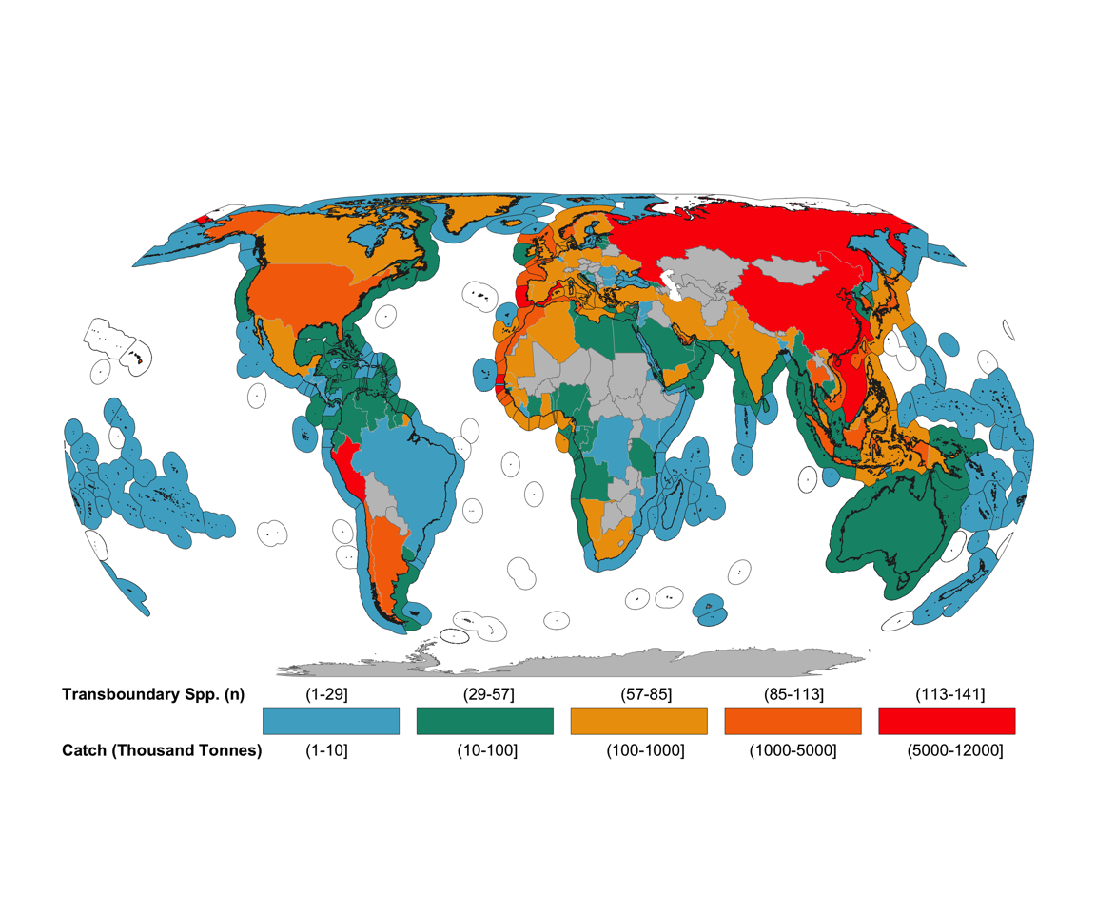

Figure 11.1: Number of transboundary species per EEZ and their contributions to countries’ EEZ catch. The number of species is displayed in the EEZ while catch (in thousand tonnes) is displayed in the land polygon

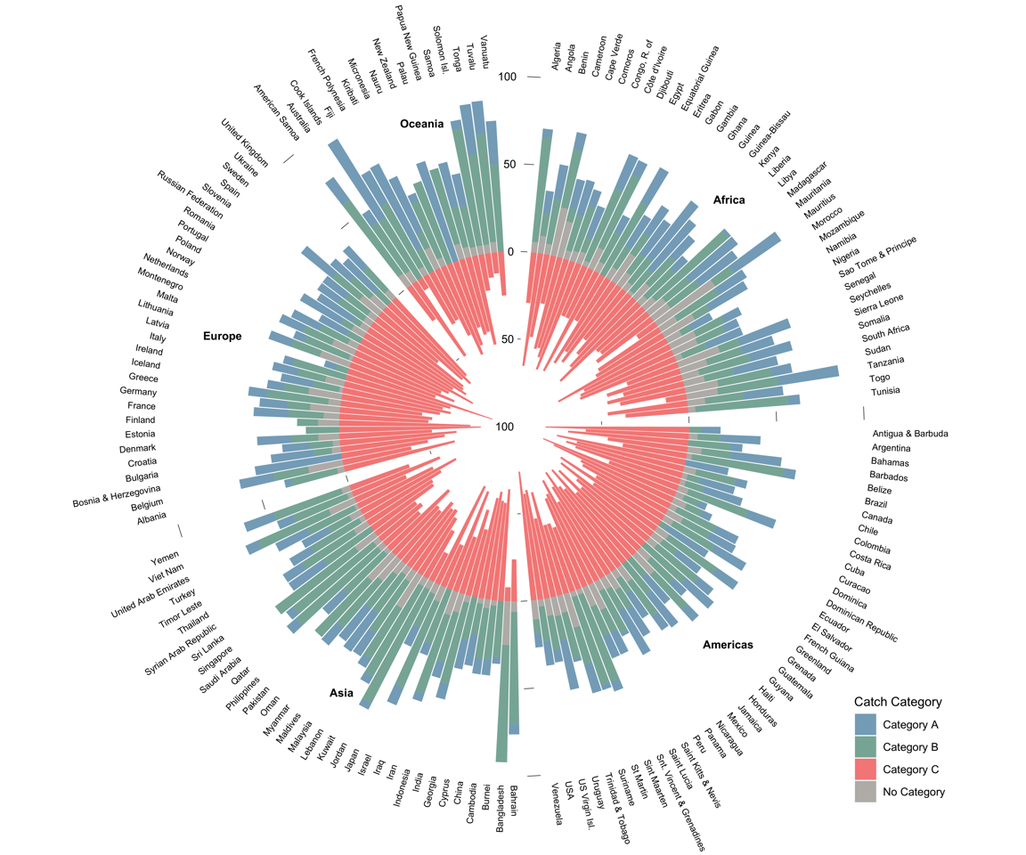

Figure 11.2: Percentage of transboundary species by catch trend and EEZ. Category A, Increasing; Category B, Constant; Category C, Decreasing. “No Category” reflects species with less than 10 years of catch data and/ or less than 5 consecutive years of catch data.

The number of grid cells in which a species is present (Area Index) is expected to directly influence whether or not a species is considered transboundary. Therefore, we tested the sensitivity of our results to the Area Index by estimating the number of transboundary species along a gradient of values (Figure 11.3). As expected, using a more relaxed value (e.g. the species is present within 10% or more of the EEZ) will result in a greater number of transboundary species (median of 40 EEZs shared per species), while a more restrictive value (e.g., 50%) results in a median estimate of 4. The current analysis utilized a 25% Area Index threshold (Figure 11.3 - darker histogram).

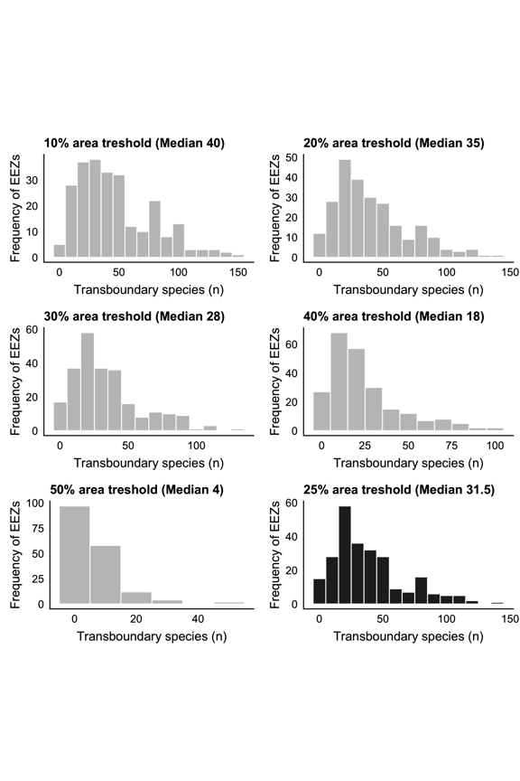

Figure 11.3: Histogram of number of transboundary species using different Area Index threshold values.

Table 11.1: Size of all the EEZs in each sub region determined by the United Nations

## 11.2 Appendix B - Supplementary information for “Early emergence of range shift-induced challenges in managing transboundary fish stocks under climate change”

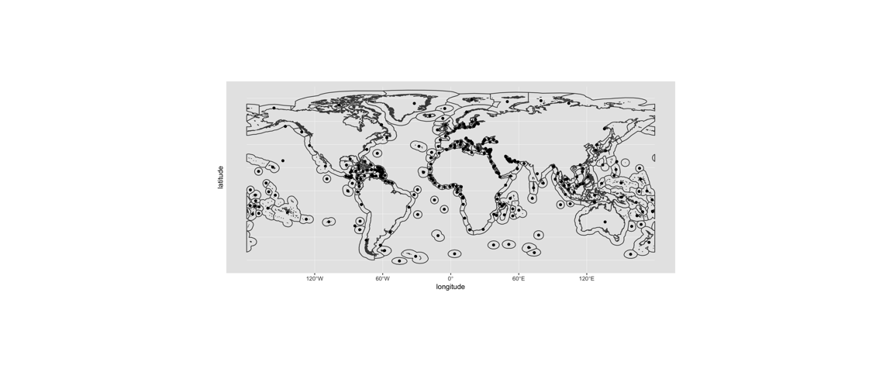

Figure 11.4: World Exclusive Economic Zones used in this study as defined by the Sea Around Us and their centroids (points).

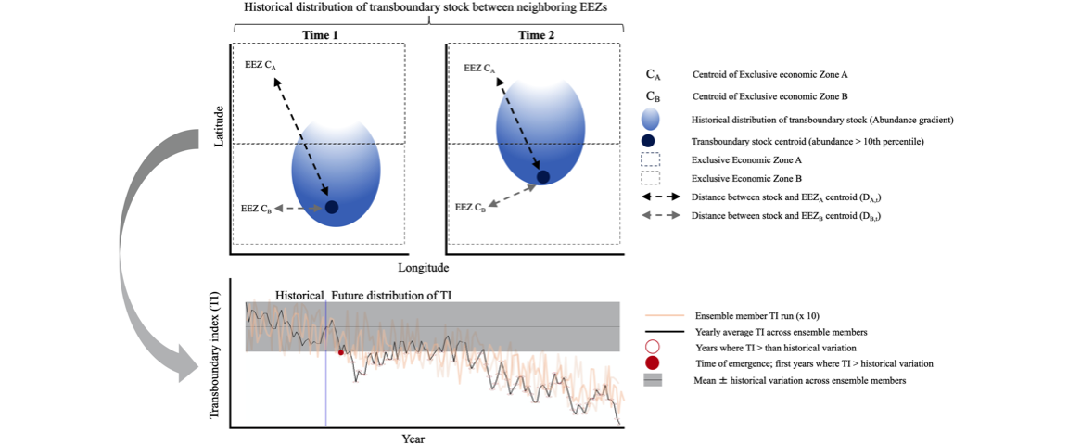

Figure 11.5: Graphical representation of the transboundary index (TI) to determine the time of emergence of transboundary stocks. The index is based on the distance between the distributional centroid of the transboundary stock and the geographic centroid of the neighbouring Exclusive Economic Zones sharing the stock (Top panel). Time of emergence is defined as the first year when the TI overpasses historical values (Bottom panel).

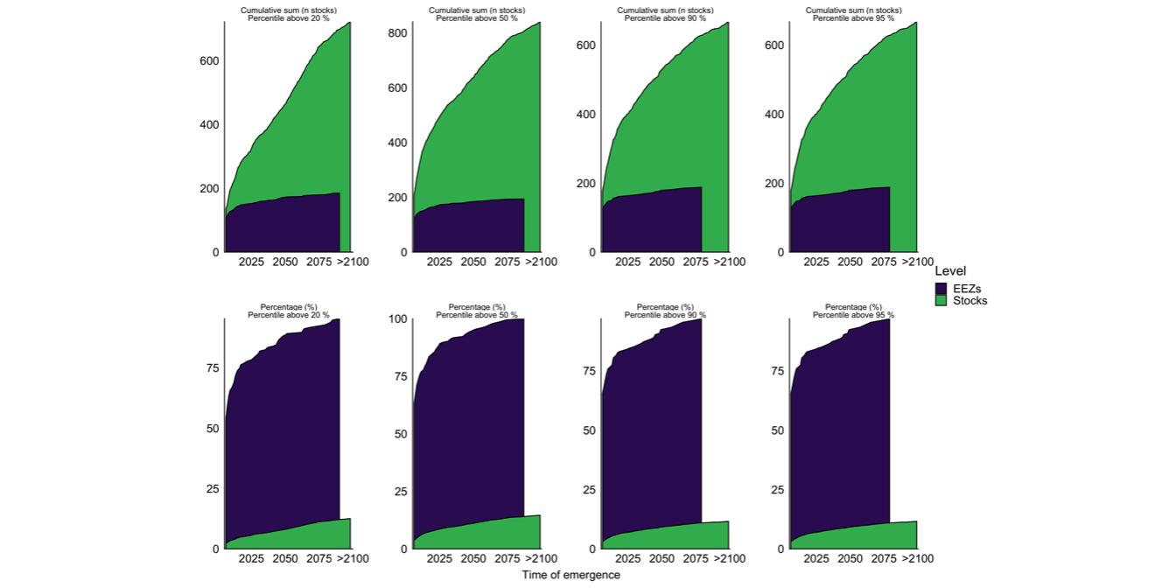

Figure 11.6: Sensitivity analysis of the number of grid cells with projected stock abundance within the neighbouring EEZs sharing the stock. The level used in this article was the top 95th percentile (e.g., far right column).

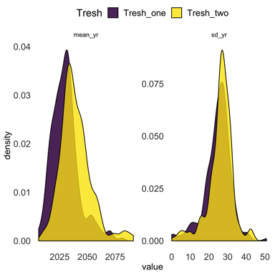

Figure 11.7: Average Time of Emergence and standard deviation for a 64% confidence threshold (purple) and a 98% confidence threshold (yellow)

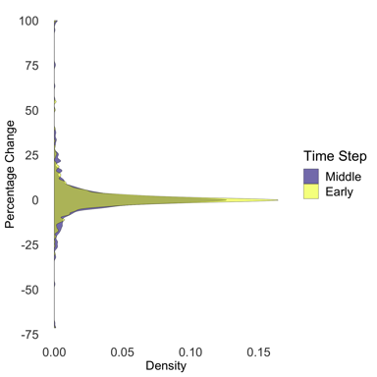

Figure 11.8: Distribution of Stock Share Ratio percentage change by the early (2021-2040) and middle (2040-2060) 21st century relative to today (1951-2005)

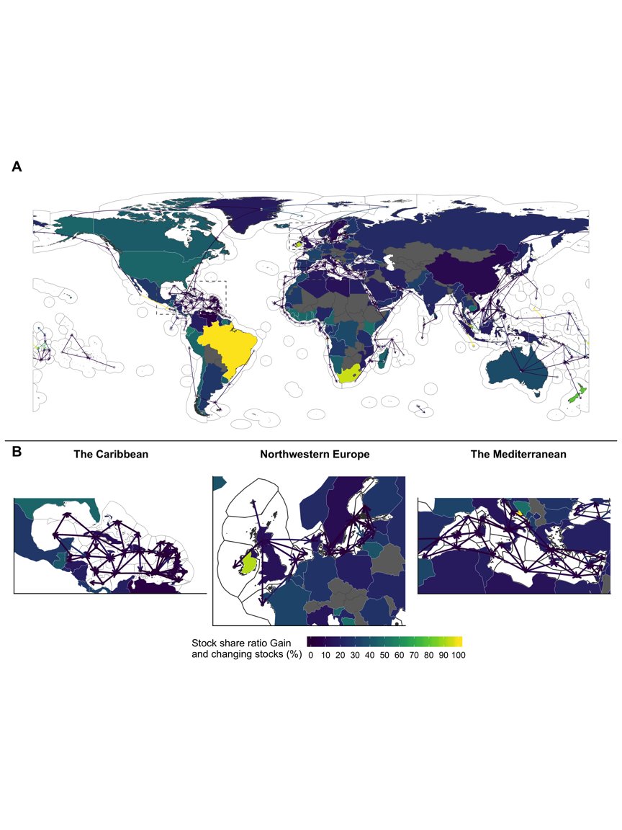

Figure 11.9: Changes in Stock Share Ration by 2050 (2041-2060) relative to 1951-2005. Lines represent the average gain of transboundary stock share ratio with arrows going from the losing EEZ (point) to the winner (arrowhead). Polygons represent the percentage of initial species that will see a shift. Panel B zooms in to specific areas shown in grey boxes of A.

## 11.3 Appendix C - Supplementary information for “Challenges to transboundary fisheries management in North America under climate change”

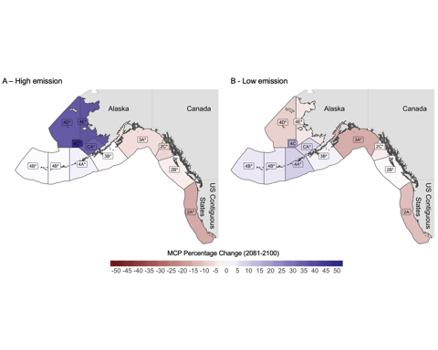

Figure 11.10: Percentage change of MCP for stocks managed by the IPHC for end-century (2081–2100) relative to 2005–2014 under a A) high emission scenario and B) low emission scenario. Labels marked with * represent regions where models do not agree in direction of change.

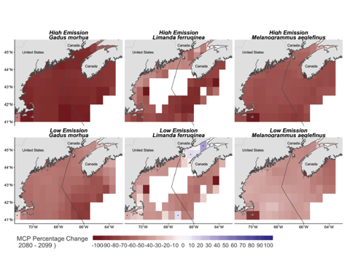

Figure 11.11: Percentage change of MCP in the Gulf of Maine under (RCP 8.5) high emission scenario and (RCP 2.6) low emission for the end of the 21stcentury (2080–2100) relative to present (2005– 2014). Values represent the mean of 3 ESM. Points represent regions where ESMs do not agree in direction of change

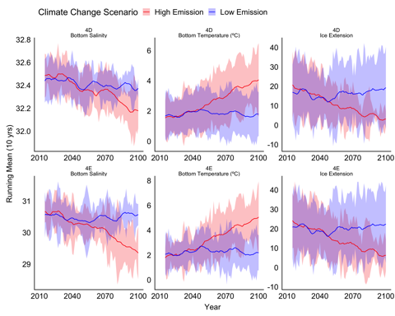

Figure 11.12: Projected environmental variables under climate change from 2010 to 2010 for Arctic regions of the IPHC (Top:4D, Bottom, 4E). The solid line represents the average of all three ESMs and the shaded area represents the model’s uncertainty (s.d.).

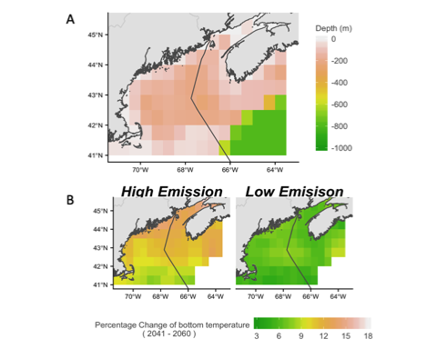

Figure 11.13: Depth profile (A) and bottom water warming of the Gulf of Maine. Everything deeper than 1000 meters is colored in green. B) Percentage change of bottom temperature relative to the present showing more intense warming in northern regions, especially under a high emission climate change scenario.

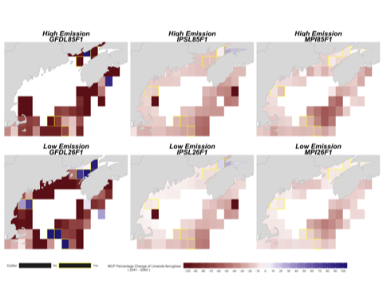

Figure 11.14: Changes in maximum catch potential of yellowtail flounder (Limanda ferruginea) within the study area by mid-century relative to present time. Results for the three global circulation models (GFDL, IPSL, MPIS) used in the current study and two climate change scenarios (Top: High emission – RCP 8.5, Bottom: Low Emission – RCP 2.6). Grid-cells marked in yellow represent discrete areas where average MCP is projected to increase by mid-century.

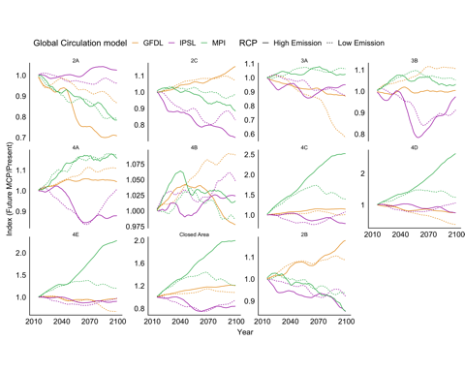

Figure 11.15: Projected MCP change relative to present (2005-2014) for each IPHC regulatory area. Colors represents the different ESM used in the study. Solid line represents a high emission scenario (RCP 8.5) and dashed line represents a low emission scenario (RCP 2.6)

1. In this case, the confidence interval used by the IPCC lies between the 17–83% probability range.
2. Northwest Atlantic Fisheries Organization, Available at <https://www.nafo.int/Science/>
3. Geophysical Fluid Dynamics Laboratory Earth System Models 2M [online] <https://www.gfdl.noaa.gov>
4. Institute Pierre Simon Laplace Climate Model 5 [online] <https://www.icmc.ipsl.fr>
5. Max Planck Institute for Meteorology Earth System Model [online] <https://www.mpimet.mpg.de/en/science/models>
6. See IPHC Time Series Datasets, Modelled FISS Stock Distribution Estimates [internet] <https://www.iphc.int/data/time-series-datasets>